

American International University-Bangladesh (AIUB)  
Department of Computer Science  
Faculty of Science &Technology (FST)  
SPRING 22-23

Section: F  
Software Quality Assurance and Testing

Star Tech

A Report

By

|  |  |  |
| --- | --- | --- |
| SN | Student Name | Student ID |
| 1 | Rana Tabassum | 20-42124-1 |
| 2 | Sadman Rafi | 20-42708-1 |
| 3 | Azraf Faheem | 20-42152-1 |
| 4 | Rubaiba Hossain | 20-42148-1 |

**Under the supervision of**

**Israt Jahan Mouri**

**Assistant Professor, Dept of CS**

**AIUB**

Software Test Plan

for

<Star Tech>

Version 1.0 approved

Prepared by <Group-1>

<American International University Bangladesh>

<16th May 2023>

**Checked By Industry Personnel**

Name:

Designation:

Company:

Sign:

Date:

Table of Contents

Revision History 3

1. TEST PLAN IDENTIFIER: STechLtd-TP01 3

2. REFERENCES 3

3. INTRODUCTION 4

Background to the Problem 4

Solution to the Problem 4

4. REQUEIREMNT SPECIFICATION 4

4.1 System Features 4

4.2 System Quality Attributes 9

5. FEATURES NOT TO BE TESTED 9

6. TESTING APPROACH 10

6.1 Testing Levels 10

6.2 Test Tools 10

6.3 Meetings 10

7. TEST CASES/TEST ITEMS 11

8. ITEM PASS/FAIL CRITERIA 113

9. TESTING SCHEDULE 113

# Revision History

|  |  |  |  |
| --- | --- | --- | --- |
| Revision | Date | Updated by | Update Comments |
| 0.1 | 2023.05.15 | Rubaiba Hossain | First Draft |
| 0.2 | 2023.05.15 | Azraf Fahim Oyon | Second Draft |
| 0.3 | 2023.05.16 | Sadman Rafi | Third Draft |
| 0.4 | 2023.05.16 | Rana Tabassum | Final Draft |

# TEST PLAN IDENTIFIER: STechLtd-TP01

# REFERENCES

* <https://www.startech.com.bd/>
* <https://www.selenium.dev/selenium-ide/docs/en/introduction/getting-started>
* Software Testing And Quality Assurance – Theory and Practice - Kshirasagar Naik & Priyadarshi Tripathy

# INTRODUCTION

## Background to the Problem

## We all know that Bangladesh is progressing towards becoming a developed country. Digital devices are playing a crucial role in this progress. They have become essential in various places like businesses, studying, offices, and even homes. As a result, everyone needs these devices. However, people have busy lives and face additional pressure from Dhaka city's crowded roads and demanding routines. This makes it hard for them to physically check product details, compare options, and make purchases. To solve this problem, many companies, including StarTech, have created websites where customers can easily buy products, compare features, and find detailed information. These websites offer a convenient and time-saving solution for busy individuals, helping them make informed decisions and access the products they need with ease.

## Solution to the Problem

# No software or website is entirely free of bugs. There is always a possibility of encountering bugs in the software or website, and StarTech is no exception. There might be certain issues that could create problems for users. For example, if there is a sorting problem in the software, it can cause inconvenience for customers while navigating through the products. Similarly, if there are any payment issues, it can be a hassle for customers when making transactions. Additionally, if there are inaccuracies in the product details, customers may not get a proper understanding of the products. Moreover, if there are any problems with the comparison feature, it can lead to confusion among customers.

# To address these potential issues, it is crucial to thoroughly test all aspects of the website. By conducting comprehensive testing, we can identify and resolve any problems that may arise. This will ensure that customers receive a smooth and hassle-free experience while using the website. Moreover, it will serve as a motivation for the growth and success of the business. Therefore, testing such websites is of utmost importance to ensure the provision of reliable and efficient services to customers.

# REQUEIREMNT SPECIFICATION

## System Features

1. System Registration  
 Functional Requirements

* 1. The system allow users to create an account by providing necessary information such as name, email address, password, and phone number
  2. . It will send an OTP to the email or the phone number that will be provided.

Priority Level: High  
Precondition: User must register to the system.

2. System Login  
Functional Requirements

* 1. The login functionality verifies the identity of registered users by validating their email and password.
  2. It ensures that only authorized users can access the system.

Priority Level: High  
Precondition: user must provide email and phone number

3. Edit User Profile  
Functional Requirements

3.1 The system should authenticate the user before allowing them to edit their profile.

3.2 If the number This ensures that only authorized users can access and modify their profile information.

Priority Level: High  
Precondition: user must have an account

4. Change Password  
Functional Requirements

4.1 The user must be authenticated and logged in to access the "Change Password" functionality.

4.2 This ensures that only authorized users can modify their passwords.

Priority Level: High  
Precondition: user must have an account

5. Order History  
Functional Requirements

5.1 Users should be able to access their order history, which provides a list of all their previous orders placed on the website.

5.2 The order history should display relevant details such as order number, date, item purchased, quantity, and total cost.

Priority Level: High  
Precondition: user must place an order

6. Wishlist

6.1 Users should be able to add items to their wishlist by clicking on a "Add to Wishlist" button or a similar functionality.

6.2 This action should store the selected items in their wishlist for future reference.

Priority Level: High  
Precondition: user must add products to wishlist

7. PC Build  
Functional Requirements

7.1 The components of the PC, including the motherboard, CPU, RAM, graphics card, storage devices, and power supply, must be compatible with each other.

7.2 Ensuring compatibility is crucial to avoid issues and ensure optimal performance.

Priority Level: High  
Precondition: user must select products as their wish

8. Payment Options  
Functional Requirements

8.1 The payment options should ensure secure processing of customer transactions, protecting sensitive financial information such as credit card details.

Priority Level: High  
Precondition: user must have an account

9. Order Placement  
Functional Requirements

9.1 The system should provide a clear and straightforward order placement process.

9.2 Users should be able to select the desired quantity, choose any applicable options and proceed to confirm the order.

Priority Level: High  
Precondition: user must have an account

10. Coupon Codes and Vouchers  
Functional Requirements

10.1 If applicable, the system should support the use of coupon codes or vouchers for accessing and redeeming offers. This includes generating unique codes, validating them during the checkout process, and applying the associated discounts.

Priority Level: Low  
Precondition: user must have an account

11. Calculation of Discounts:  
Functional Requirements

11.1 The system should accurately calculate the discounts or price reductions associated with offers.

11.2 This includes applying percentage-based discounts, fixed amount reductions, or other applicable pricing rules.

Priority Level: High  
Precondition: user must have an account

12. Offer Display:  
Functional Requirements

12.1 The system should display the offers prominently on the website, ensuring they are easily visible to users.

12.2 This may involve showing the offer details on product pages, category pages, or through banners and pop-ups.

Priority Level: Low  
Precondition: user must have an account

13. Add to Cart:  
Functional Requirements

13.1 Users should be able to add products to their cart by clicking an "Add to Cart" button or a similar action.

13.2 The selected product should be stored in the user's cart for future reference.

Priority Level: High  
Precondition: user must have an account

14. Remove from Cart:  
Functional Requirements

14.1 Users should have the option to remove items from their cart if they no longer wish to purchase them. This can be done through a "Remove" or "Delete" button associated with each item in the cart.

Priority Level: High  
Precondition: user must have an account

15. System Logout  
Functional Requirements

15.1 The system should ensure that only authenticated users can access the logout functionality.

15.2 This may involve verifying user credentials, such as username and password, or using other authentication methods like two-factor authentication.

Priority Level: High  
Precondition: user must have an account

16. Side-by-Side Comparison

Functional Requirements

16.1 The selected products should be displayed side by side in a clear and organized manner, presenting their key features, specifications, and prices. This allows users to easily compare the attributes of different products.

Priority Level: High

Precondition: user must have an account

17. Sorting and Filtering:  
Functional Requirements

17.1 Users should have the ability to sort and filter the compared products based on different criteria.

17.2 For example, they may want to sort by price, rating, or popularity to make an informed decision.

Priority Level: High  
Precondition: user must have an account

## System Quality Attributes

* Usability: The system should have an intuitive and user-friendly interface, making it easy for users to navigate, perform tasks and access the desired information efficiently. It should consider factors such as accessibility, responsiveness across different devices and support for assistive technologies.
* Reliability: It means system should be reliable and available for users at any time, minimizing downtime and ensuring that data integrity is maintained. It should be able to recover gracefully from failures such as server outages or network disruptions.
* Interoperability: Interoperability means its able to communicate or exchange data seamlessly between different operating systems.
* Security: The system should implement robust and security measures to protect user data and prevent unauthorized access or malicious activities. It is the most important attributes for a e-commerce websites.
* Performance: It is the ability of a system in the form of responsiveness and perform efficiently, ensuring that it can handle a high volume of users and concurrent requests without experiencing significant slowdowns or latency issues.
* Testability: Testability means how easy a software solution is to test to find bugs or ensure that it meets all predefined criteria.

# FEATURES NOT TO BE TESTED

The following is a list of the areas that will not be specifically addressed. All testing in these areas will be indirect as a result of other testing efforts. For example:

* Payment procedure will not be tested as this testing can only be done through use of external API

which can be difficult to configure and requires additional account or credit card number.

* Help Center will not be tested as this testing can only be done through use of external API which can be difficult to configure and requires additional account or credit card number.

# TESTING APPROACH

## Testing Levels

* The testing approach to test the website will focus on SYSTEM testing due to the unavailability of the source code. This means UNIT testing and INTEGRATION testing cannot be performed as they require source code. Due to the shortage of time, it is not possible to manage vast amount of users for ACCEPTANCE testing. Consequently, a team of testers will perform SYSTEM testing.
* The leader of the development team and the test manager will support the actual end users throughout testing. where the software's functionality and usability are the main priorities. At this point in testing, the software should be sufficiently free of errors to permit a change in direction. It typically occurs just before the user or client takes control of the software. During acceptability testing, some things are tested. Check that the system complies with the specifications, identify any discrepancies, and determine whether it is prepared to be switched to live operations. Despite the fact that it is a web-based program, reliability, usability, security, availability, scalability, and maintainability are our top priorities.

## Test Tools

The only test tools to be used are the standard AS/400 provided utilities and commands.

**Selenium IDE:** It is a popular record and playback tool used for web application testing. It is an open-source integrated development environment that allows testers and developers to create automated test scripts without the need for extensive programming knowledge. It’s mainly a browser extension. The interface is user-friendly and helps to reuse test cases and fix issues.

## Meetings

Multiple meetings were conducted. The summary of the each of the meetings are given below:

o Meeting 1 (May 08, 2023): Requirements and features were collected and noted down from the website.

o Meeting 2 (May 11, 2023): Features were distributed to the team members of the project.

o Meeting 3 (May 12, 2023): Work updates were noted results were reported.

o Meeting 4 (May 14, 2023): All test cases were run and the results were reported.

o Meeting 5 (May 15, 2023): Final test cases were run the results were reported. Final meeting

was done and the full report was drafted finally.

Here is a screenshot of our first meeting on 9th May that was conducted online on Microsoft Teams.

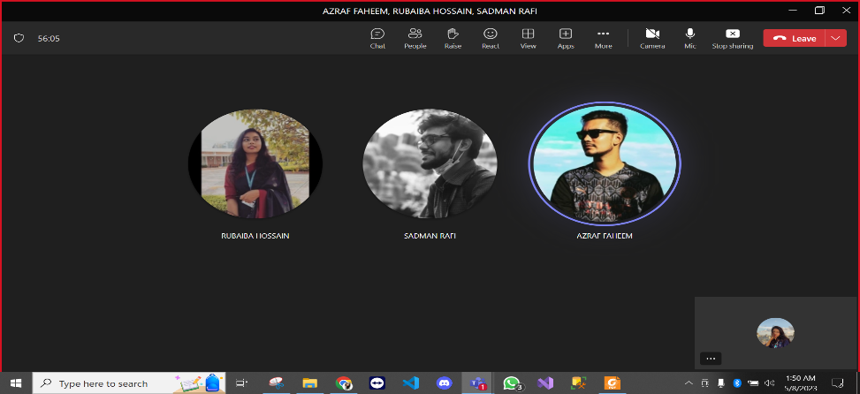

# TEST CASES/TEST ITEMS

|  |  |  |  |  |  |
| --- | --- | --- | --- | --- | --- |
| Project Name: StarTech | | | Test Designed by: Rana Tabassum | | |
| Test Case ID: Tabassum-TC01 | | | Test Designed date: 12/05/2023 | | |
| Test Priority (Low, Medium, High): Medium | | | Test Executed by: Rana Tabassum | | |
| Module Name: Add to cart | | | Test Execution date: 12/05/2023 | | |
| Test Title: add products to the cart | | |  | | |
| Description: Test whether the user can add as many products to the cart they want | | |  | | |
| Precondition (If any): N/A | | | | | |
| Test Steps | Test Data | Expected Results | | Actual Results | Status  (Pass/Fail) |
| 1. Go to the StarTech website 2. Click on “Any Product”. 3. Click on “Buy Now”. 4. Click on “View Cart” | Click on Headphones | User should get a list of products that are added to the cart | | as expected, | pass |

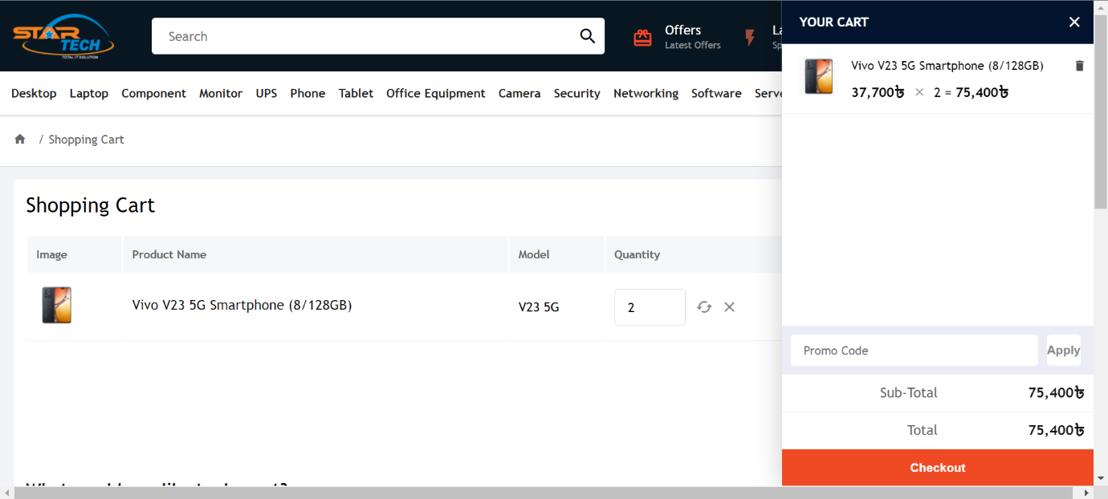

**Fig-1: Add product to cart**

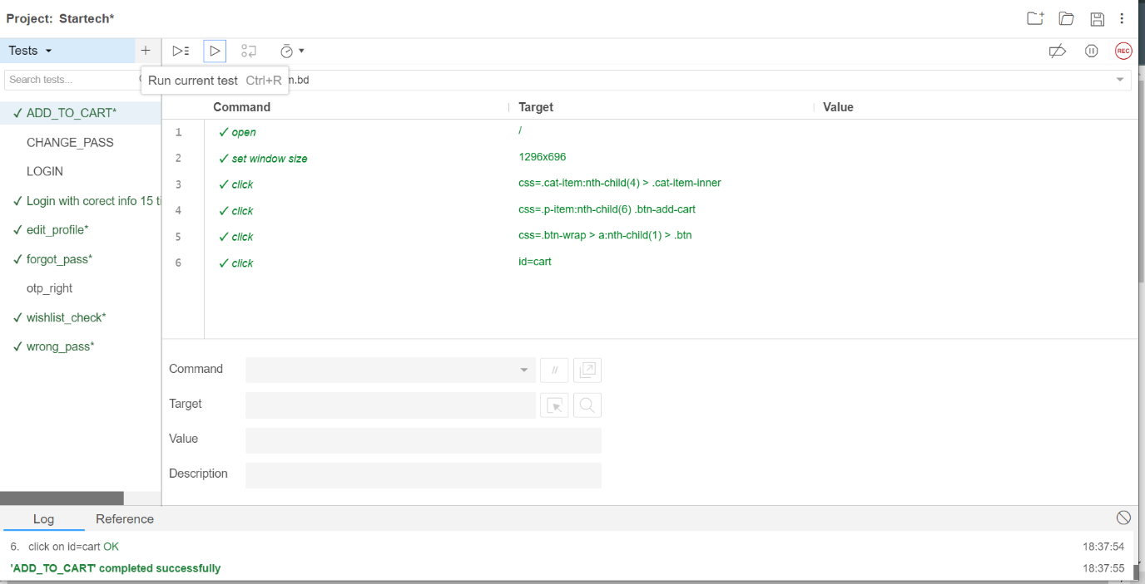

**Fig-2: Add product to cart test case execution result**

|  |  |  |  |  |  |
| --- | --- | --- | --- | --- | --- |
| Project Name: StarTech | | | Test Designed by: Rana Tabassum | | |
| Test Case ID: Tabassum-TC02 | | | Test Designed date: 12/05/2023 | | |
| Test Priority (Low, Medium, High): Medium | | | Test Executed by: Rana Tabassum | | |
| Module Name: Add to cart increment | | | Test Execution date: 12/05/2023 | | |
| Test Title: Increment of quantity and price in Add to cart | | |  | | |
| Description: Test whether the user can increment of quantity in cart and the price gets incremented as well. | | |  | | |
| Precondition (If any): N/A | | | | | |
| Test Steps | Test Data | Expected Results | | Actual Results | Status  (Pass/Fail) |
| 1. Go to the Startech website 2. Click on “Cart”. 3. Click on + button | 5 times added to the cart | User should get a increment of quantity in cart and the price gets incremented also. | | as expected, | pass |

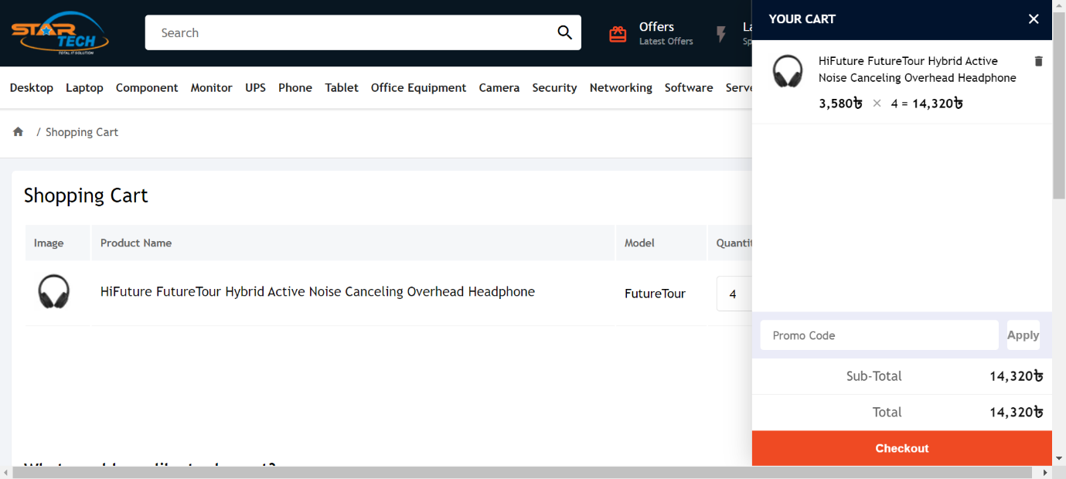

**Fig-3: Add to cart increment**

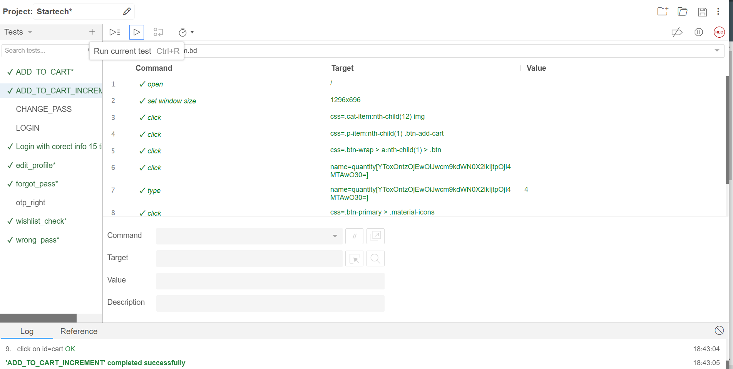

**Fig-4: Add to cart increment test case execution result**

|  |  |  |  |  |  |
| --- | --- | --- | --- | --- | --- |
| Project Name: StarTech | | | Test Designed by: Rana Tabassum | | |
| Test Case ID: Tabassum-TC03 | | | Test Designed date: 12/05/2023 | | |
| Test Priority (Low, Medium, High): High | | | Test Executed by: Rana Tabassum | | |
| Module Name: Change Password | | | Test Execution date: 12/05/2023 | | |
| Test Title: Change the password | | |  | | |
| Description: Test whether the user can Change the password | | |  | | |
| Precondition (If any): User must Login with a valid Startech user ID | | | | | |
| Test Steps | Test Data | Expected Results | | Actual Results | Status  (Pass/Fail) |
| 1. Go to the Startech website 2. Click on “Profile” 3. Click on “Change password” 4. Give a new password 5. Confirm the given password | Given password “2222” | User should be able to Change the password | | as expected, | pass |

|  |  |  |  |  |  |
| --- | --- | --- | --- | --- | --- |
| Project Name: StarTech | | | Test Designed by: Rana Tabassum | | |
| Test Case ID: Tabassum-TC04 | | | Test Designed date: 12/05/2023 | | |
| Test Priority (Low, Medium, High): High | | | Test Executed by: Rana Tabassum | | |
| Module Name: Login | | | Test Execution date: 12/05/2023 | | |
| Test Title: Login | | |  | | |
| Description: Test whether the user can log in after changing the password | | |  | | |
| Precondition (If any): User must Login with a valid Startech user ID | | | | | |
| Test Steps | Test Data | Expected Results | | Actual Results | Status  (Pass/Fail) |
| 1. Go to the Startech website 2. Click on “Profile” 3. Click on “Login” 4. Give the new password 5. Click on “Login” | Used number 01312406739 | User should be able to login after Change the password | | as expected, | pass |

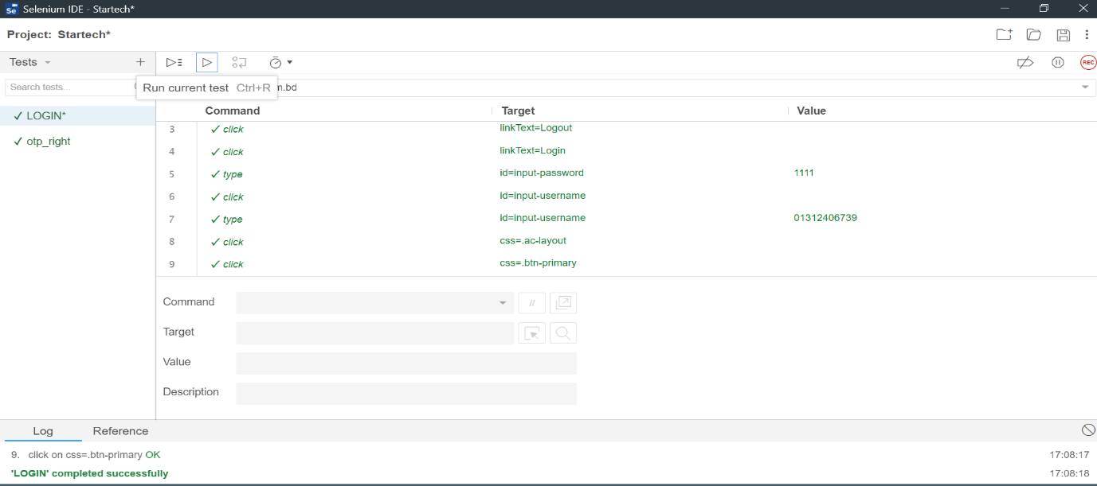

**Fig-5: Log test case execution result**

|  |  |  |  |  |  |
| --- | --- | --- | --- | --- | --- |
| Project Name: StarTech | | | Test Designed by: Rana Tabassum | | |
| Test Case ID: Tabassum-TC05 | | | Test Designed date: 12/05/2023 | | |
| Test Priority (Low, Medium, High): High | | | Test Executed by: Rana Tabassum | | |
| Module Name: Login for 15 times | | | Test Execution date: 12/05/2023 | | |
| Test Title: Login for 15 times | | |  | | |
| Description: Test whether the user can log in can be done 15 times in a row | | |  | | |
| Precondition (If any): User must Login with a valid StarTech user ID | | | | | |
| Test Steps | Test Data | Expected Results | | Actual Results | Status  (Pass/Fail) |
| 1. Go to the StarTech website 2. Click on “Profile” 3. Click on “Login” 4. Give the new password 5. Click on “Login” | Used number 01312406739 | User should be able to login for 15 times at the same time | | as expected, | pass |

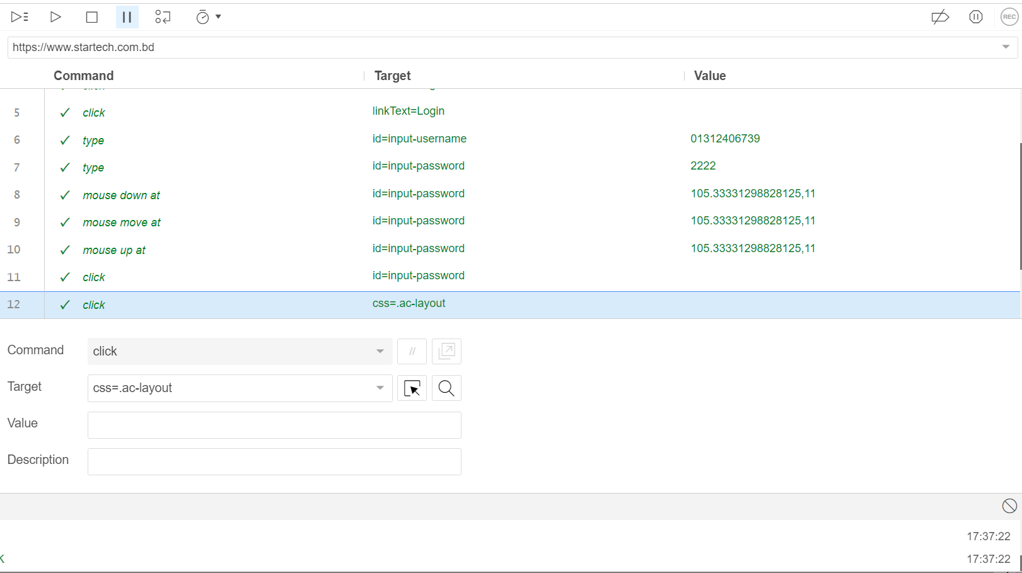

**Fig-6: Login for 15 times test case execution result**

|  |  |  |  |  |  |
| --- | --- | --- | --- | --- | --- |
| Project Name: StarTech | | | Test Designed by: Rana Tabassum | | |
| Test Case ID: Tabassum-TC06 | | | Test Designed date: 12/05/2023 | | |
| Test Priority (Low, Medium, High): Medium | | | Test Executed by: Rana Tabassum | | |
| Module Name: Cart delete | | | Test Execution date: 12/05/2023 | | |
| Test Title: Cart Delete | | |  | | |
| Description: Test whether the user can delete the products added to the cart | | |  | | |
| Precondition (If any): | | | | | |
| Test Steps | Test Data | Expected Results | | Actual Results | Status  (Pass/Fail) |
| 1. Go to the Startech website 2. Click on “Cart” 3. Click on “Delete” | Null | User should be able to Delete the products added on the cart previously | | as expected, | pass |

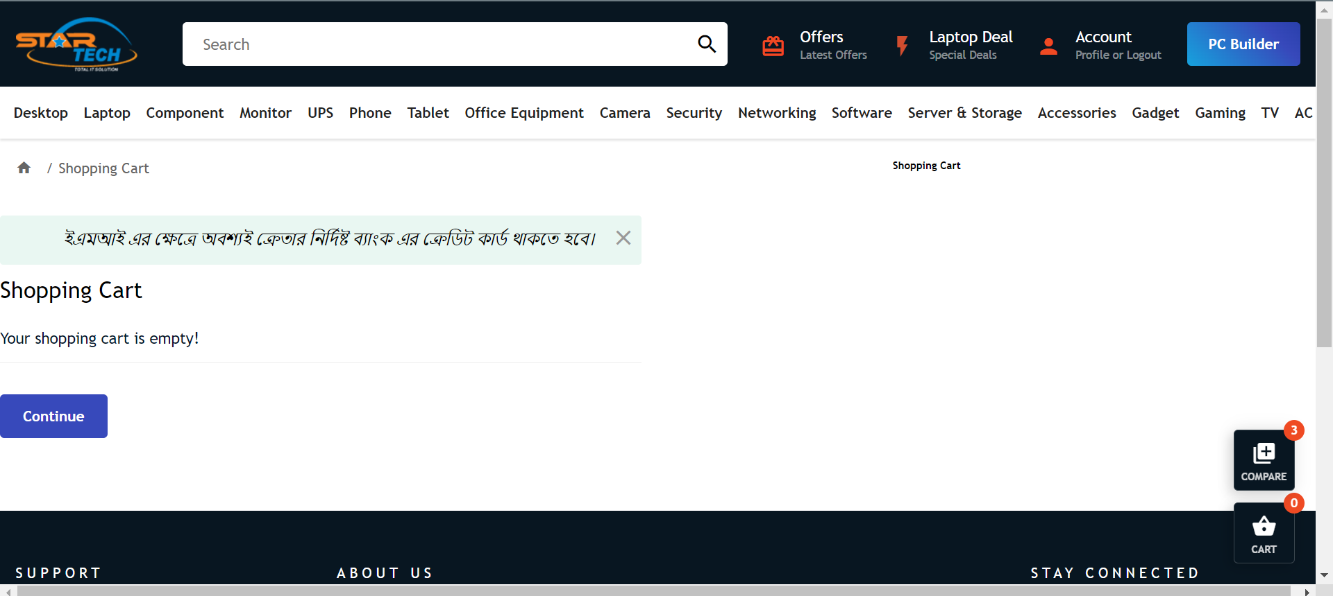

**Fig-7: Cart delete**

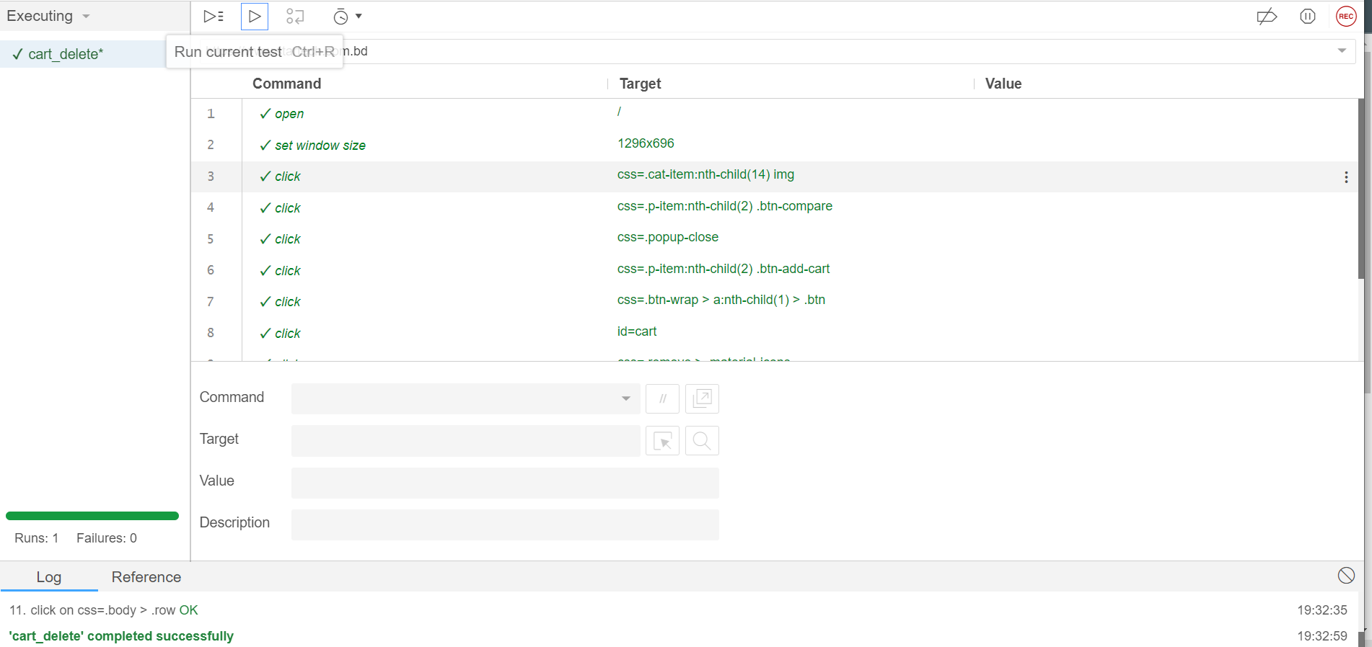

**Fig-8: Cart delete test case execution result**

|  |  |  |  |  |  |
| --- | --- | --- | --- | --- | --- |
| Project Name: StarTech | | | Test Designed by: Rana Tabassum | | |
| Test Case ID: Tabassum-TC07 | | | Test Designed date: 12/05/2023 | | |
| Test Priority (Low, Medium, High): High | | | Test Executed by: Rana Tabassum | | |
| Module Name: Add address | | | Test Execution date: 12/05/2023 | | |
| Test Title: Add address | | |  | | |
| Description: Test whether the user can add address | | |  | | |
| Precondition (If any): User must Login with a valid StarTech user ID | | | | | |
| Test Steps | Test Data | Expected Results | | Actual Results | Status  (Pass/Fail) |
| 1. Go to the StarTech website 2. Click on “Profile” 3. Click on “Add address” 4. Give all the information 5. Click on “Add” | Address of team member | User should be able to add their address | | as expected, | pass |

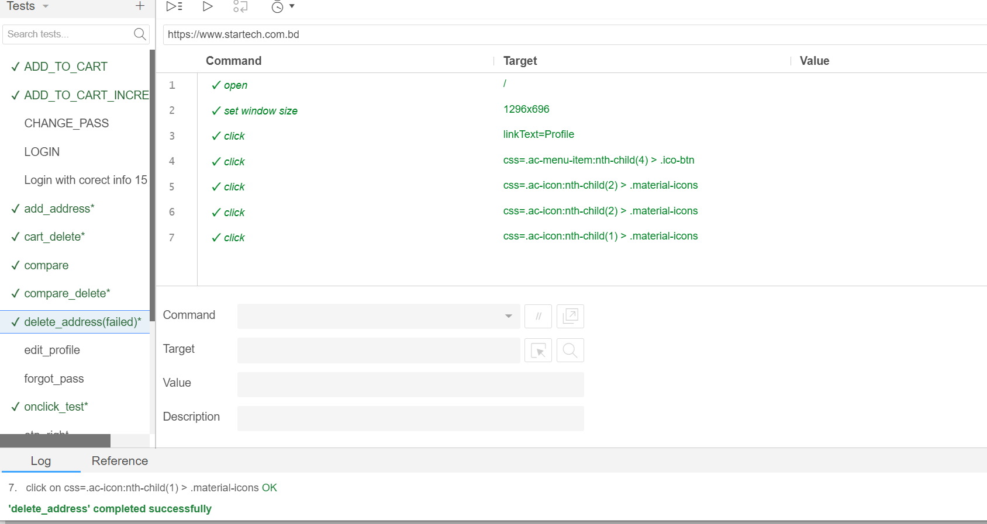

**Fig-9: Add address test case execution result**

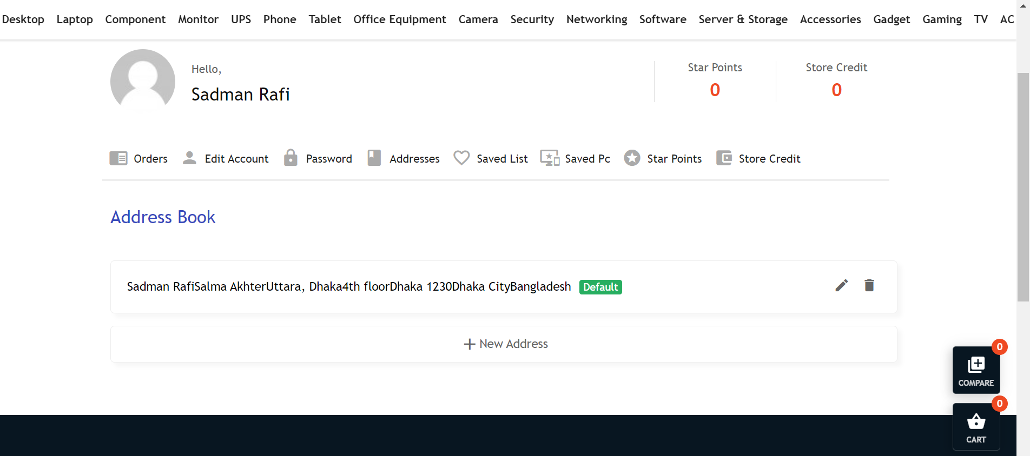

**Fig-10: Add address**

|  |  |  |  |  |  |
| --- | --- | --- | --- | --- | --- |
| Project Name: StarTech | | | Test Designed by: Rana Tabassum | | |
| Test Case ID Tabassum-TC08 | | | Test Designed date: 12/05/2023 | | |
| Test Priority (Low, Medium, High): Low | | | Test Executed by: Rana Tabassum | | |
| Module Name: Delete address | | | Test Execution date: 12/05/2023 | | |
| Test Title: Delete address | | |  | | |
| Description: Test whether the user can delete their previously added address | | |  | | |
| Precondition (If any): User must Login with a valid Startech user ID | | | | | |
| Test Steps | Test Data | Expected Results | | Actual Results | Status  (Pass/Fail) |
| 1. Go to the Startech website 2. Click on “Profile” 3. Click on “Add address” 4. Click on “Delete” | Null | Test whether the user can delete their previously added address | | as expected, | Fail |



**Fig-11: Delete address**



**Fig-12: Delete address test case execution result**

|  |  |  |  |  |  |
| --- | --- | --- | --- | --- | --- |
| Project Name: StarTech | | | Test Designed by: Rana Tabassum | | |
| Test Case ID: Tabassum-TC09 | | | Test Designed date: 12/05/2023 | | |
| Test Priority (Low, Medium, High): High | | | Test Executed by: Rana Tabassum | | |
| Module Name: Compare | | | Test Execution date: 12/05/2023 | | |
| Test Title: Compare | | |  | | |
| Description: Test whether the user can compare between multiple products | | |  | | |
| Precondition (If any): N/A | | | | | |
| Test Steps | Test Data | Expected Results | | Actual Results | Status  (Pass/Fail) |
| 1. Go to the Startech website 2. Click on “Add to compare” 3. Click on “Compare list” | Null | User should be able to compare and see a comparison in the list of added products | | As expected, | Pass |

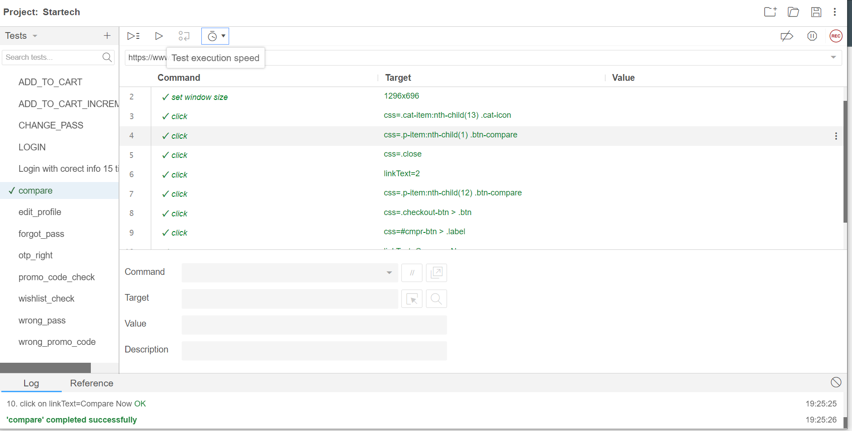

**Fig-13: Compare products test case execution result**

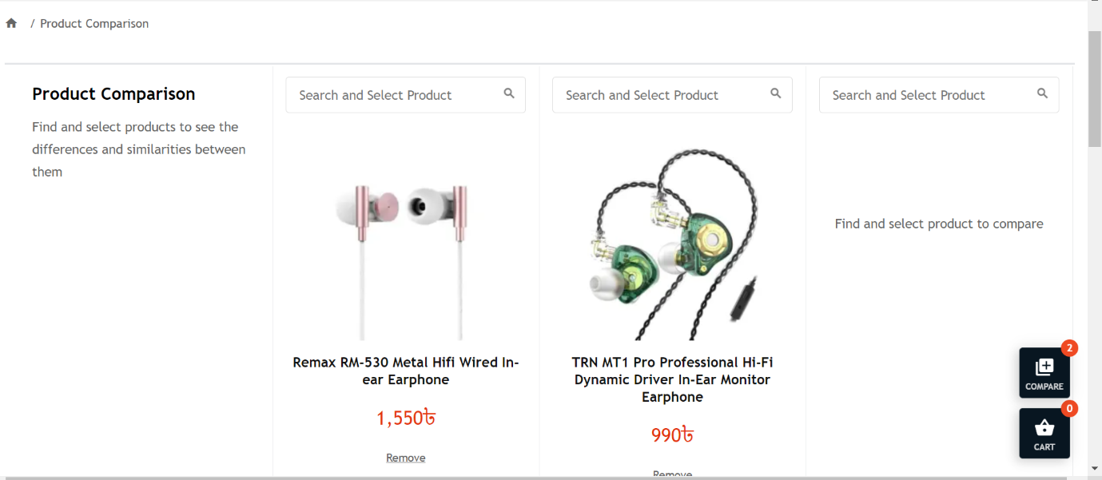

**Fig-14: Compare products**

|  |  |  |  |  |  |
| --- | --- | --- | --- | --- | --- |
| Project Name: StarTech | | | Test Designed by: Rana Tabassum | | |
| Test Case ID: Tabassum-TC010 | | | Test Designed date: 12/05/2023 | | |
| Test Priority (Low, Medium, High): Low | | | Test Executed by: Rana Tabassum | | |
| Module Name: Compare delete | | | Test Execution date: 12/05/2023 | | |
| Test Title: Compare delete | | |  | | |
| Description: Test whether the user can delete the products in compared list | | |  | | |
| Precondition (If any): User must Login with a valid StarTech user ID | | | | | |
| Test Steps | Test Data | Expected Results | | Actual Results | Status  (Pass/Fail) |
| 1. Go to the StarTech website 2. Click on “Compare” 3. Click on “delete” | Null | T user should be able to delete the products in compared list | | as expected, | pass |

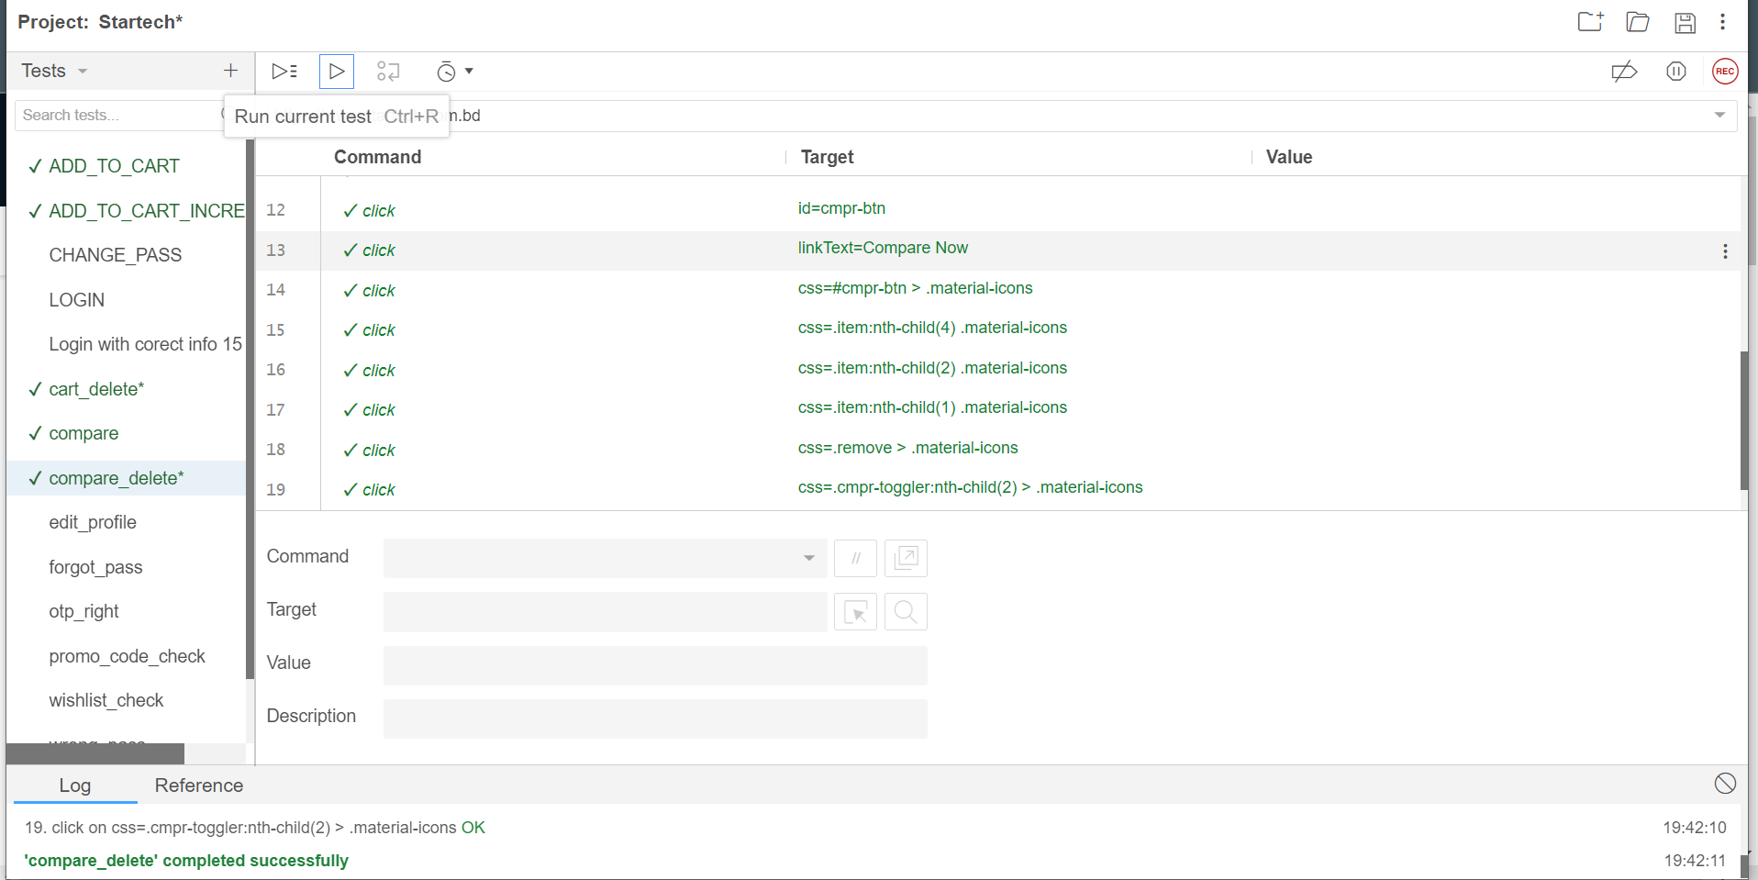

**Fig-15: Compare product delete test case execution result**

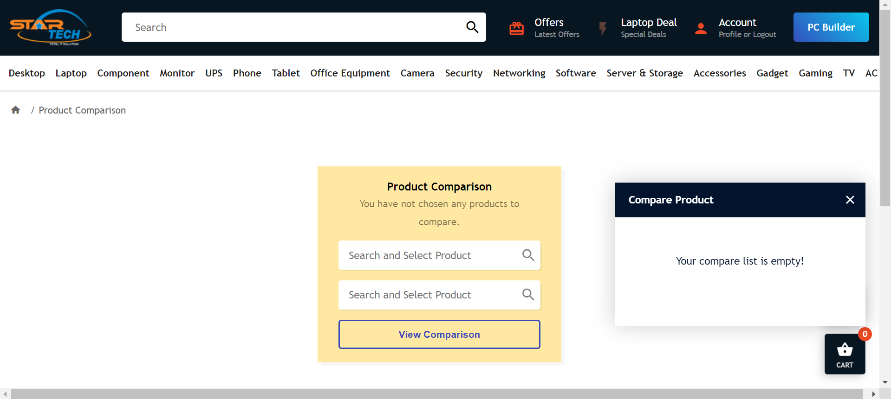

**Fig-16: Compare product delete**

|  |  |  |  |  |  |
| --- | --- | --- | --- | --- | --- |
| Project Name: StarTech | | | Test Designed by: Rana Tabassum | | |
| Test Case ID: Tabassum-TC011 | | | Test Designed date: 12/05/2023 | | |
| Test Priority (Low, Medium, High): High | | | Test Executed by: Rana Tabassum | | |
| Module Name: Edit Profile | | | Test Execution date: 12/05/2023 | | |
| Test Title: Edit Profile | | |  | | |
| Description: Test whether the user can edit their profile | | |  | | |
| Precondition (If any): User must Login with a valid StarTech user ID | | | | | |
| Test Steps | Test Data | Expected Results | | Actual Results | Status  (Pass/Fail) |
| 1. Go to the StarTech website 2. Click on “Profile” 3. Click on “Edit profile” 4. Edit the informations 5. Click on “submit” | Null | User should be able to edit their profile | | as expected, | pass |

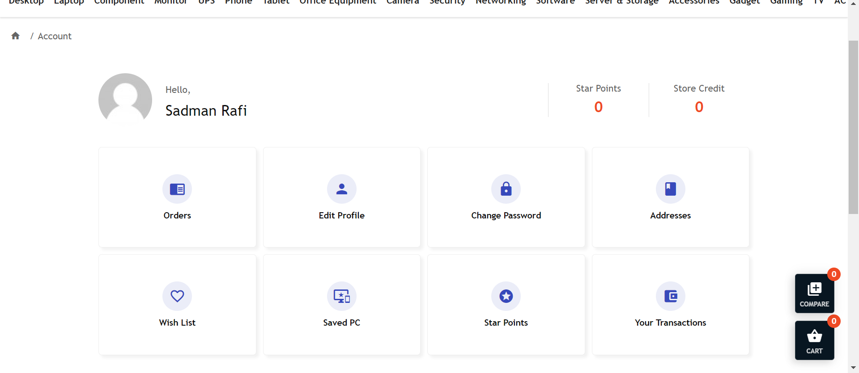

**Fig-17: Edit profile**

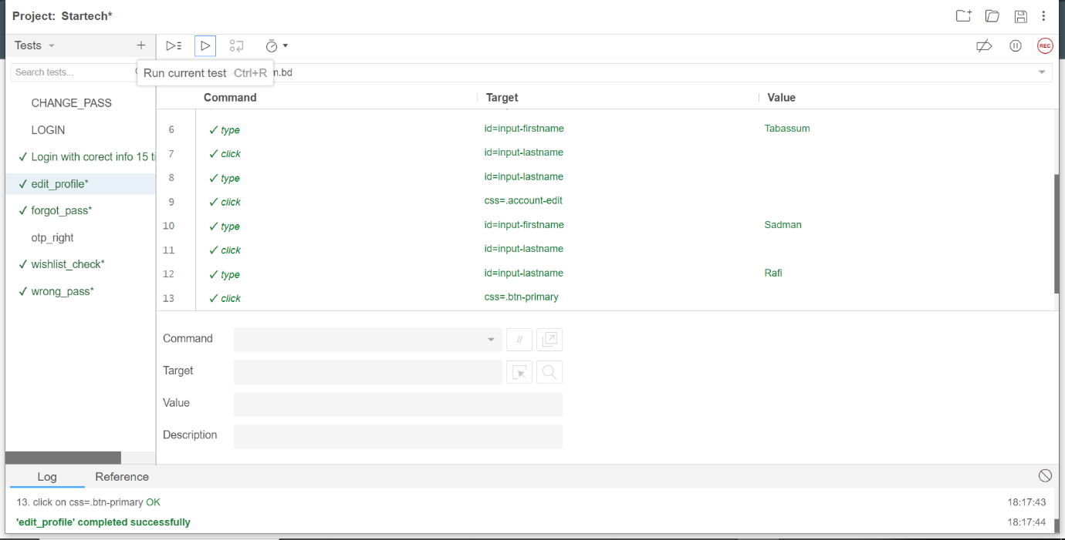

**Fig-18: Edit profile test case execution**

|  |  |  |  |  |  |
| --- | --- | --- | --- | --- | --- |
| Project Name: StarTech | | | Test Designed by: Rana Tabassum | | |
| Test Case ID: Tabassum-TC012 | | | Test Designed date: 12/05/2023 | | |
| Test Priority (Low, Medium, High): low | | | Test Executed by: Rana Tabassum | | |
| Module Name: On click test | | | Test Execution date: 12/05/2023 | | |
| Test Title: On click test | | |  | | |
| Description: Test whether the user is redirected to the button that is clicked | | |  | | |
| Precondition (If any): User must Login with a valid StarTech user ID | | | | | |
| Test Steps | Test Data | Expected Results | | Actual Results | Status  (Pass/Fail) |
| 1. Go to the StarTech website 2. Click on “product” 3. Click on “Description” 4. Click on “Specifications” | Null | User should be able to Test whether is redirected to the button that is clicked | | as expected, | pass |

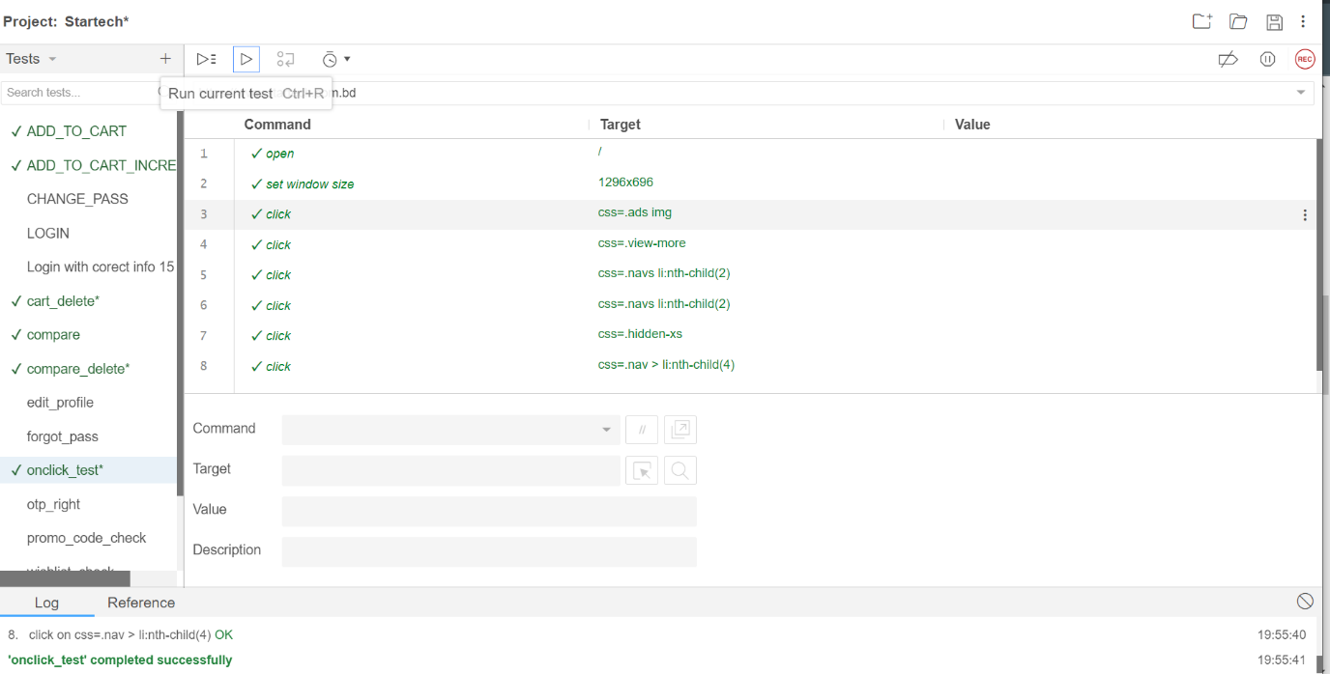

**Fig-19: On click test case execution**

|  |  |  |  |  |  |
| --- | --- | --- | --- | --- | --- |
| Project Name: StarTech | | | Test Designed by: Rana Tabassum | | |
| Test Case ID: Tabassum-TC013 | | | Test Designed date: 12/05/2023 | | |
| Test Priority (Low, Medium, High): High | | | Test Executed by: Rana Tabassum | | |
| Module Name: Check with correct OTP | | | Test Execution date: 12/05/2023 | | |
| Test Title: Check with correct OTP | | |  | | |
| Description: Test whether the user can log in by giving correct OTP | | |  | | |
| Precondition (If any): User must Login with a valid StarTech user ID | | | | | |
| Test Steps | Test Data | Expected Results | | Actual Results | Status  (Pass/Fail) |
| 1. Go to the StarTech website 2. Click on “Profile” 3. Click on “Login” 4. Give the new password 5. Click on “Login” | Used number 01312406739 | User should be able to login with correct OTP | | as expected, | pass |

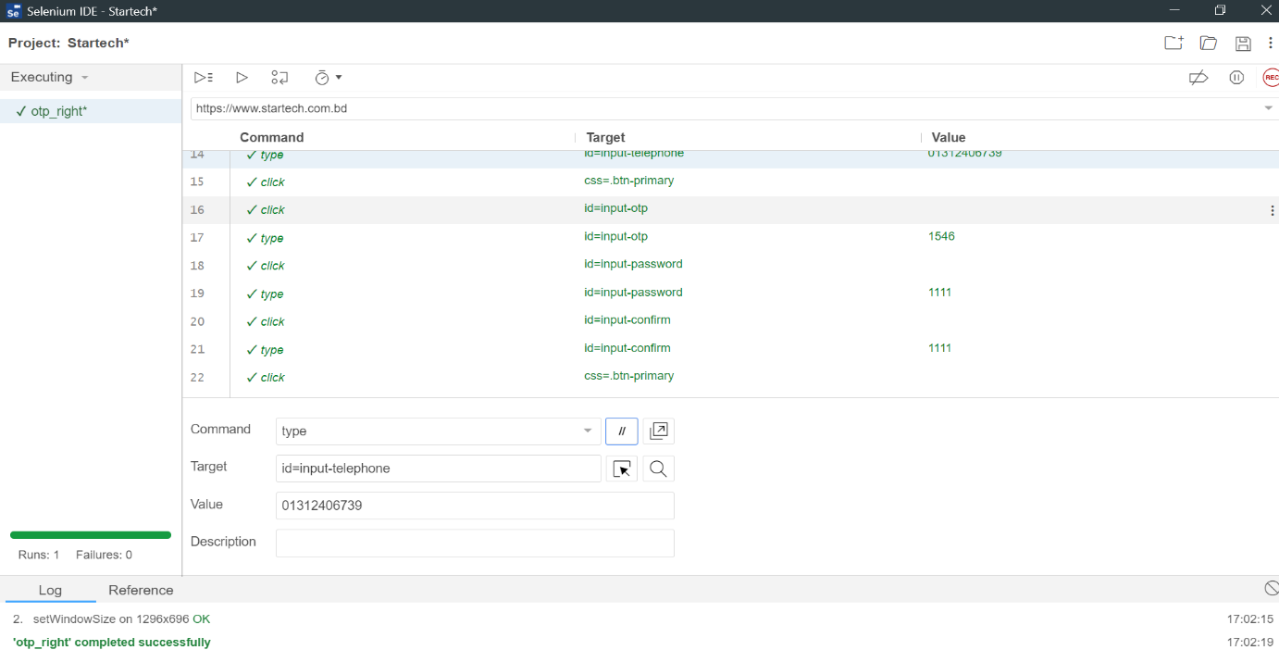

**Fig-20: Check with right OTP test case execution**

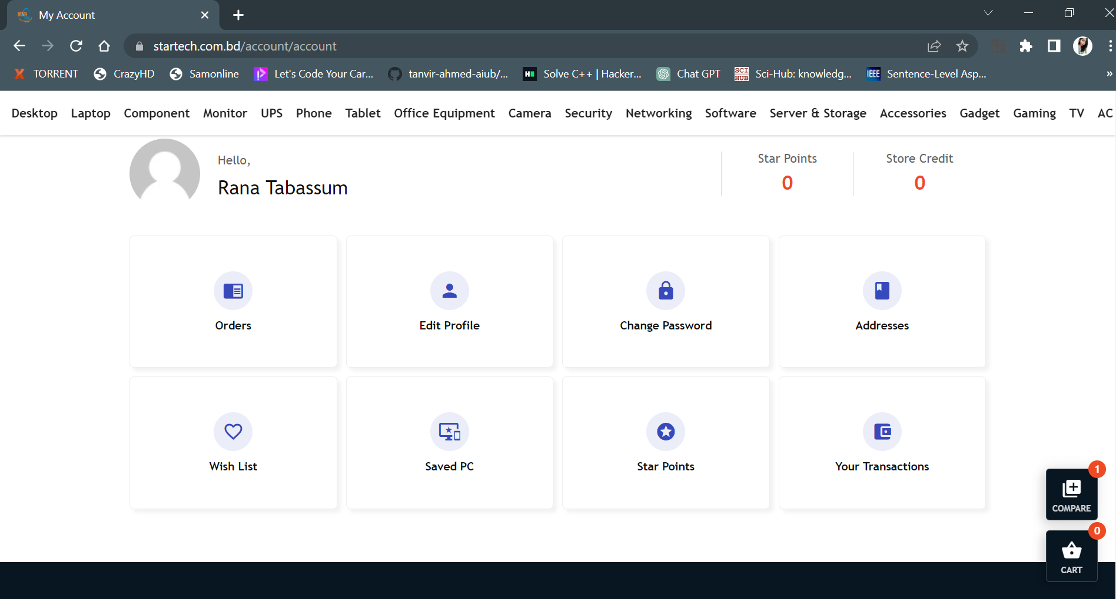

**Fig-21: Check with right OTP**

|  |  |  |  |  |  |
| --- | --- | --- | --- | --- | --- |
| Project Name: StarTech | | | Test Designed by: Rana Tabassum | | |
| Test Case ID: Tabassum-TC014 | | | Test Designed date: 12/05/2023 | | |
| Test Priority (Low, Medium, High): Medium | | | Test Executed by: Rana Tabassum | | |
| Module Name: Wishlist check | | | Test Execution date: 12/05/2023 | | |
| Test Title: Wishlist check | | |  | | |
| Description: Test whether products get added to the wishlist | | |  | | |
| Precondition (If any): User must Login with a valid StarTech user ID | | | | | |
| Test Steps | Test Data | Expected Results | | Actual Results | Status  (Pass/Fail) |
| 1. Go to the StarTech website 2. Click on “wishlist button on the product” 3. Click on “Login” 4. Check wishlist list | Null | User should be able to add products to wishlist | | as expected, | pass |

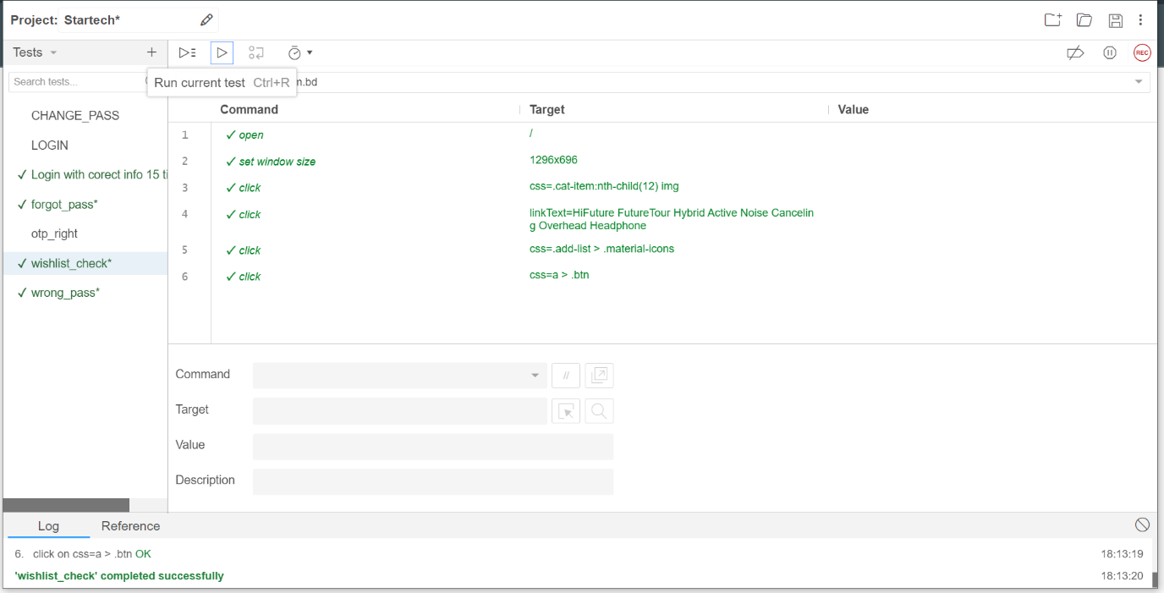

**Fig-22: Wishlist check test case execution**

|  |  |  |  |  |  |
| --- | --- | --- | --- | --- | --- |
| Project Name: StarTech | | | Test Designed by: Rana Tabassum | | |
| Test Case ID: Tabassum-TC015 | | | Test Designed date: 12/05/2023 | | |
| Test Priority (Low, Medium, High): High | | | Test Executed by: Rana Tabassum | | |
| Module Name: Wrong password | | | Test Execution date: 12/05/2023 | | |
| Test Title: wrong password | | |  | | |
| Description: Test whether the user can log in with wrong password or not | | |  | | |
| Precondition (If any): User must Login with a valid StarTech user ID | | | | | |
| Test Steps | Test Data | Expected Results | | Actual Results | Status  (Pass/Fail) |
| 1. Go to the StarTech website 2. Click on “Profile” 3. Click on “Login” 4. Give a random password 5. Click on “Login” | Used number 01312406739 | User should not be able to log in with wrong password | | as expected, | pass |

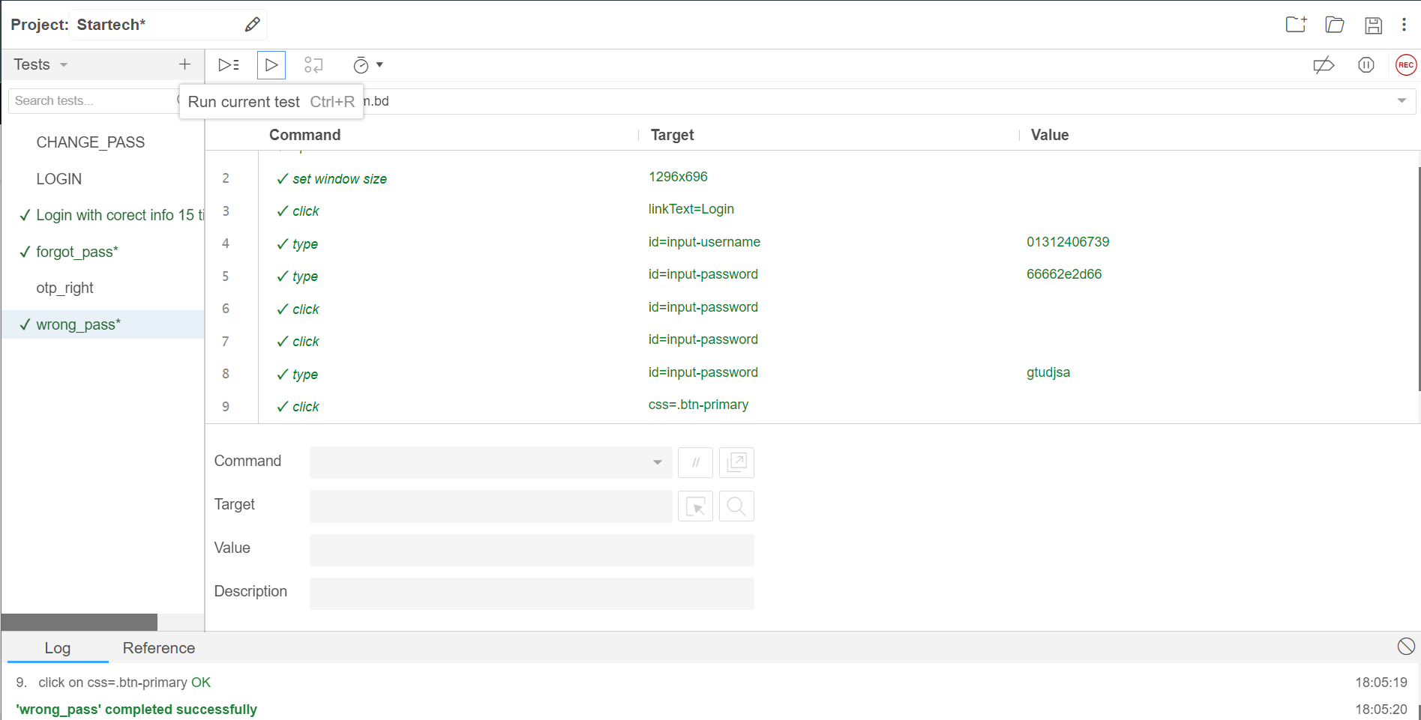

**Fig-23: Wrong password test case execution**

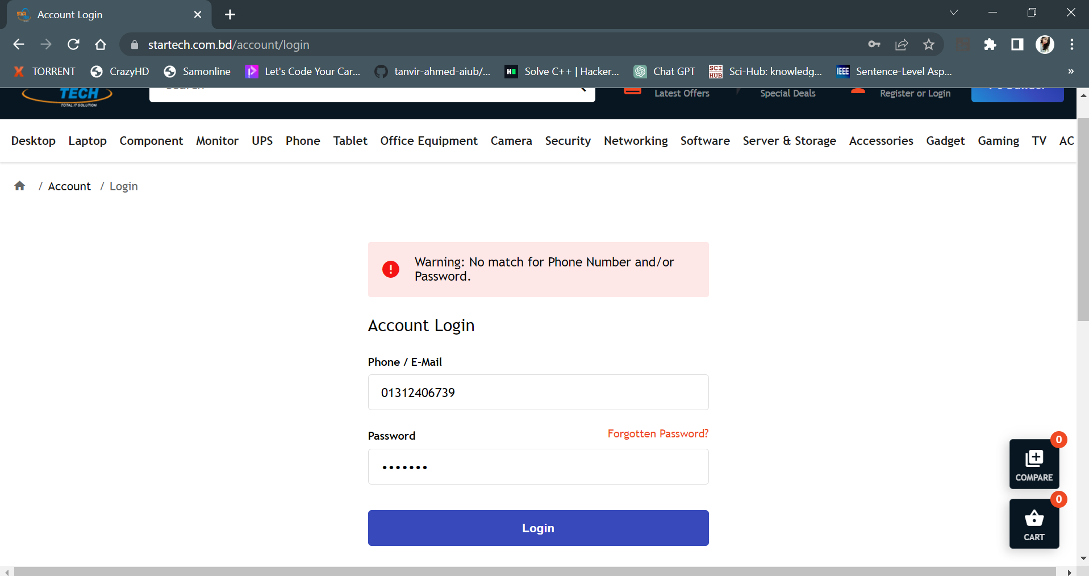

**Fig-24: Wrong password**

|  |  |  |  |  |  |
| --- | --- | --- | --- | --- | --- |
| Project Name: StarTech | | | Test Designed by: Rana Tabassum | | |
| Test Case ID: Tabassum-TC016 | | | Test Designed date: 12/05/2023 | | |
| Test Priority (Low, Medium, High): High | | | Test Executed by: Rana Tabassum | | |
| Module Name: Forgot Password | | | Test Execution date: 12/05/2023 | | |
| Test Title: Forgot password | | |  | | |
| Description: Test whether the user can get the OTP and recover forgotten password | | |  | | |
| Precondition (If any): User must Login with a valid StarTech user ID | | | | | |
| Test Steps | Test Data | Expected Results | | Actual Results | Status  (Pass/Fail) |
| 1. Go to the StarTech website 2. Click on “Profile” 3. Click on “Logout” 4. Click on “Forgot Password?” 5. Give the OTP sent on the given number or email 6. Click on “Submit” | Used number 01312406739 | User should be able to get the OTP and recover forgotten password | | as expected, | pass |

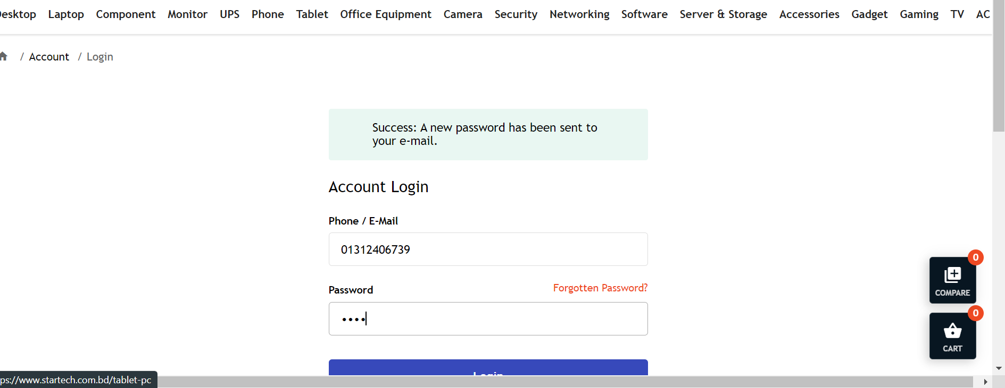

**Fig-25: Forgot password**

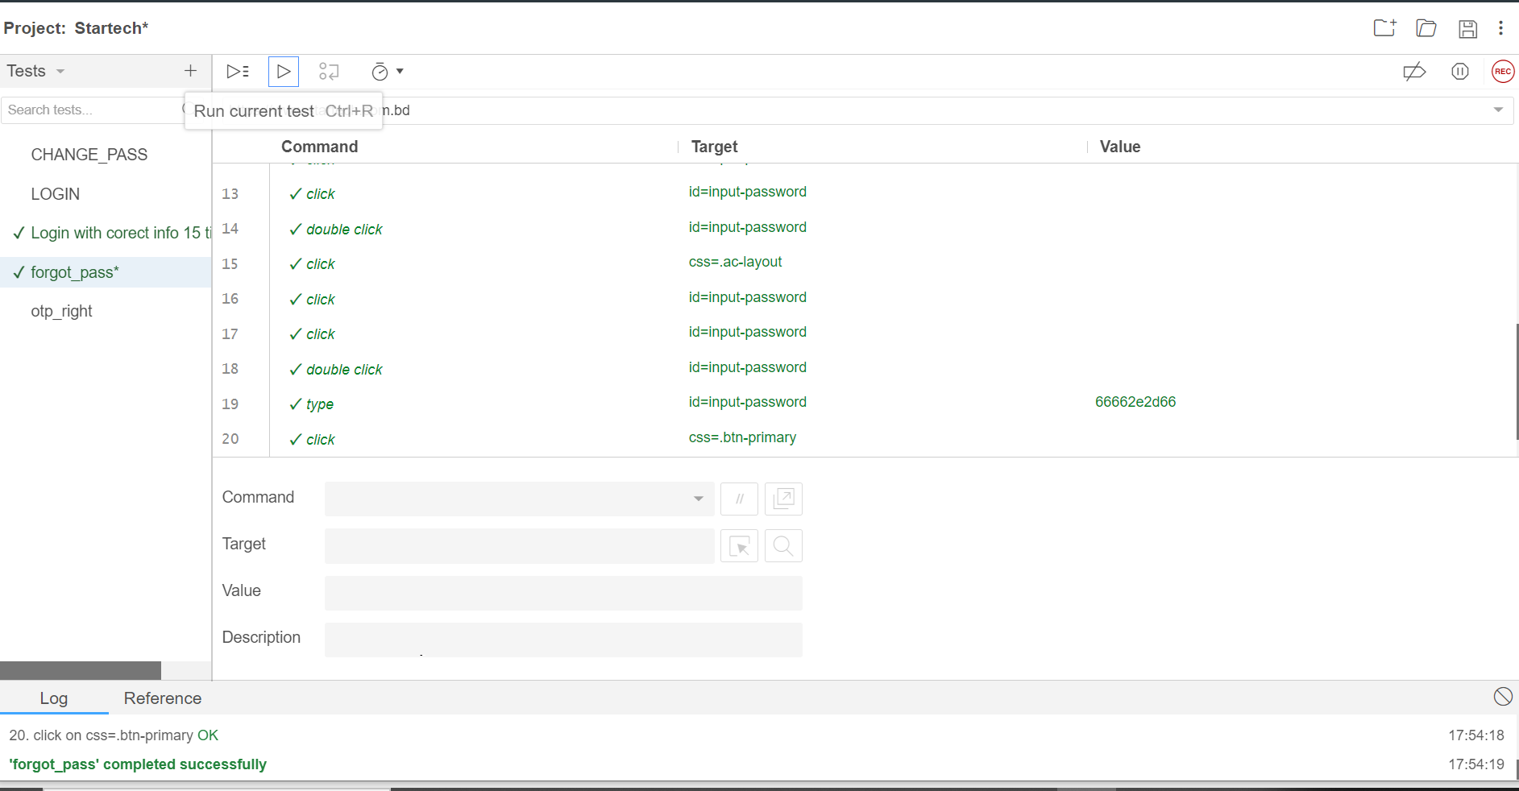

**Fig-26: Forgot password test case execution**

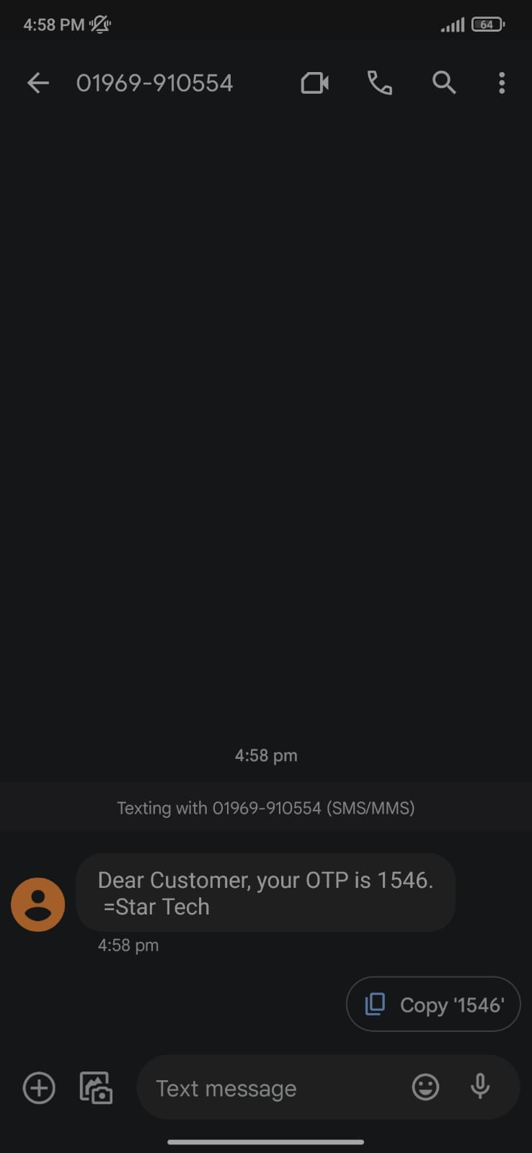

|  |  |  |  |  |  |
| --- | --- | --- | --- | --- | --- |
| Project Name: StarTech | | | Test Designed by: Sadman Rafi | | |
| Test Case ID: SadmanRafi-TC01 | | | Test Designed date: 12/05/2023 | | |
| Test Priority (Low, Medium, High): High | | | Test Executed by: Sadman Rafi | | |
| Module Name: Cost sorting in pc building | | | Test Execution date: 12/05/2023 | | |
| Test Title: Cost sorting in pc building | | |  | | |
| Description: Test whether the user can Cost sorting in pc building | | |  | | |
| Precondition (If any): User must Login with a valid StarTech user ID | | | | | |
| Test Steps | Test Data | Expected Results | | Actual Results | Status  (Pass/Fail) |
| 1. Go to the StarTech website 2. Click on “PC Build” 3. Click on “sort by cost” | Used number 01312406739 | User should be able to Cost sorting in pc building | | as expected, | Fail |

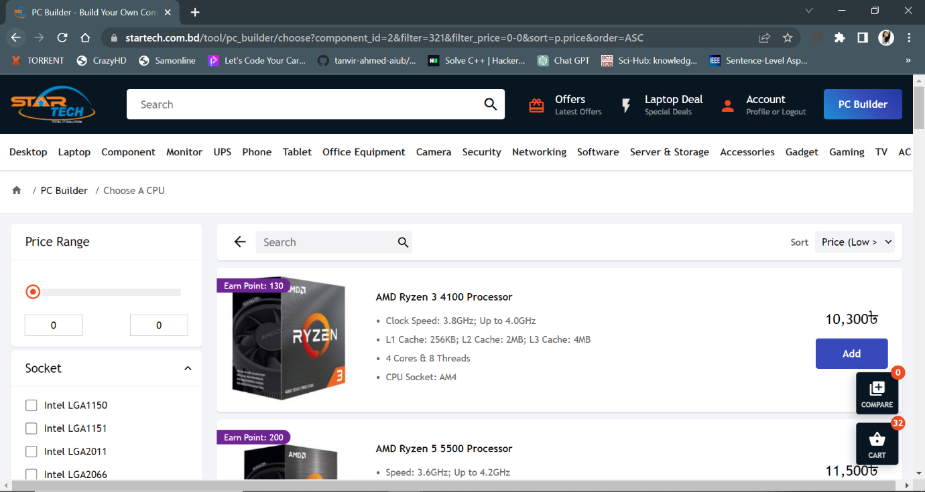

**Fig-27: Cost sorting in pc building**

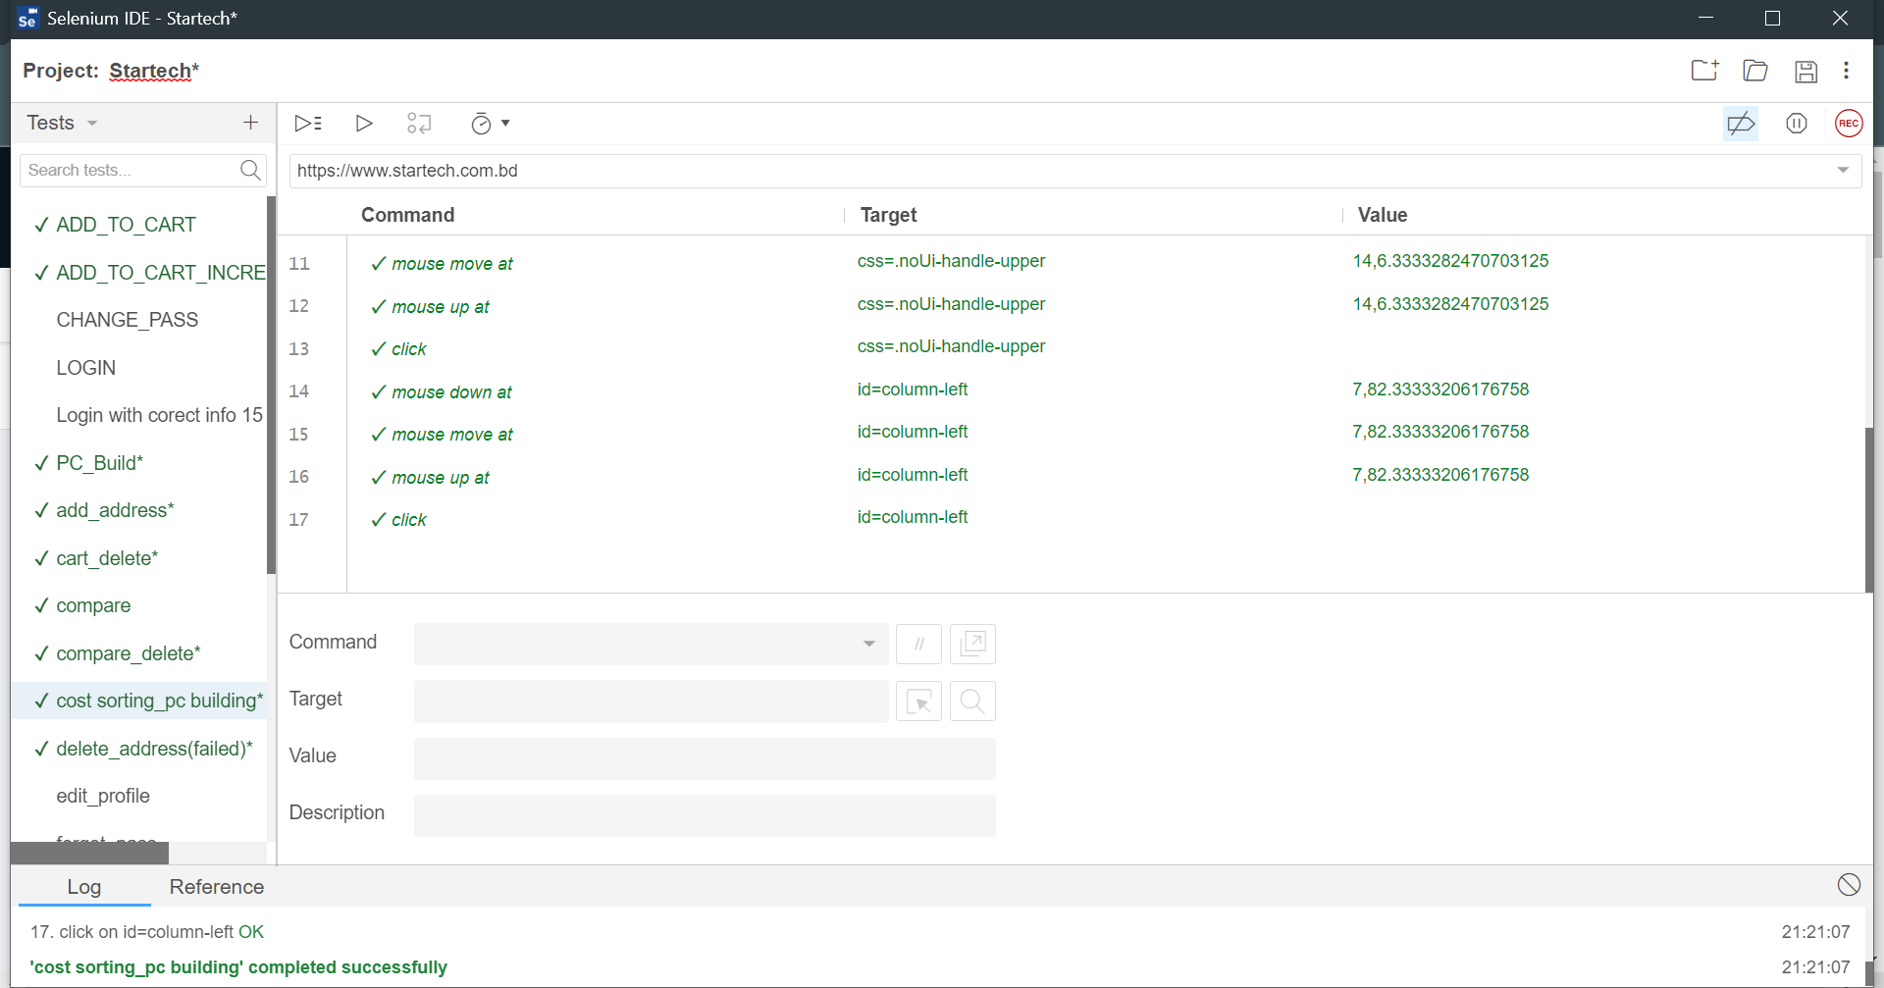

**Fig-27: Cost sorting in pc building test case execution**

|  |  |  |  |  |  |
| --- | --- | --- | --- | --- | --- |
| Project Name: StarTech | | | Test Designed by: Sadman Rafi | | |
| Test Case ID: SadmanRafi-TC02 | | | Test Designed date: 12/05/2023 | | |
| Test Priority (Low, Medium, High): High | | | Test Executed by: Sadman Rafi | | |
| Module Name: Quantity increment with cost | | | Test Execution date: 12/05/2023 | | |
| Test Title: Quantity add cost | | |  | | |
| Description: Test whether the user can Quantity ad cost | | |  | | |
| Precondition (If any): User must Login with a valid StarTech user ID | | | | | |
| Test Steps | Test Data | Expected Results | | Actual Results | Status  (Pass/Fail) |
| 1. Go to the StarTech website 2. Click on “PC Build” 3. Click on “cost” | Used number 01312406739 | User should be able to Quantity add cost | | as expected, | pass |

|  |  |  |  |  |  |
| --- | --- | --- | --- | --- | --- |
| Project Name: StarTech | | | Test Designed by: Sadman Rafi | | |
| Test Case ID: SadmanRafi-TC03 | | | Test Designed date: 12/05/2023 | | |
| Test Priority (Low, Medium, High): Low | | | Test Executed by: Sadman Rafi | | |
| Module Name: Remove and hide unselected things | | | Test Execution date: 12/05/2023 | | |
| Test Title: Remove and hide unselected things | | |  | | |
| Description: Test whether the user can Remove and hide unselected things | | |  | | |
| Precondition (If any): User must Login with a valid StarTech user ID | | | | | |
| Test Steps | Test Data | Expected Results | | Actual Results | Status  (Pass/Fail) |
| 1. Go to the Startech website 2. Click on “PC Build” 3. Click on “sort by cost” | Used number 01312406739 | User should be able to Remove and hide unselected things | | as expected, | pass |

|  |  |  |  |  |  |
| --- | --- | --- | --- | --- | --- |
| Project Name: StarTech | | | Test Designed by: Sadman Rafi | | |
| Test Case ID: SadmanRafi-TC04 | | | Test Designed date: 12/05/2023 | | |
| Test Priority (Low, Medium, High): Low | | | Test Executed by: Sadman Rafi | | |
| Module Name: Without choice pc building | | | Test Execution date: 12/05/2023 | | |
| Test Title: Without choice pc building | | |  | | |
| Description: Test whether the user can build pc without choice | | |  | | |
| Precondition (If any): User must Login with a valid StarTech user ID | | | | | |
| Test Steps | Test Data | Expected Results | | Actual Results | Status  (Pass/Fail) |
| 1. Go to the StarTech website 2. Click on “PC Build” | Null | User should be able to build pc without choosing | | as expected, | pass |

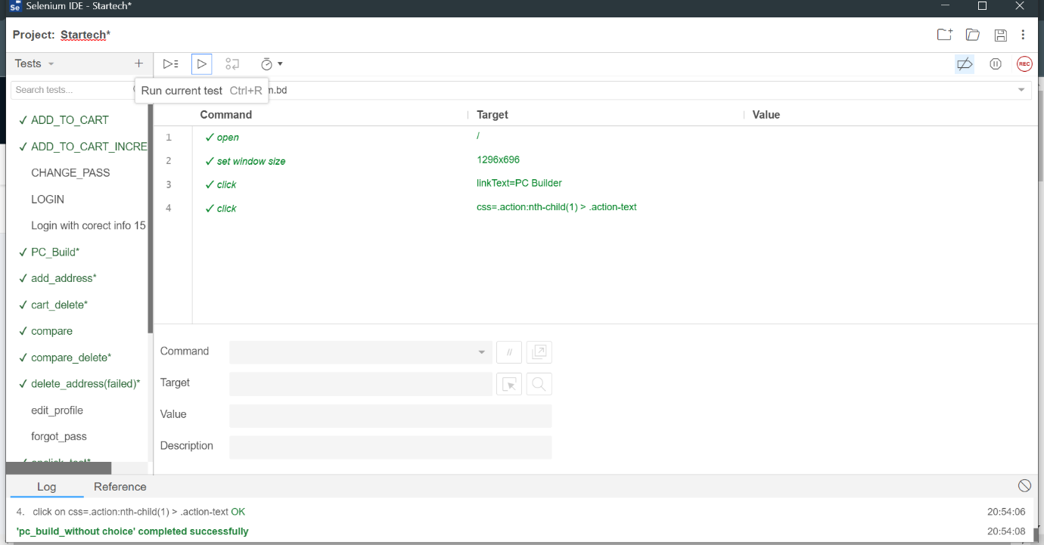

**Fig-28: Without choice pc build test case execution**

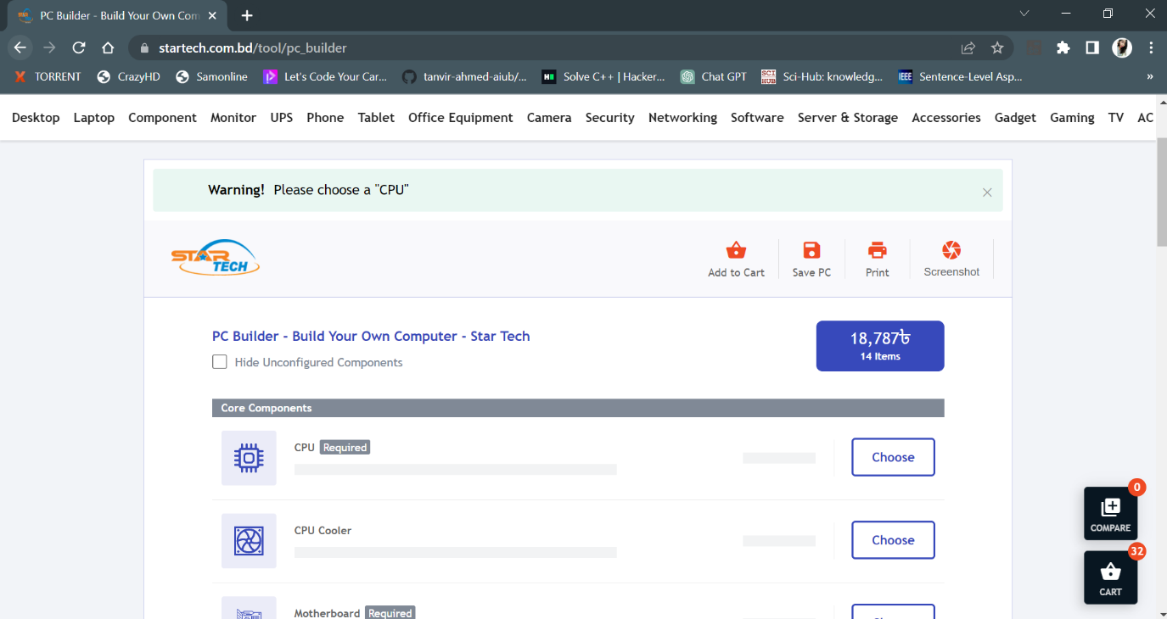

**Fig-27: Without choice pc build**

|  |  |  |  |  |  |
| --- | --- | --- | --- | --- | --- |
| Project Name: StarTech | | | Test Designed by: Sadman Rafi | | |
| Test Case ID: SadmanRafi-TC05 | | | Test Designed date: 12/05/2023 | | |
| Test Priority (Low, Medium, High): High | | | Test Executed by: Sadman Rafi | | |
| Module Name: Registration | | | Test Execution date: 12/05/2023 | | |
| Test Title: Create an account | | |  | | |
| Description: Test whether the user can Cost sorting in pc building | | |  | | |
| Precondition (If any): User must Login with a valid Startech user ID | | | | | |
| Test Steps | Test Data | Expected Results | | Actual Results | Status  (Pass/Fail) |
| 1. Go to the Startech website 2. Click on “Register” 3. Give the informations | Used number 01312406739 | User should be able to create an account | | as expected, | Pass |

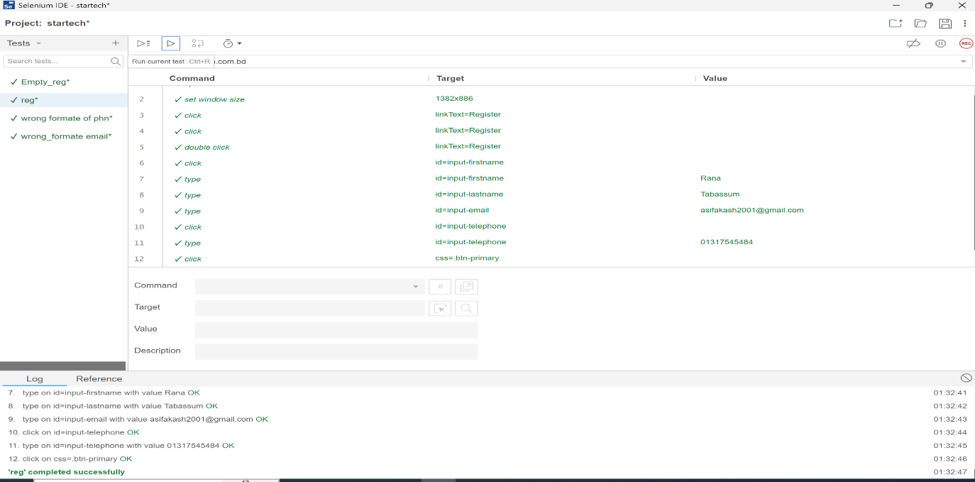

**Fig-28: Registration test case execution**

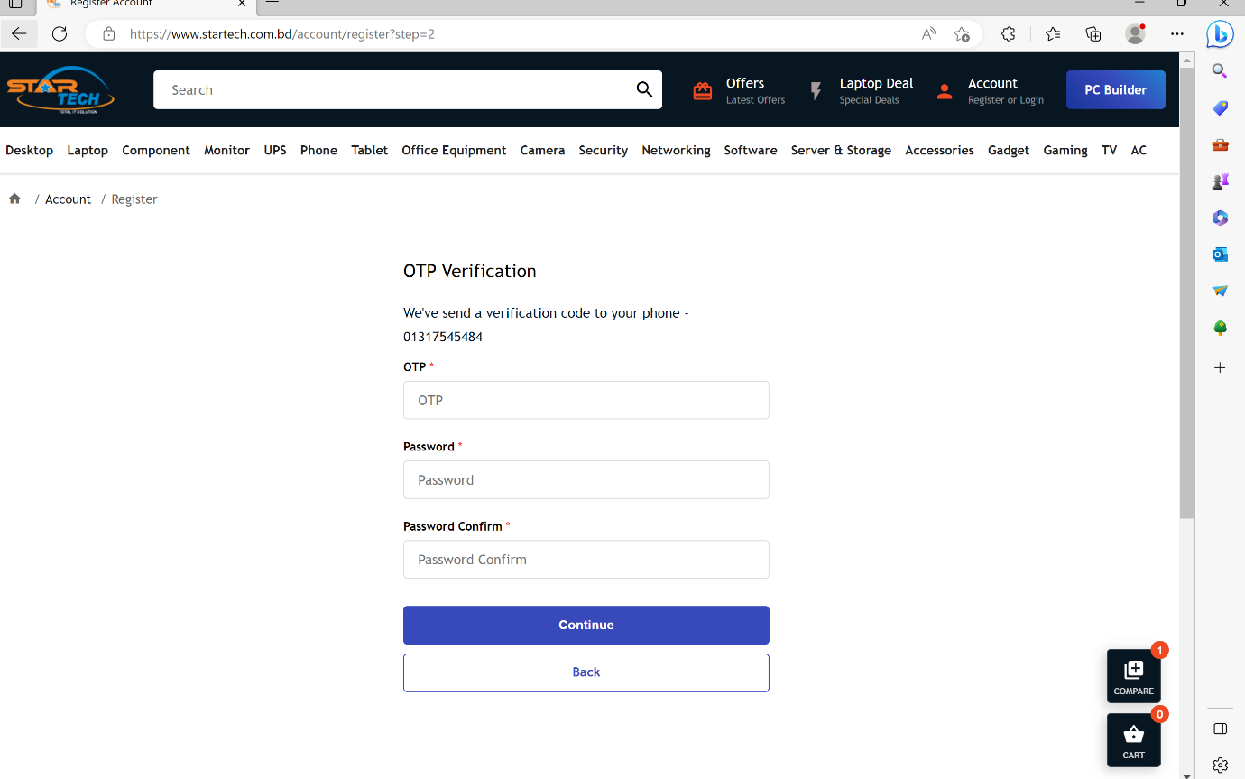

**Fig-29: Registration**

|  |  |  |  |  |  |
| --- | --- | --- | --- | --- | --- |
| Project Name: StarTech | | | Test Designed by: Sadman Rafi | | |
| Test Case ID: SadmanRafi-TC06 | | | Test Designed date: 12/05/2023 | | |
| Test Priority (Low, Medium, High): Low | | | Test Executed by: Sadman Rafi | | |
| Module Name: Print | | | Test Execution date: 12/05/2023 | | |
| Test Title: Print testing | | |  | | |
| Description: Test whether the user can print by the option | | |  | | |
| Precondition (If any): User must Login with a valid Startech user ID | | | | | |
| Test Steps | Test Data | Expected Results | | Actual Results | Status  (Pass/Fail) |
| 1. Go to the Startech website 2. Click on “PC Build” 3. Click on “print” | Null | User should be able to print | | as expected, | pass |

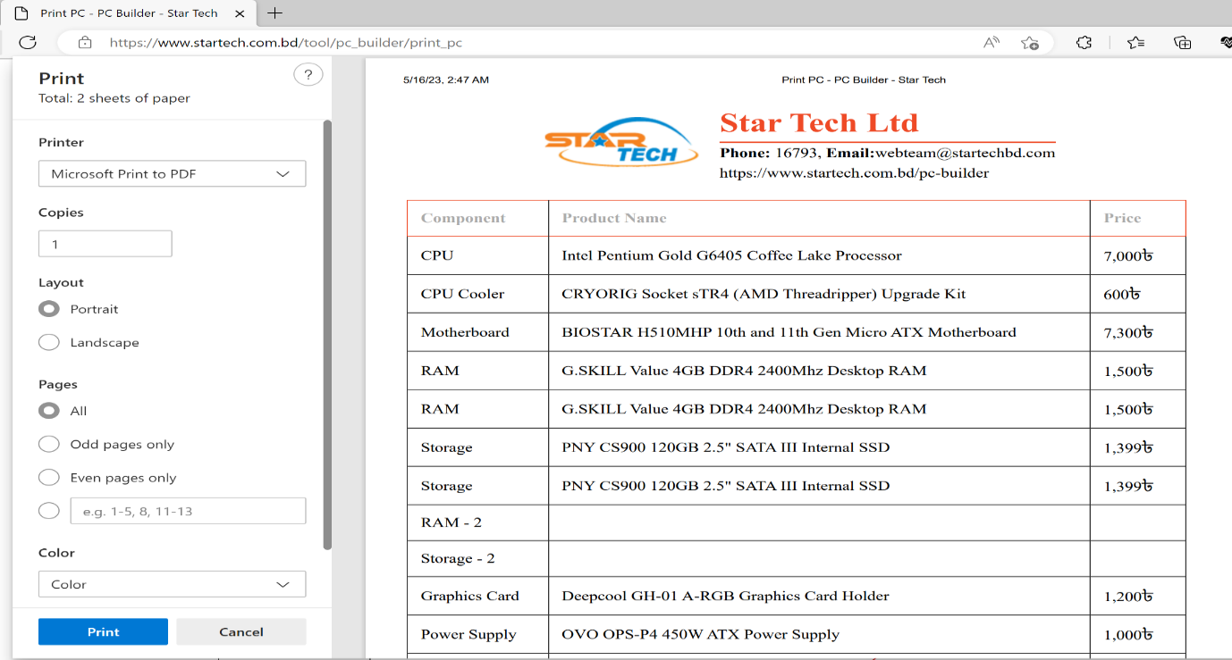

**Fig-30: Print**

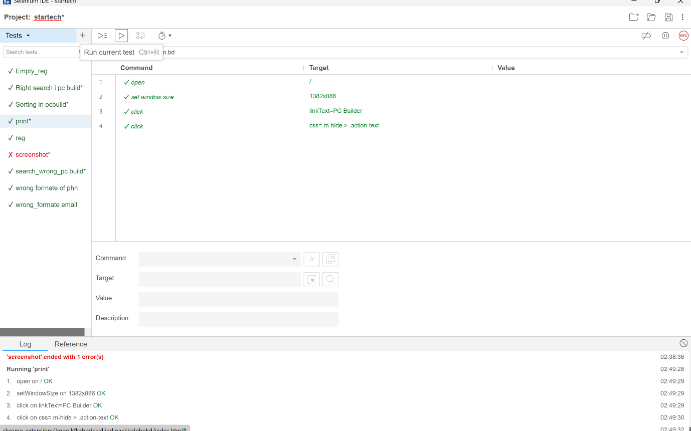

**Fig-31: Print test case execution**

|  |  |  |  |  |  |
| --- | --- | --- | --- | --- | --- |
| Project Name: StarTech | | | Test Designed by: Sadman Rafi | | |
| Test Case ID: SadmanRafi-TC07 | | | Test Designed date: 12/05/2023 | | |
| Test Priority (Low, Medium, High): High | | | Test Executed by: Sadman Rafi | | |
| Module Name: Empty Registration | | | Test Execution date: 12/05/2023 | | |
| Test Title: Empty Registration | | |  | | |
| Description: Test whether the user can register account without giving any input | | |  | | |
| Precondition (If any): N/A | | | | | |
| Test Steps | Test Data | Expected Results | | Actual Results | Status  (Pass/Fail) |
| 1. Go to the Startech website 2. Click on “Register” 3. Keep all the form blank | Null | User should not be able to register without giving any information | | as expected, | pass |

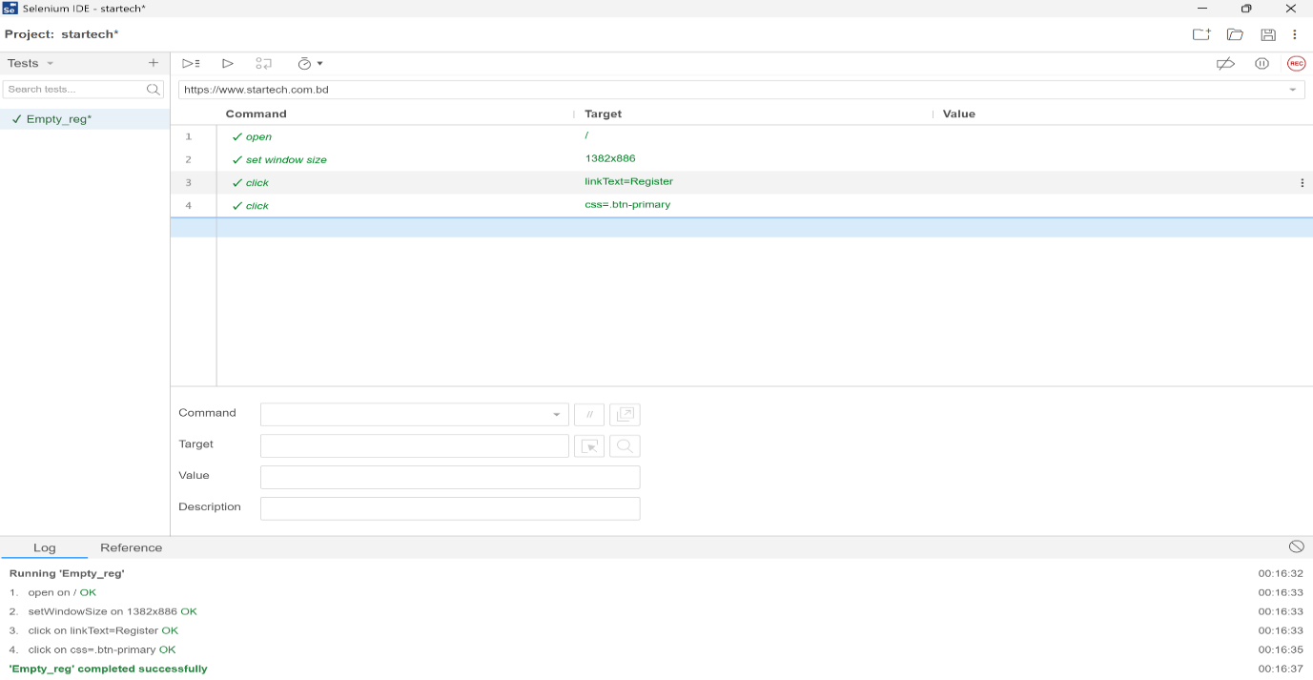

**Fig-32: Empty registration test case execution**

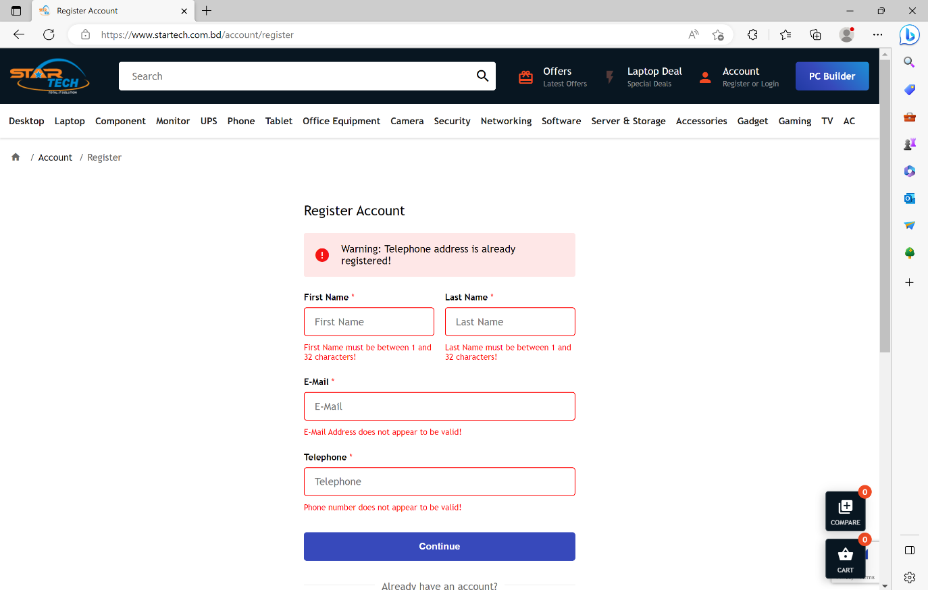

**Fig-33: Empty registration**

|  |  |  |  |  |  |
| --- | --- | --- | --- | --- | --- |
| Project Name: StarTech | | | Test Designed by: Sadman Rafi | | |
| Test Case ID: SadmanRafi-TC08 | | | Test Designed date: 12/05/2023 | | |
| Test Priority (Low, Medium, High): Low | | | Test Executed by: Sadman Rafi | | |
| Module Name: Right search in PC Build | | | Test Execution date: 12/05/2023 | | |
| Test Title: Right search in PC Build | | |  | | |
| Description: Test whether the user can get the right search information in pc building | | |  | | |
| Precondition (If any): User must Login with a StarTech user ID | | | | | |
| Test Steps | Test Data | Expected Results | | Actual Results | Status  (Pass/Fail) |
| 1. Go to the StarTech website 2. Click on “PC Build” 3. Click on “search” 4. Type the name of the product | AMD | User should be able to find the exact product they are searching | | as expected, | pass |

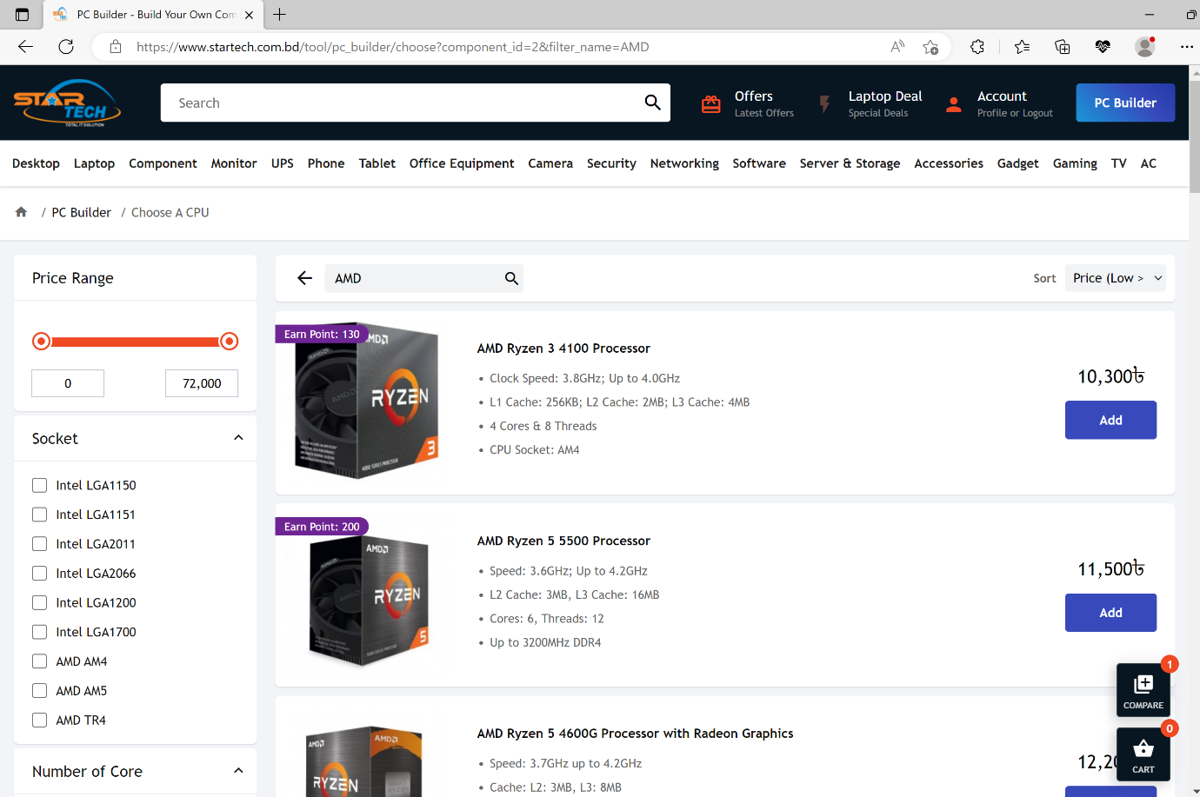

**Fig-34: Right search in pc build**

|  |  |  |  |  |  |
| --- | --- | --- | --- | --- | --- |
| Project Name: StarTech | | | Test Designed by: Sadman Rafi | | |
| Test Case ID: SadmanRafi-TC09 | | | Test Designed date: 12/05/2023 | | |
| Test Priority (Low, Medium, High): High | | | Test Executed by: Sadman Rafi | | |
| Module Name: Save pc | | | Test Execution date: 12/05/2023 | | |
| Test Title: Save pc | | |  | | |
| Description: Test whether the user can save the pc that was build earlier | | |  | | |
| Precondition (If any): User must Login with a valid Startech user ID | | | | | |
| Test Steps | Test Data | Expected Results | | Actual Results | Status  (Pass/Fail) |
| 1. Go to the Startech website 2. Click on “Profile” 3. Click on “Saved PC” | Null | User should be able to print | | as expected, | pass |

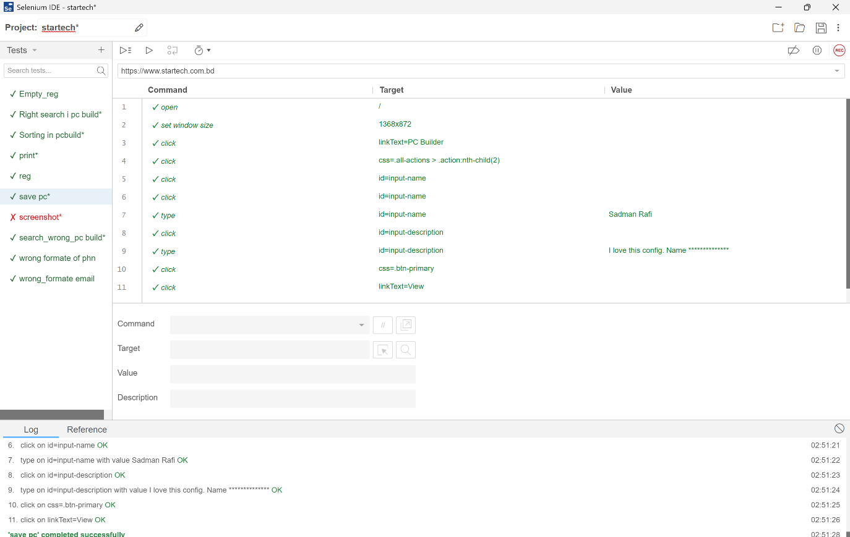

**Fig-35: Save pc test case execution**

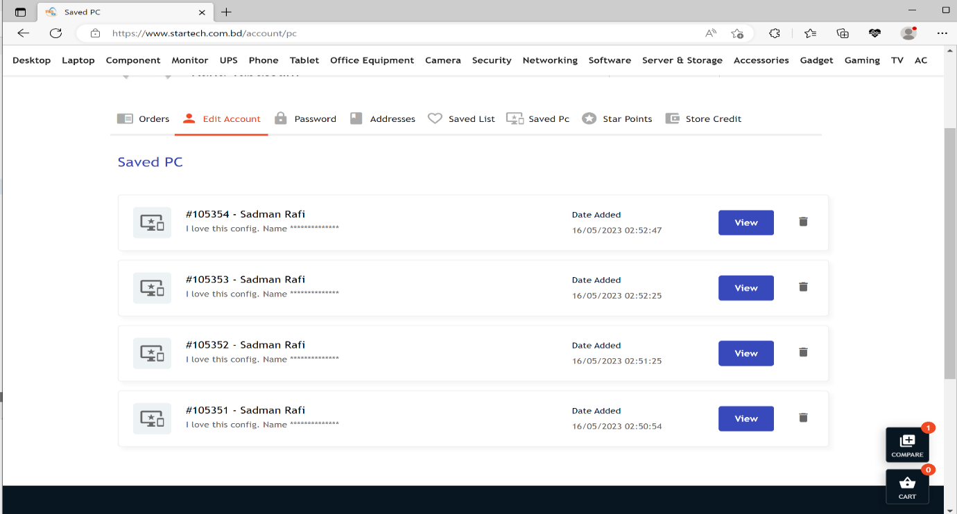

**Fig-36: Save pc**

|  |  |  |  |  |  |
| --- | --- | --- | --- | --- | --- |
| Project Name: StarTech | | | Test Designed by: Sadman Rafi | | |
| Test Case ID: SadmanRafi-TC10 | | | Test Designed date: 12/05/2023 | | |
| Test Priority (Low, Medium, High): High | | | Test Executed by: Sadman Rafi | | |
| Module Name: View the saved pc | | | Test Execution date: 12/05/2023 | | |
| Test Title: View the saved pc | | |  | | |
| Description: Test whether the user can view the pc that was saved | | |  | | |
| Precondition (If any): User must Login with a valid Startech user ID | | | | | |
| Test Steps | Test Data | Expected Results | | Actual Results | Status  (Pass/Fail) |
| 1. Go to the Startech website 2. Click on “Profile 3. Click on “Saved PC” | Null | User should be able to view the saved PC | | as expected, | pass |

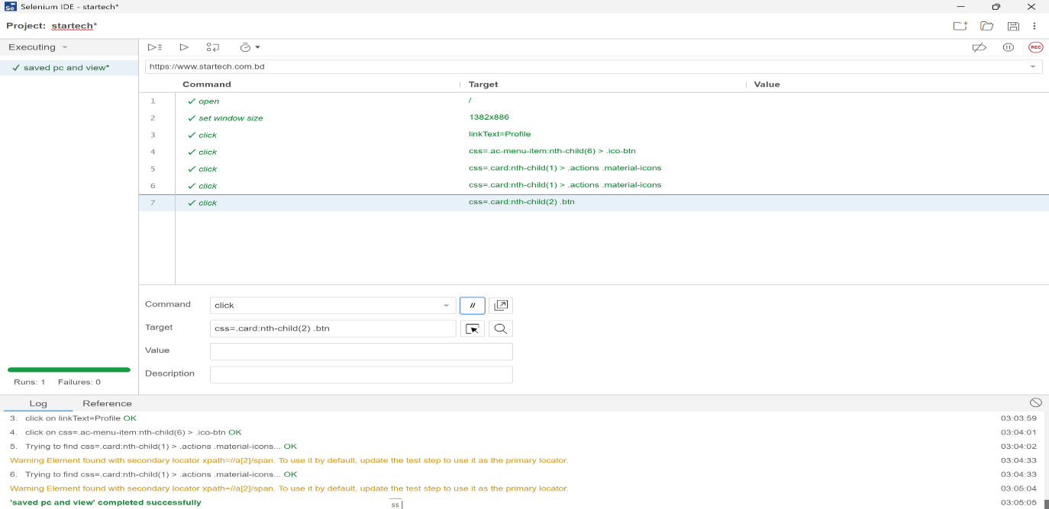

**Fig-37: Save pc and view test case execution**

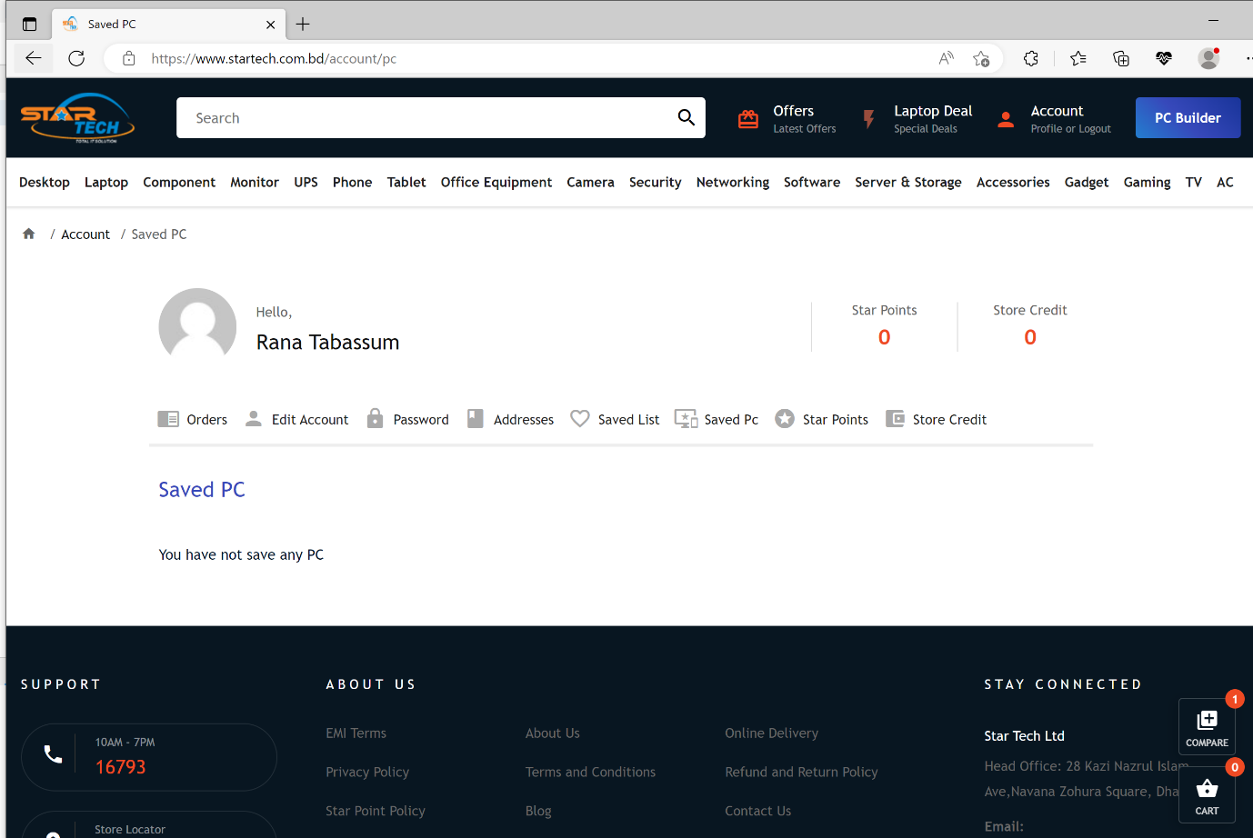

**Fig-38: Save pc and view**

|  |  |  |  |  |  |
| --- | --- | --- | --- | --- | --- |
| Project Name: StarTech | | | Test Designed by: Sadman Rafi | | |
| Test Case ID: SadmanRafi-TC011 | | | Test Designed date: 12/05/2023 | | |
| Test Priority (Low, Medium, High): Low | | | Test Executed by: Sadman Rafi | | |
| Module Name: Save PC Without name | | | Test Execution date: 12/05/2023 | | |
| Test Title: Save PC Without name | | |  | | |
| Description: Test whether the user can Save without name | | |  | | |
| Precondition (If any): User must Login with a valid Startech user ID | | | | | |
| Test Steps | Test Data | Expected Results | | Actual Results | Status  (Pass/Fail) |
| 1. Go to the Startech website 2. Click on “PC Build” 3. Click on “save” | Null | User should not be able to save pc without name | | as expected, | pass |

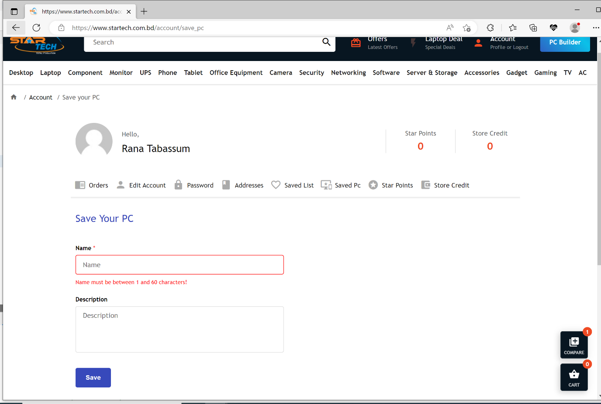

**Fig-39: Save pc without name**

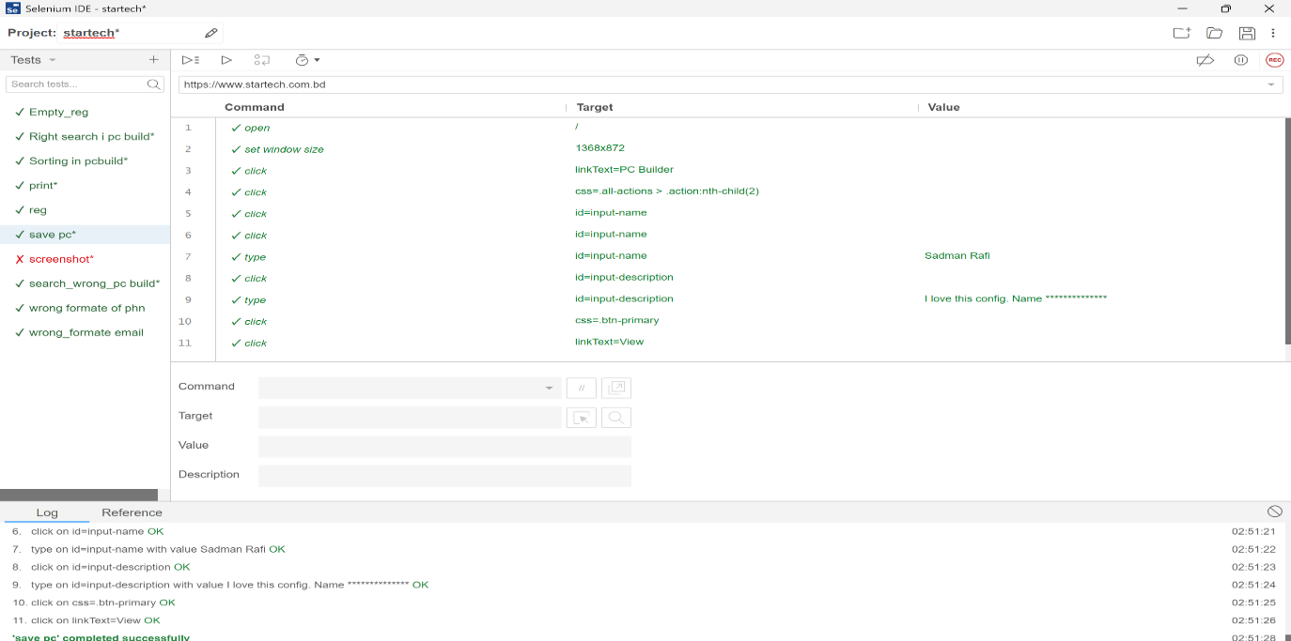

**Fig-40: Save pc without name test case execution**

|  |  |  |  |  |
| --- | --- | --- | --- | --- |
| Project Name: StarTech | | | Test Designed by: Sadman Rafi | |
| Test Case ID: SadmanRafi-TC12 | | | Test Designed date: 12/05/2023 | |
| Test Priority (Low, Medium, High): Medium | | | Test Executed by: Sadman Rafi | |
| Module Name: Promo code checking | | | Test Execution date: 12/05/2023 | |
| Test Title: Promo code checking | | |  | |
| Description: Test whether the user can use promo code and get discount | | |  | |
| Precondition (If any): User must Login with a valid Startech user ID | | | | |
| Test Steps | Test Data | Expected Results | Actual Results | Status  (Pass/Fail) |
| 1. Go to the Startech website 2. Click on “Promotional ad” 3. Type the promo code 4. Click on “add promo code” | STAYCOOL | User should be able to use promo code | as expected, | pass |

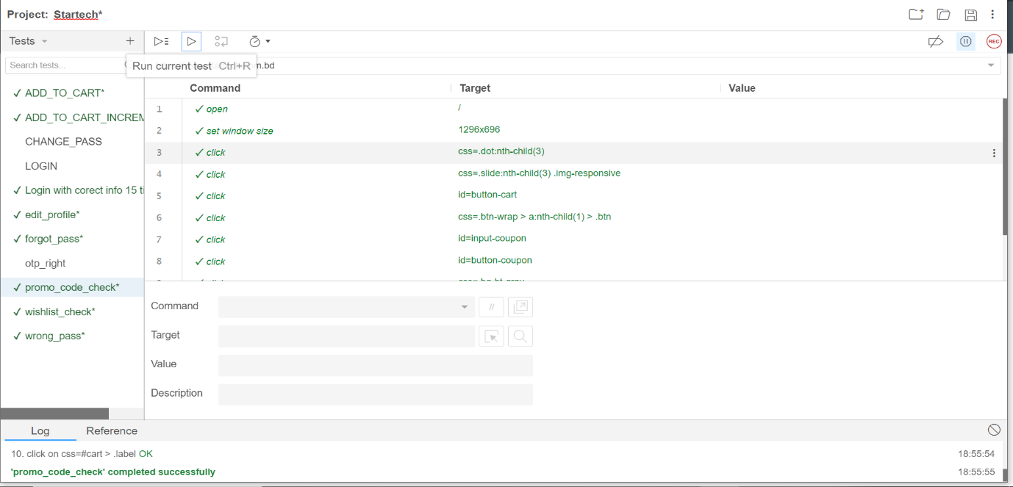

**Fig-41: Promo code check test case execution**

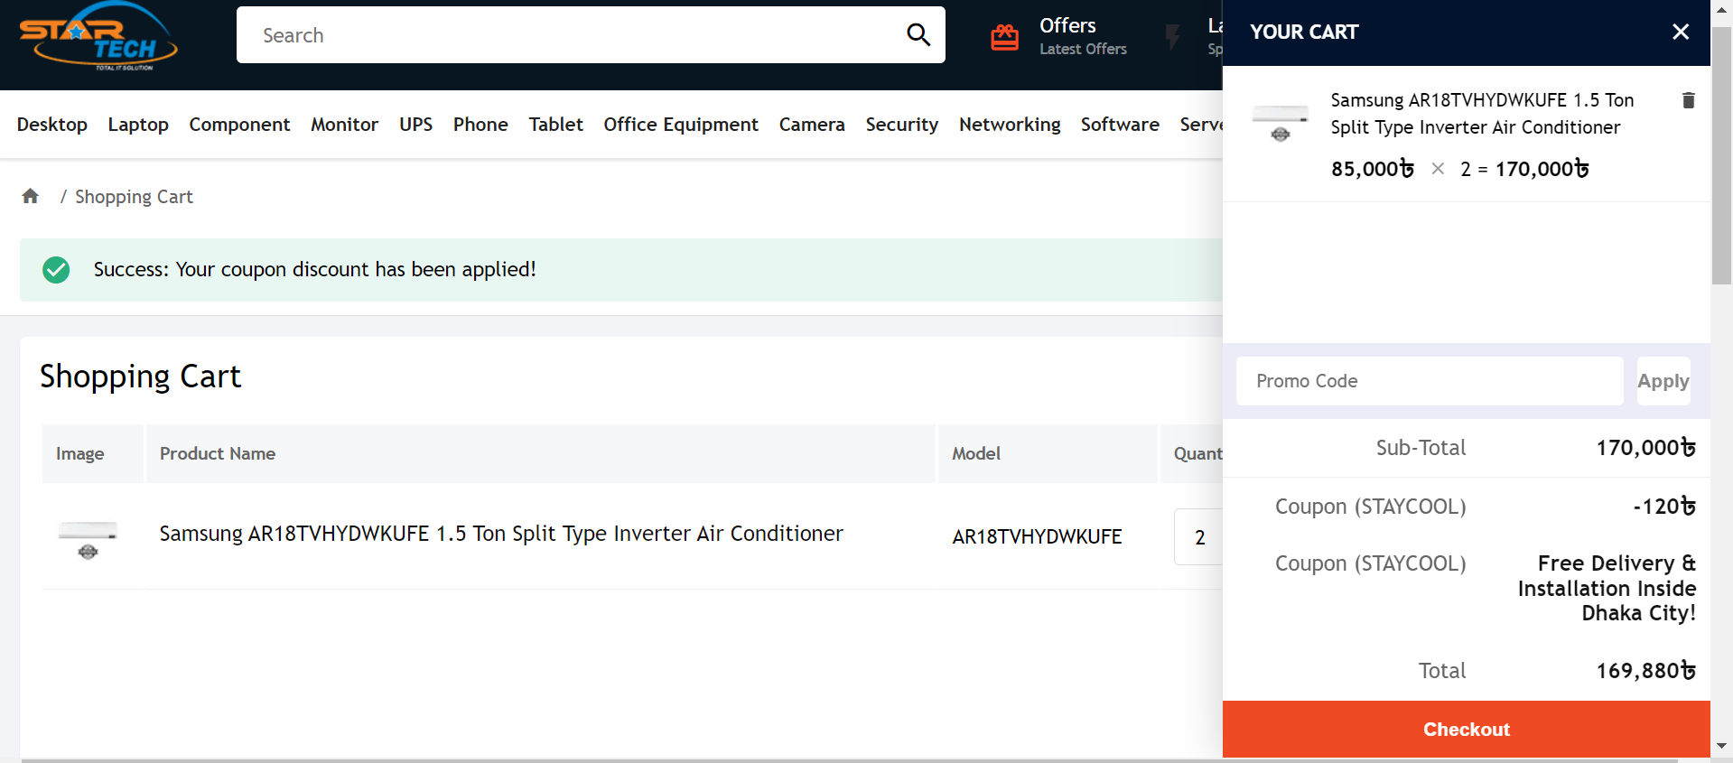

**Fig-42: Promo code check**

|  |  |  |  |  |  |
| --- | --- | --- | --- | --- | --- |
| Project Name: StarTech | | | Test Designed by: Sadman Rafi | | |
| Test Case ID: SadmanRafi-TC013 | | | Test Designed date: 12/05/2023 | | |
| Test Priority (Low, Medium, High): Medium | | | Test Executed by: Sadman Rafi | | |
| Module Name: wrong promo code | | | Test Execution date: 12/05/2023 | | |
| Test Title: wrong promo code | | |  | | |
| Description: Test whether the user get discount with wrong promo code | | |  | | |
| Precondition (If any): User must Login with a valid Startech user ID | | | | | |
| Test Steps | Test Data | Expected Results | | Actual Results | Status  (Pass/Fail) |
| 1. Go to the Startech website 2. Click on “Promotional ad” 3. Type the promo code 4. Click on “add promo code” | kdwgfh | User should not be able to get discount with wrong promo code | | as expected, | pass |

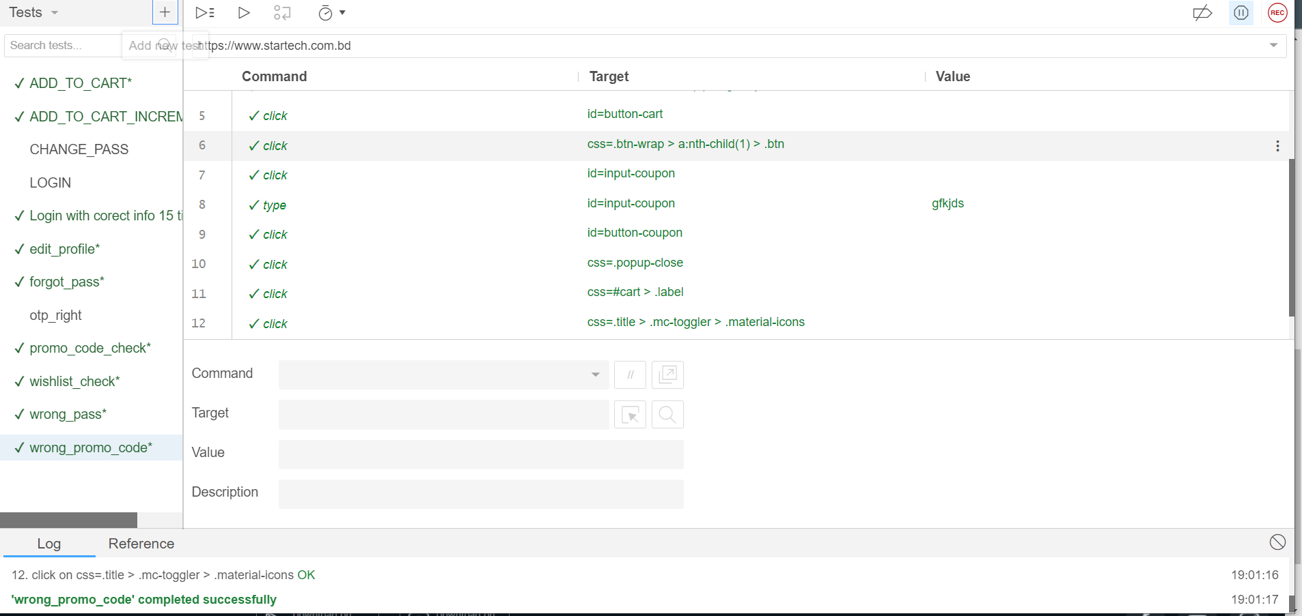

**Fig-44: Wrong promo code test case execution**

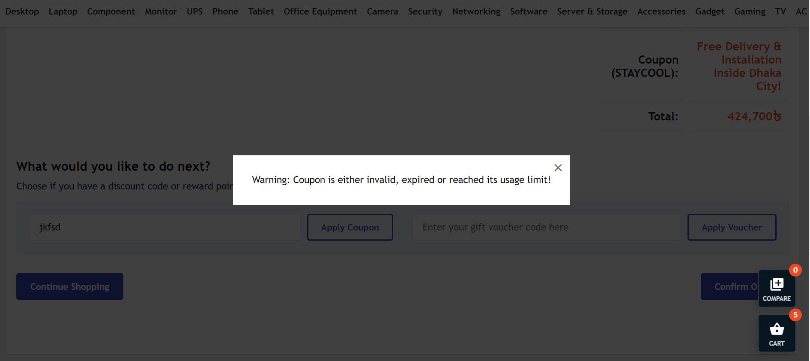

**Fig-45: Wrong promo code**

|  |  |  |  |  |  |
| --- | --- | --- | --- | --- | --- |
| Project Name: StarTech | | | Test Designed by: Sadman Rafi | | |
| Test Case ID: SadmanRafi-TC014 | | | Test Designed date: 12/05/2023 | | |
| Test Priority (Low, Medium, High): Medium | | | Test Executed by: Sadman Rafi | | |
| Module Name: Search wrong pc build | | | Test Execution date: 12/05/2023 | | |
| Test Title: Search wrong pc build | | |  | | |
| Description: Test whether the user can search for wrong pc | | |  | | |
| Precondition (If any): N/A | | | | | |
| Test Steps | Test Data | Expected Results | | Actual Results | Status  (Pass/Fail) |
| 1. Go to the Startech website 2. Click on “PC build” 3. Search with wrong name | Randomly input wrong products name | User will not be able to see the search products as a list | | As expected, | Pass |
| Post Condition: After searching the product user will not be able to see the searched items. | | | | | |

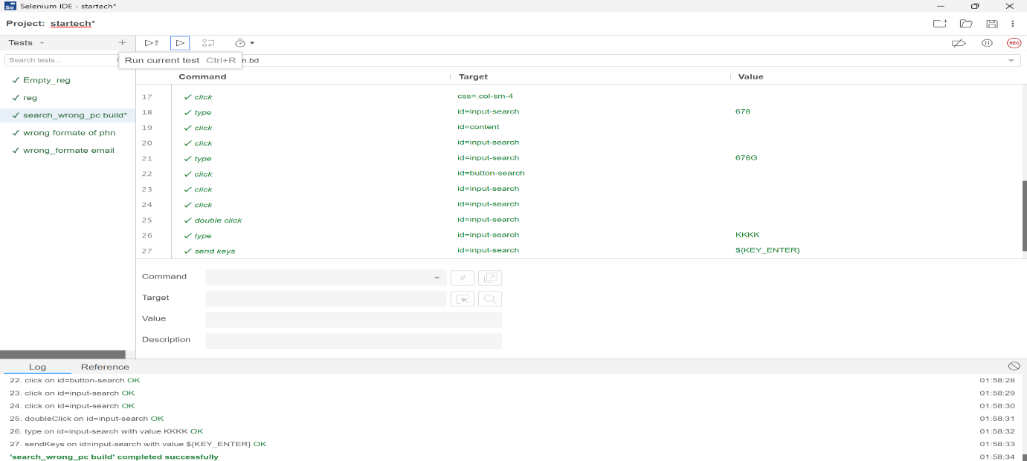

**Fig-46: Wrong search pc build test case execution**

|  |  |  |  |  |  |
| --- | --- | --- | --- | --- | --- |
| Project Name: StarTech | | | Test Designed by: Sadman Rafi | | |
| Test Case ID: SadmanRafi-TC015 | | | Test Designed date: 12/05/2023 | | |
| Test Priority (Low, Medium, High): Medium | | | Test Executed by: Sadman Rafi | | |
| Module Name: wrong format of phone | | | Test Execution date: 12/05/2023 | | |
| Test Title: Search wrong format of phone | | |  | | |
| Description: Test whether the user can search for wrong phone | | |  | | |
| Precondition (If any): N/A | | | | | |
| Test Steps | Test Data | Expected Results | | Actual Results | Status  (Pass/Fail) |
| 1. Go to the Startech website 2. Click on Phone 3. Search with wrong name | Randomly input wrong phn name | User will not be able to see the search products as a list | | As expected, | Pass |
| Post Condition: After searching the product user will not be able to see the searched items. | | | | | |

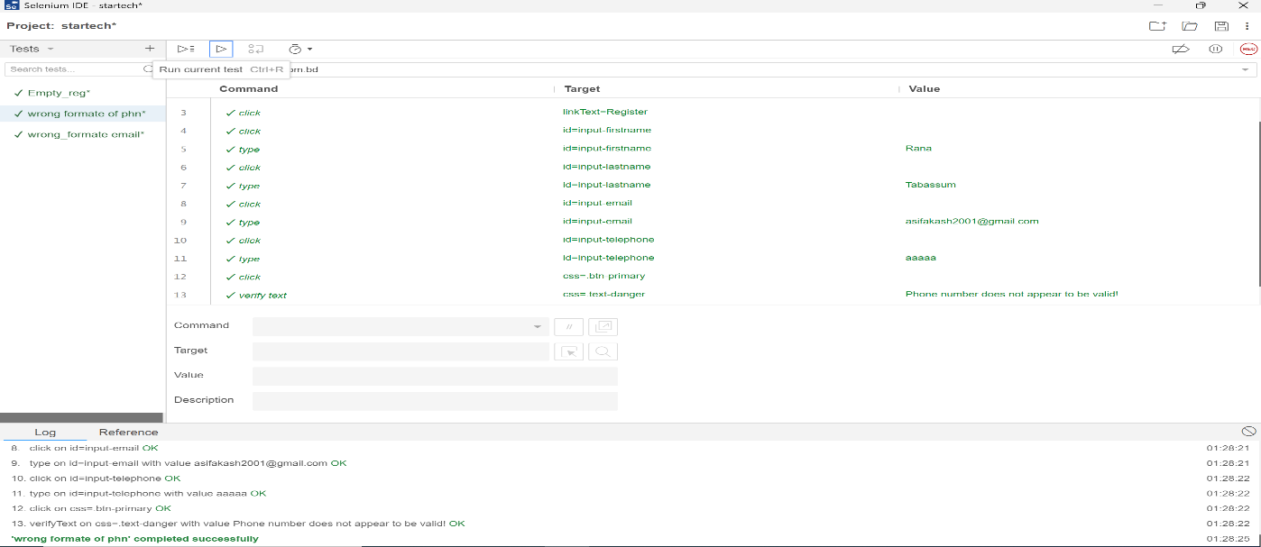

**Fig-47: Wrong format phone test case execution**

|  |  |  |  |  |  |
| --- | --- | --- | --- | --- | --- |
| Project Name: StarTech | | | Test Designed by: Sadman Rafi | | |
| Test Case ID: SadmanRafi-TC016 | | | Test Designed date: 12/05/2023 | | |
| Test Priority (Low, Medium, High): Medium | | | Test Executed by: Sadman Rafi | | |
| Module Name: wrong format email | | | Test Execution date: 12/05/2023 | | |
| Test Title: Input wrong email | | |  | | |
| Description: Test whether the user give wrong email or not | | |  | | |
| Precondition (If any): User must go to the registration section. | | | | | |
| Test Steps | Test Data | Expected Results | | Actual Results | Status  (Pass/Fail) |
| 1. Go to the Startech website 2. Click on Registration      1. Type wrong email | Randomly input wrong email | User will not be able to registration account | | As expected, | Pass |
| Post Condition: After giving the wrong email user register for an account. | | | | | |

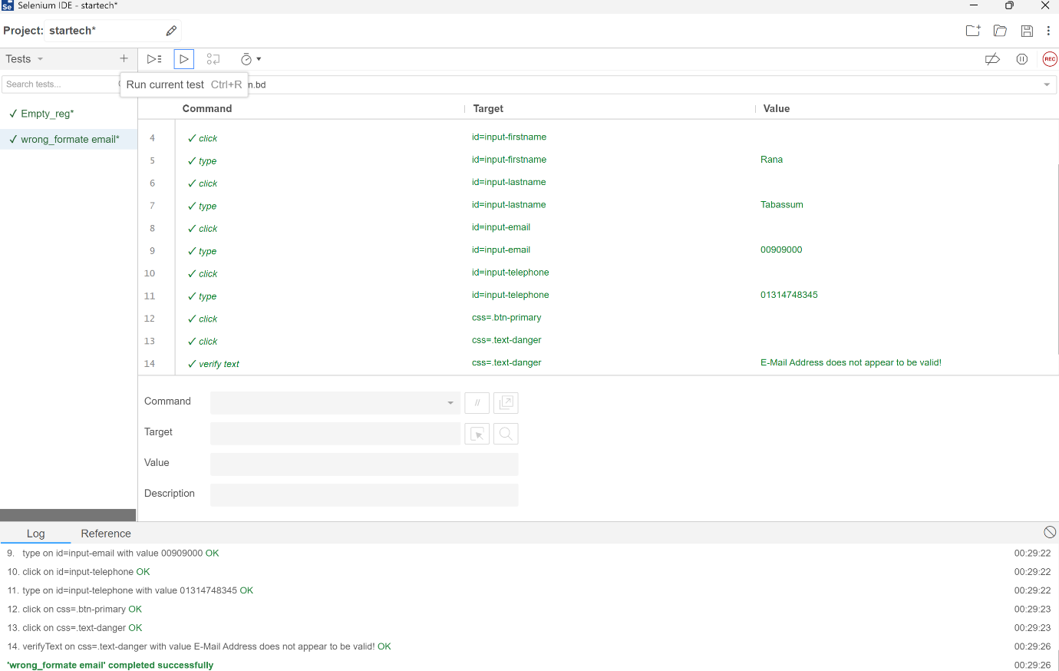

**Fig-48: Wrong format email test case execution**

|  |  |  |  |  |  |
| --- | --- | --- | --- | --- | --- |
| Project Name: Star Tech Ltd | | | Test Designed by: Rubaiba Hossain | | |
| Test Case ID: ST-TC-01 | | | Test Designed date: 14/05/2023 | | |
| Test Priority (Low, Medium, High): Medium | | | Test Executed by: Rubaiba Hossain | | |
| Module Name: URL check | | | Test Execution date: 14/05/2023 | | |
| Test Title: URL check from footer | | |  | | |
| Description: Test whether user can use all the URL from footer. | | |  | | |
| Precondition (If any): Not available | | | | | |
| Test Steps | Test Data | Expected Results | | Actual Results | Status (Pass/Fail) |
| 1. Go to the website 2. Click on About us 3. Click on Privacy policy 4. Click on blog 5. Click on terms and condition | Null | User will able to see the details | | As expected, | Pass |
| Post Condition: N/A | | | | | |

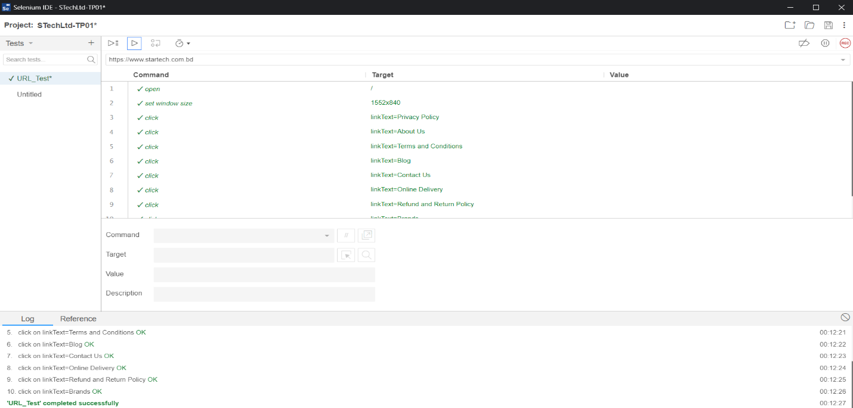

**Fig-49: Footer URL check test case execution**

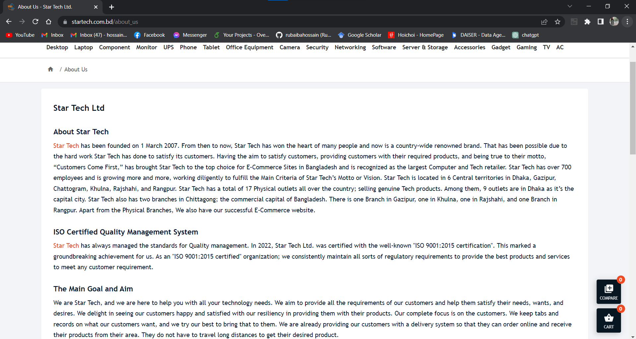

**Fig-50: Footer URL check**

|  |  |  |  |  |  |
| --- | --- | --- | --- | --- | --- |
| Project Name: Star Tech Ltd | | | Test Designed by: Rubaiba Hossain | | |
| Test Case ID: ST-TC-02 | | | Test Designed date: 14/05/2023 | | |
| Test Priority (Low, Medium, High): Medium | | | Test Executed by: Rubaiba Hossain | | |
| Module Name: App Check | | | Test Execution date: 14/05/2023 | | |
| Test Title: find software in app store | | |  | | |
| Description: Test whether user will able to find app in app store | | |  | | |
| Precondition (If any): Not available | | | | | |
| Test Steps | Test Data | Expected Results | | Actual Results | Status (Pass/Fail) |
| 1. Go to the website 2. Click on Download on google play store 3. Click on Download on app store | Google play, App store | User will able to find the software in play store. | | As expected, | Pass |
| Post Condition: N/A | | | | | |

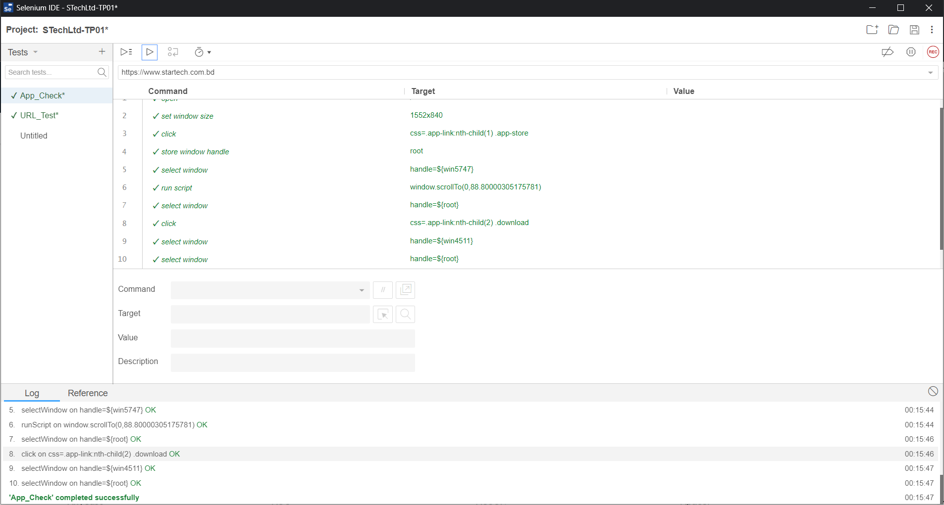

**Fig-51: App store check test case execution**

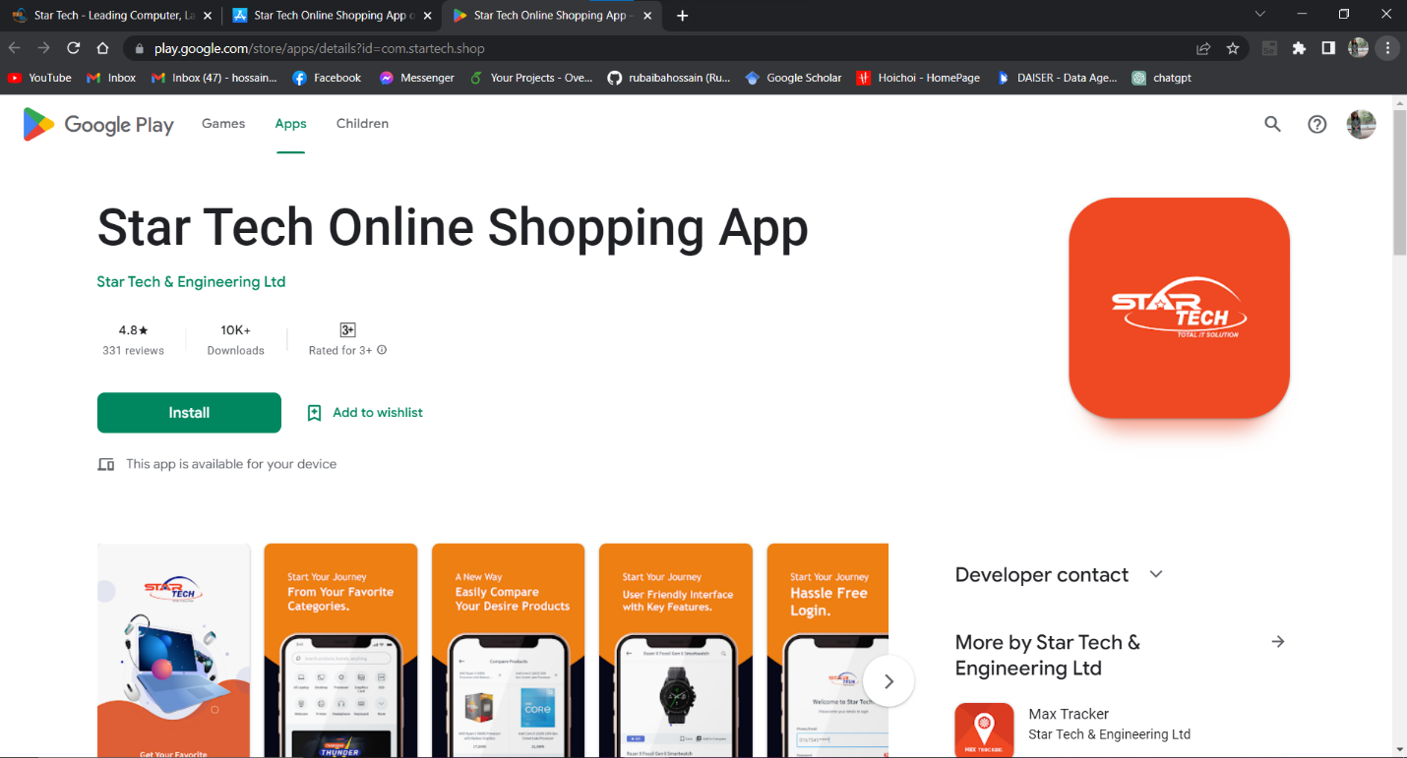

**Fig-52: App store check**

|  |  |  |  |  |  |
| --- | --- | --- | --- | --- | --- |
| Project Name: Star Tech Ltd | | | Test Designed by: Rubaiba Hossain | | |
| Test Case ID: ST-TC-03 | | | Test Designed date: 14/05/2023 | | |
| Test Priority (Low, Medium, High): Medium | | | Test Executed by: Rubaiba Hossain | | |
| Module Name: Location check | | | Test Execution date: 14/05/2023 | | |
| Test Title: Check location from map | | |  | | |
| Description: Test user can find the location from map | | |  | | |
| Precondition (If any): User must open location option | | | | | |
| Test Steps | Test Data | Expected Results | | Actual Results | Status (Pass/Fail) |
| 1. Go to the website 2. Click on Find our stores 3. Click on map | Google map | User will able to see the store location on google map. | | As expected, | Pass |
| Post Condition: User find the store location in google map | | | | | |

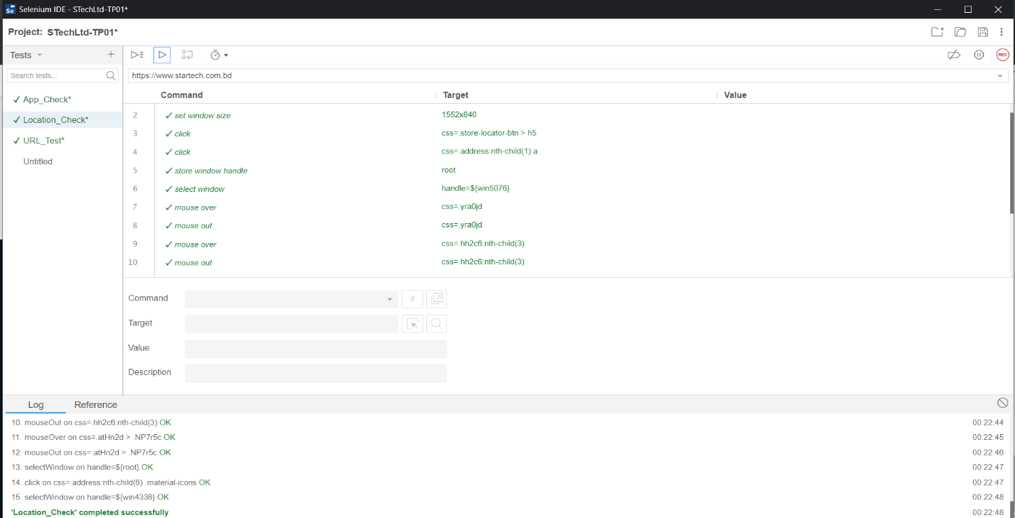

**Fig-53: Store location check test case execution**

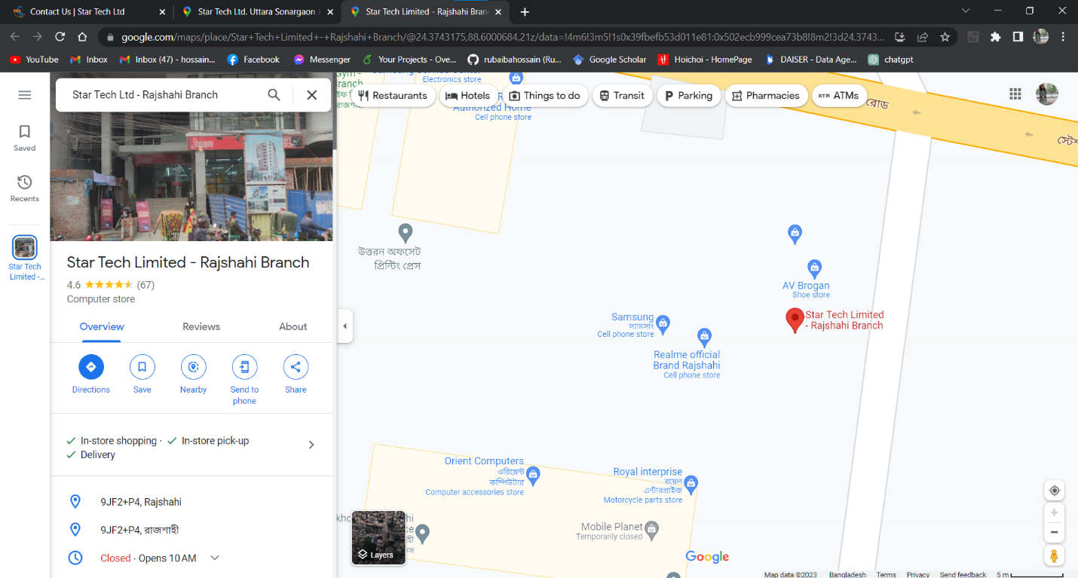

**Fig-54: Store location check**

|  |  |  |  |  |  |
| --- | --- | --- | --- | --- | --- |
| Project Name: Star Tech Ltd | | | Test Designed by: Rubaiba Hossain | | |
| Test Case ID: ST-TC-04 | | | Test Designed date: 14/05/2023 | | |
| Test Priority (Low, Medium, High): Medium | | | Test Executed by: Rubaiba Hossain | | |
| Module Name: Search Loc | | | Test Execution date: 14/05/2023 | | |
| Test Title: Search the location | | |  | | |
| Description: Test the search bar with valid and invalid input. | | |  | | |
| Precondition (If any): User must open location option | | | | | |
| Test Steps | Test Data | Expected Results | | Actual Results | Status (Pass/Fail) |
| 1. Go to the website 2. Click on Find our stores 3. Click on search bar 4. Type any area name 5. Type any invalid name | Dhaka, Rajshahi, abcd | If user type valid area name then he/she can be see the store location of that area, otherwise the result will show nothing. | | As expected, | Pass |
| Post Condition: User can be able to see the store location | | | | | |

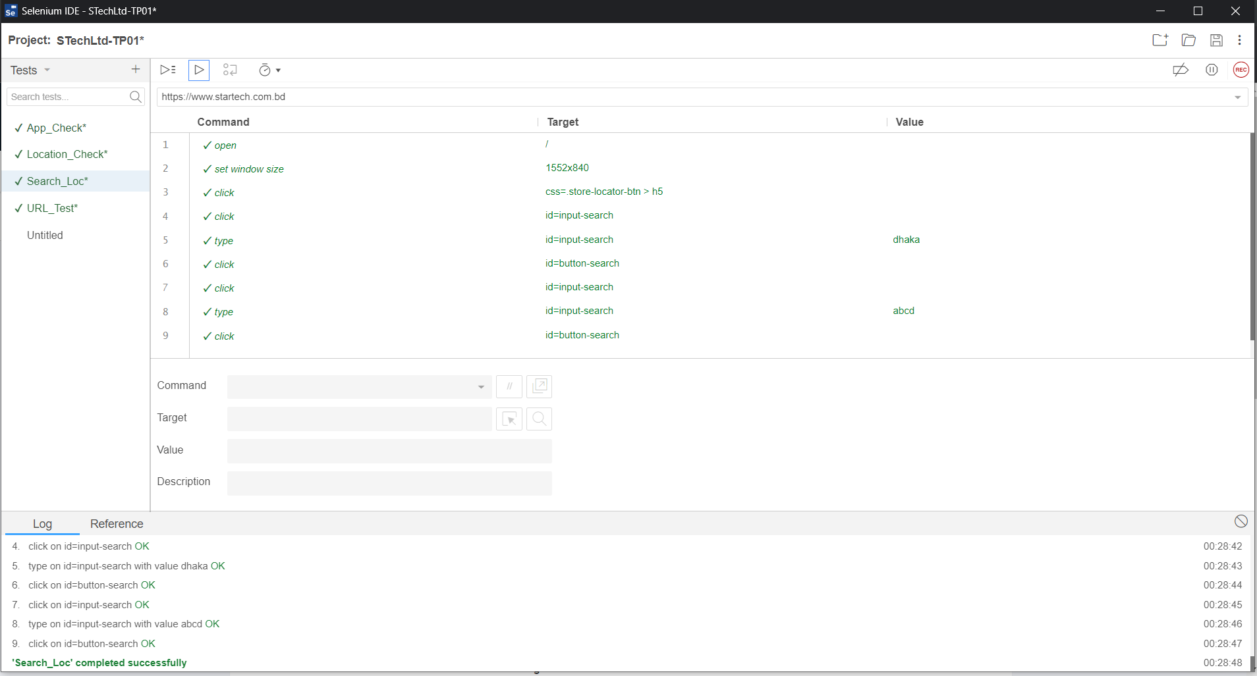

**Fig-55: Search location test case execution**

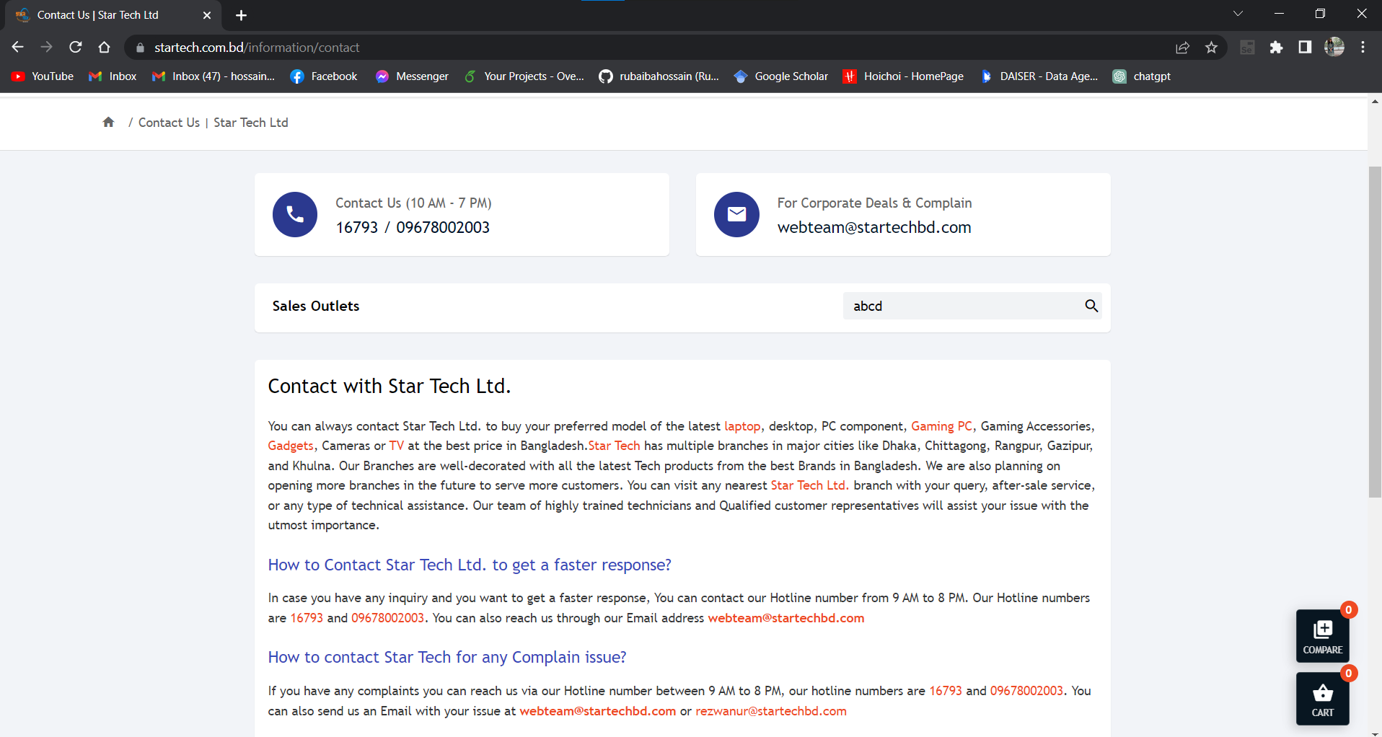

**Fig-56: Search location**

|  |  |  |  |  |  |
| --- | --- | --- | --- | --- | --- |
| Project Name: Star Tech Ltd | | | Test Designed by: Rubaiba Hossain | | |
| Test Case ID: ST-TC-05 | | | Test Designed date: 14/05/2023 | | |
| Test Priority (Low, Medium, High): Medium | | | Test Executed by: Rubaiba Hossain | | |
| Module Name: Email_send | | | Test Execution date: 14/05/2023 | | |
| Test Title: Send email from website | | |  | | |
| Description: Test whether the user send mail directly to website mail. | | |  | | |
| Precondition (If any): User must login their gmail account | | | | | |
| Test Steps | Test Data | Expected Results | | Actual Results | Status (Pass/Fail) |
| 1. Go to the website 2. Click on Email option 3. Send mail | Null | User can send mail to website mail directly | | As expected, | Pass |
| Post Condition: N/A | | | | | |

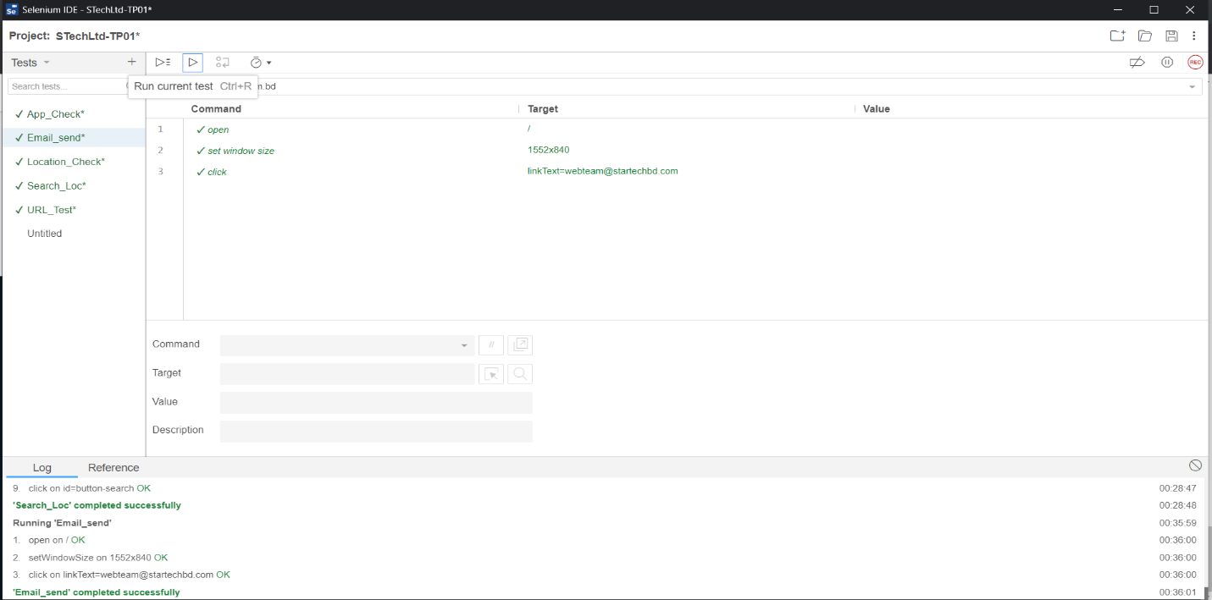

**Fig-57: Send email directly from website test case execution**

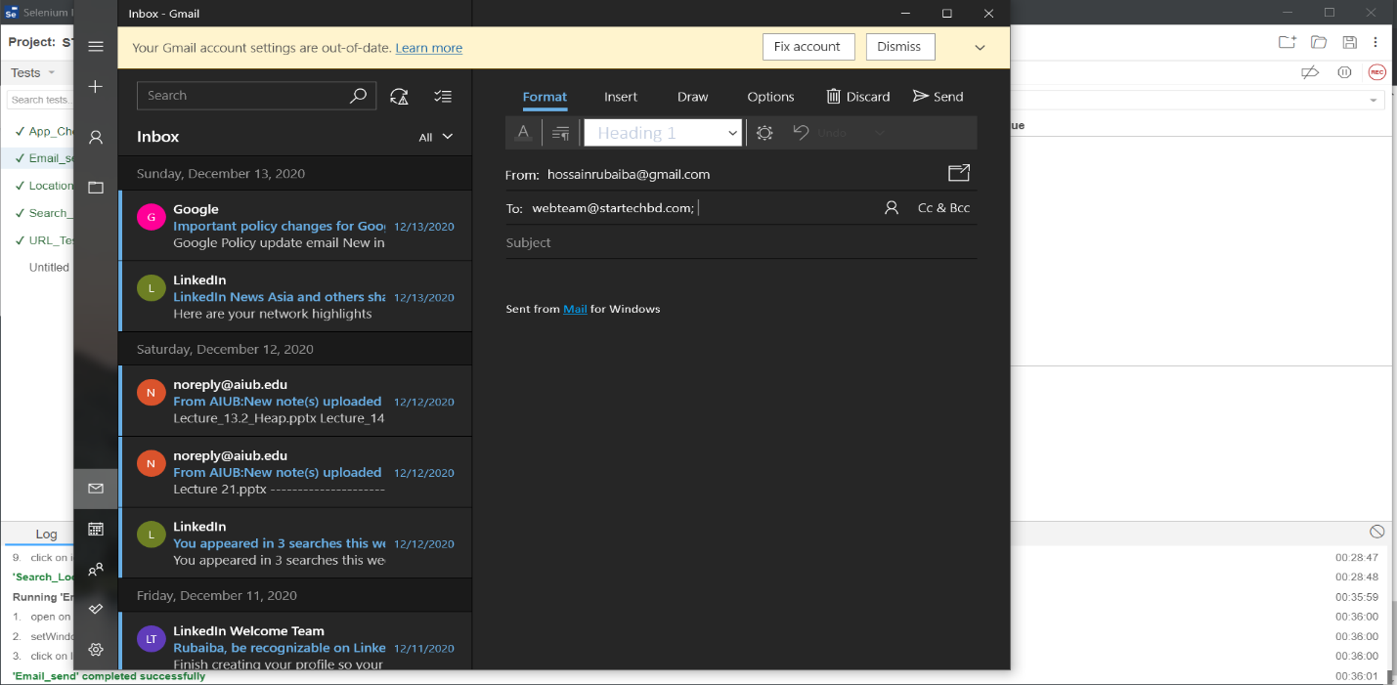

**Fig-58: Send email**

|  |  |  |  |  |  |
| --- | --- | --- | --- | --- | --- |
| Project Name: Star Tech Ltd | | | Test Designed by: Rubaiba Hossain | | |
| Test Case ID: ST-TC-06 | | | Test Designed date: 14/05/2023 | | |
| Test Priority (Low, Medium, High): Medium | | | Test Executed by: Rubaiba Hossain | | |
| Module Name: Social-media | | | Test Execution date: 14/05/2023 | | |
| Test Title: Social media visit | | |  | | |
| Description: Test whether user able to see the social media page. | | |  | | |
| Precondition (If any): N/A | | | | | |
| Test Steps | Test Data | Expected Results | | Actual Results | Status (Pass/Fail) |
| 1. Go to the website 2. Click on Facebook option 3. Click on YouTube 4. Click on Instagram | Null | User can see the Facebook page of star tech and see the YouTube channel. | | As expected, | Pass |
| Post Condition: N/A | | | | | |

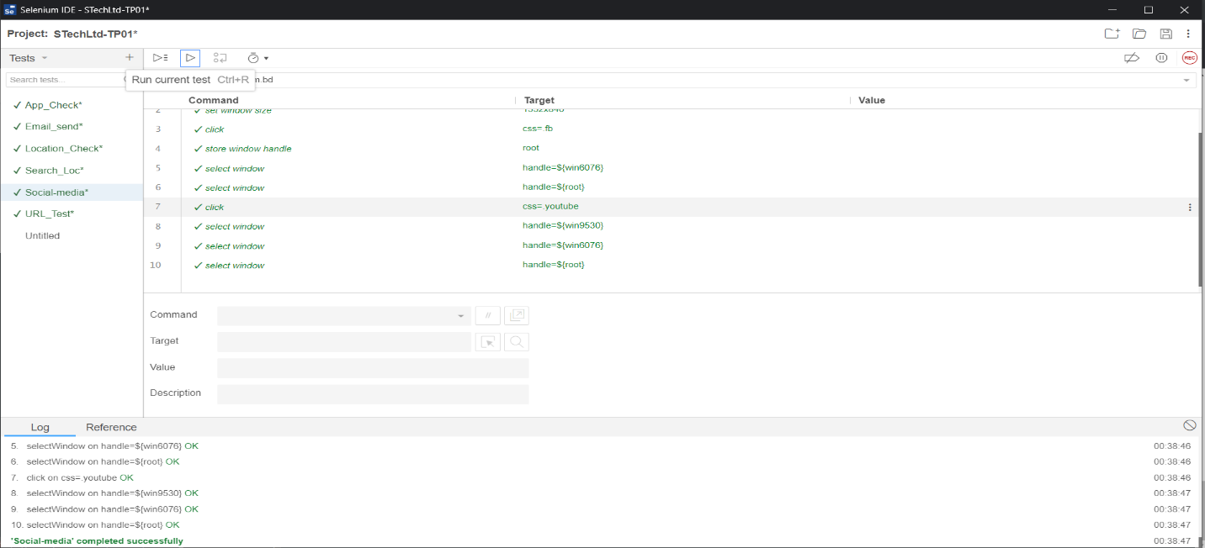

**Fig-59: Social-media connect test case execution**

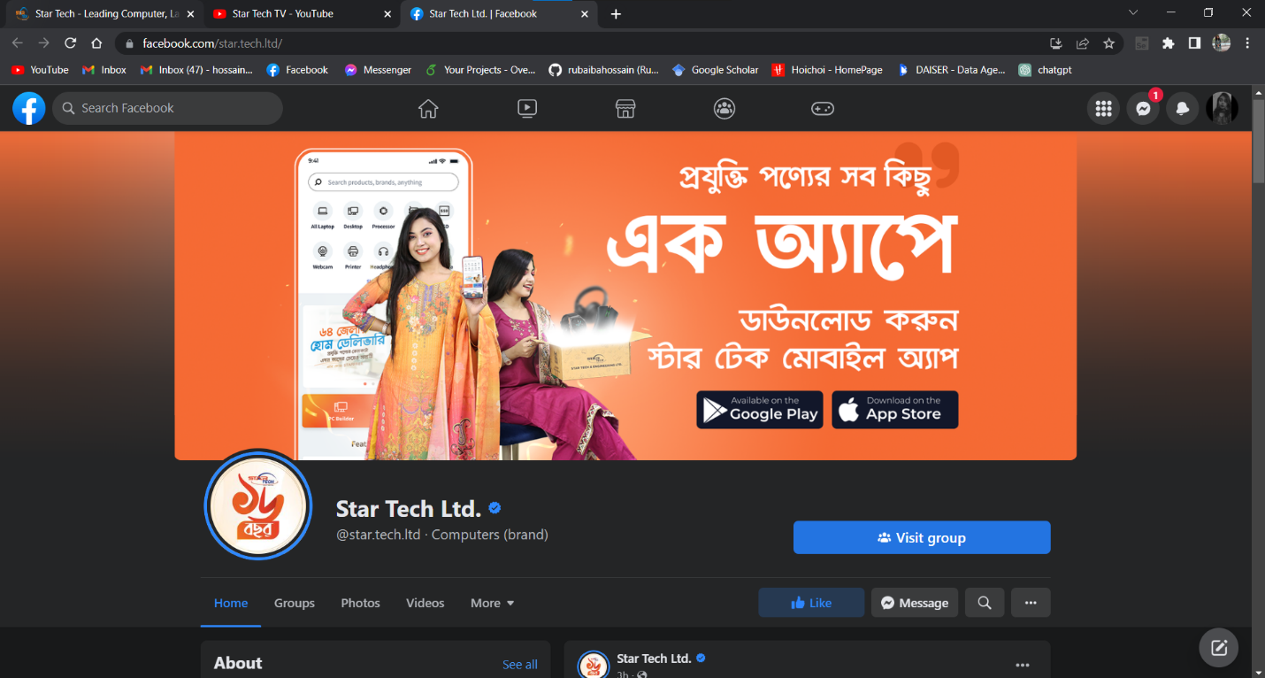

**Fig-60: Social-media connection check**

|  |  |  |  |  |  |
| --- | --- | --- | --- | --- | --- |
| Project Name: Star Tech Ltd | | | Test Designed by: Rubaiba Hossain | | |
| Test Case ID: ST-TC-07 | | | Test Designed date: 14/05/2023 | | |
| Test Priority (Low, Medium, High): Medium | | | Test Executed by: Rubaiba Hossain | | |
| Module Name: Online-support | | | Test Execution date: 14/05/2023 | | |
| Test Title: Online service support | | |  | | |
| Description: Test whether user able to give the complaint with or without login | | |  | | |
| Precondition (If any): User must give the information on that form | | | | | |
| Test Steps | Test Data | Expected Results | | Actual Results | Status (Pass/Fail) |
| 1. Go to the website 2. Click on Online service support 3. Fill the form valid input 4. Click on submit 5. Submit the form without login account. | Rubaiba Hossain, [hossainrubaiba@gmail.com](mailto:hossainrubaiba@gmail.com), abcdef | User can submit the complain when login account or logout account. If there is input, then try to submit the result will be invalid. | | As expected, | Pass |
| Post Condition: N/A | | | | | |

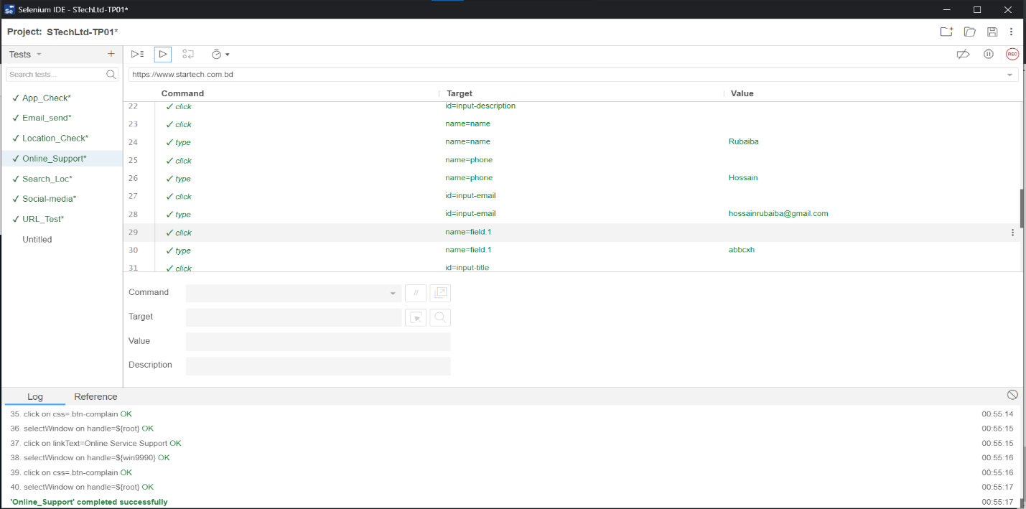

**Fig-61: Online service support test case execution**

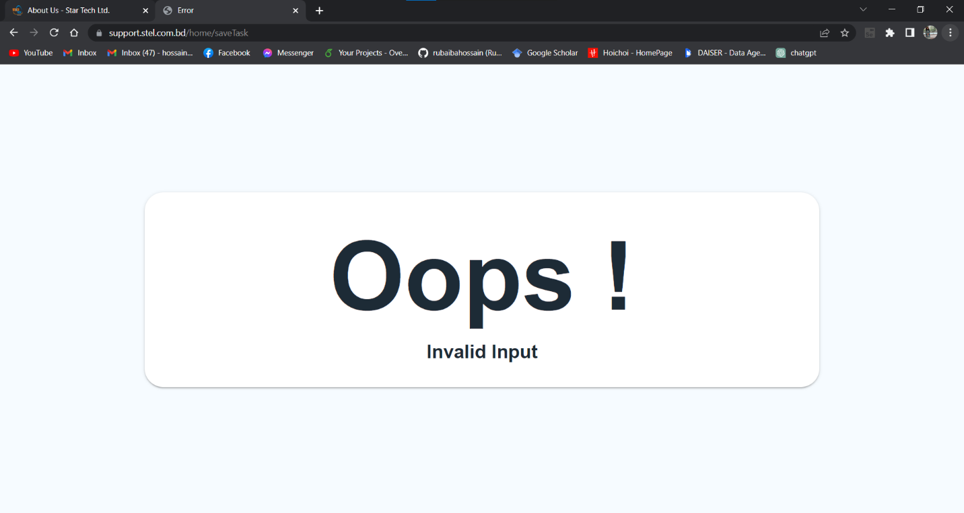

**Fig-62: Invalid complain**

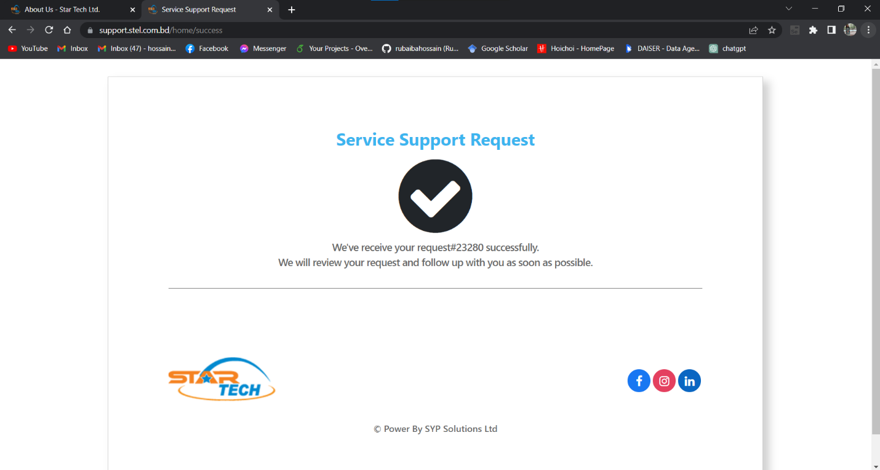

**Fig-63: Valid complain**

|  |  |  |  |  |  |
| --- | --- | --- | --- | --- | --- |
| Project Name: Star Tech Ltd | | | Test Designed by: Rubaiba Hossain | | |
| Test Case ID: ST-TC-08 | | | Test Designed date: 14/05/2023 | | |
| Test Priority (Low, Medium, High): Medium | | | Test Executed by: Rubaiba Hossain | | |
| Module Name: Offers | | | Test Execution date: 14/05/2023 | | |
| Test Title: Check offers | | |  | | |
| Description: Test add offers product and remove product from cart. | | |  | | |
| Precondition (If any): N/A | | | | | |
| Test Steps | Test Data | Expected Results | | Actual Results | Status (Pass/Fail) |
| 1. Go to the website 2. Click on Offers 3. Click on one product view details 4. Click on buy now 5. Click on view cart 6. Remove product | Television | User can see the offers details of a product and add it to cart. If user want he can remove the product also. | | As expected, | Pass |
| Post Condition: User will able to add and remove product from cart. | | | | | |

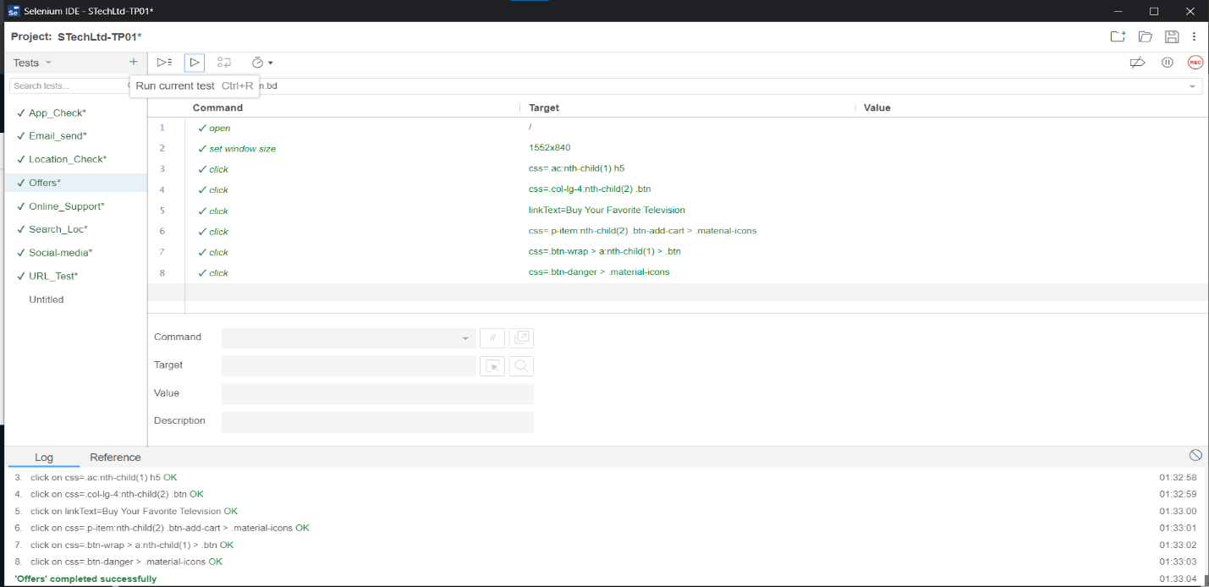

**Fig-64: Offers product test case execution**

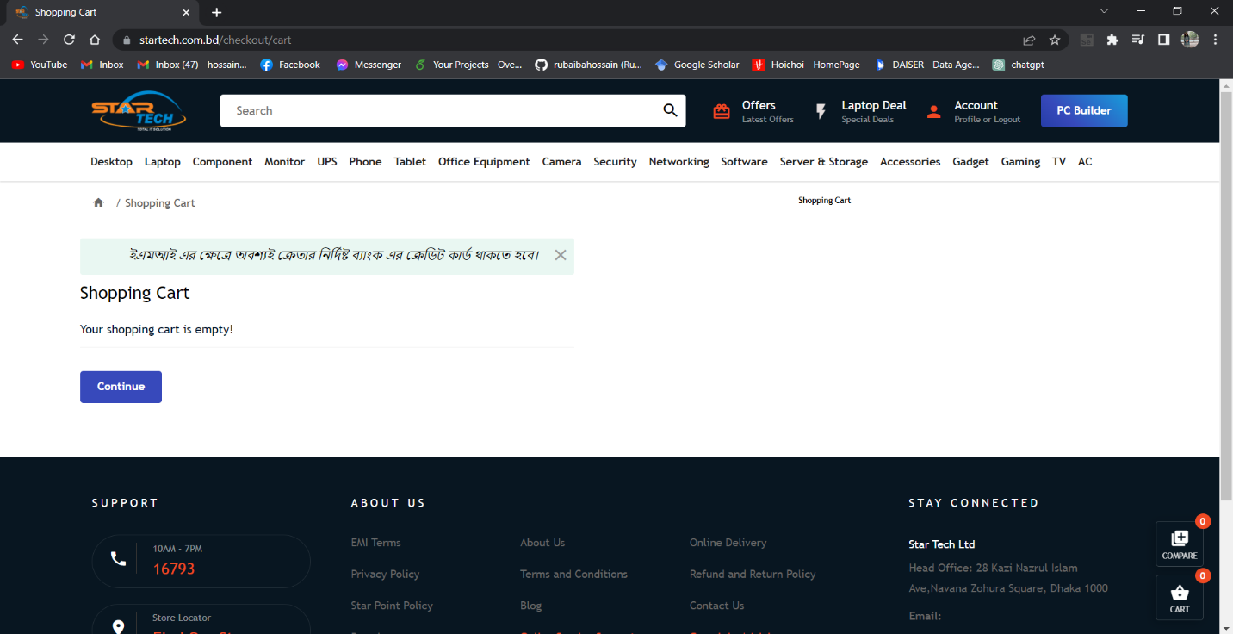

**Fig-65: Offers product delete from cart**

|  |  |  |  |  |  |
| --- | --- | --- | --- | --- | --- |
| Project Name: Star Tech Ltd | | | Test Designed by: Rubaiba Hossain | | |
| Test Case ID: ST-TC-09 | | | Test Designed date: 14/05/2023 | | |
| Test Priority (Low, Medium, High): Medium | | | Test Executed by: Rubaiba Hossain | | |
| Module Name: Offers Sorting | | | Test Execution date: 14/05/2023 | | |
| Test Title: Sorting price and other details | | |  | | |
| Description: Test prices and other details if it is work properly or not. | | |  | | |
| Precondition (If any): User must login into their account. | | | | | |
| Test Steps | Test Data | Expected Results | | Actual Results | Status (Pass/Fail) |
| 1. Go to the website 2. Click on Offers 3. Click on one product view details 4. Click on availability, size, type, special features | Availability, size, special features, type etc | User can sort product details of their preference. | | As expected, | Pass |
| Post Condition: User will able to see the product what they look for. | | | | | |

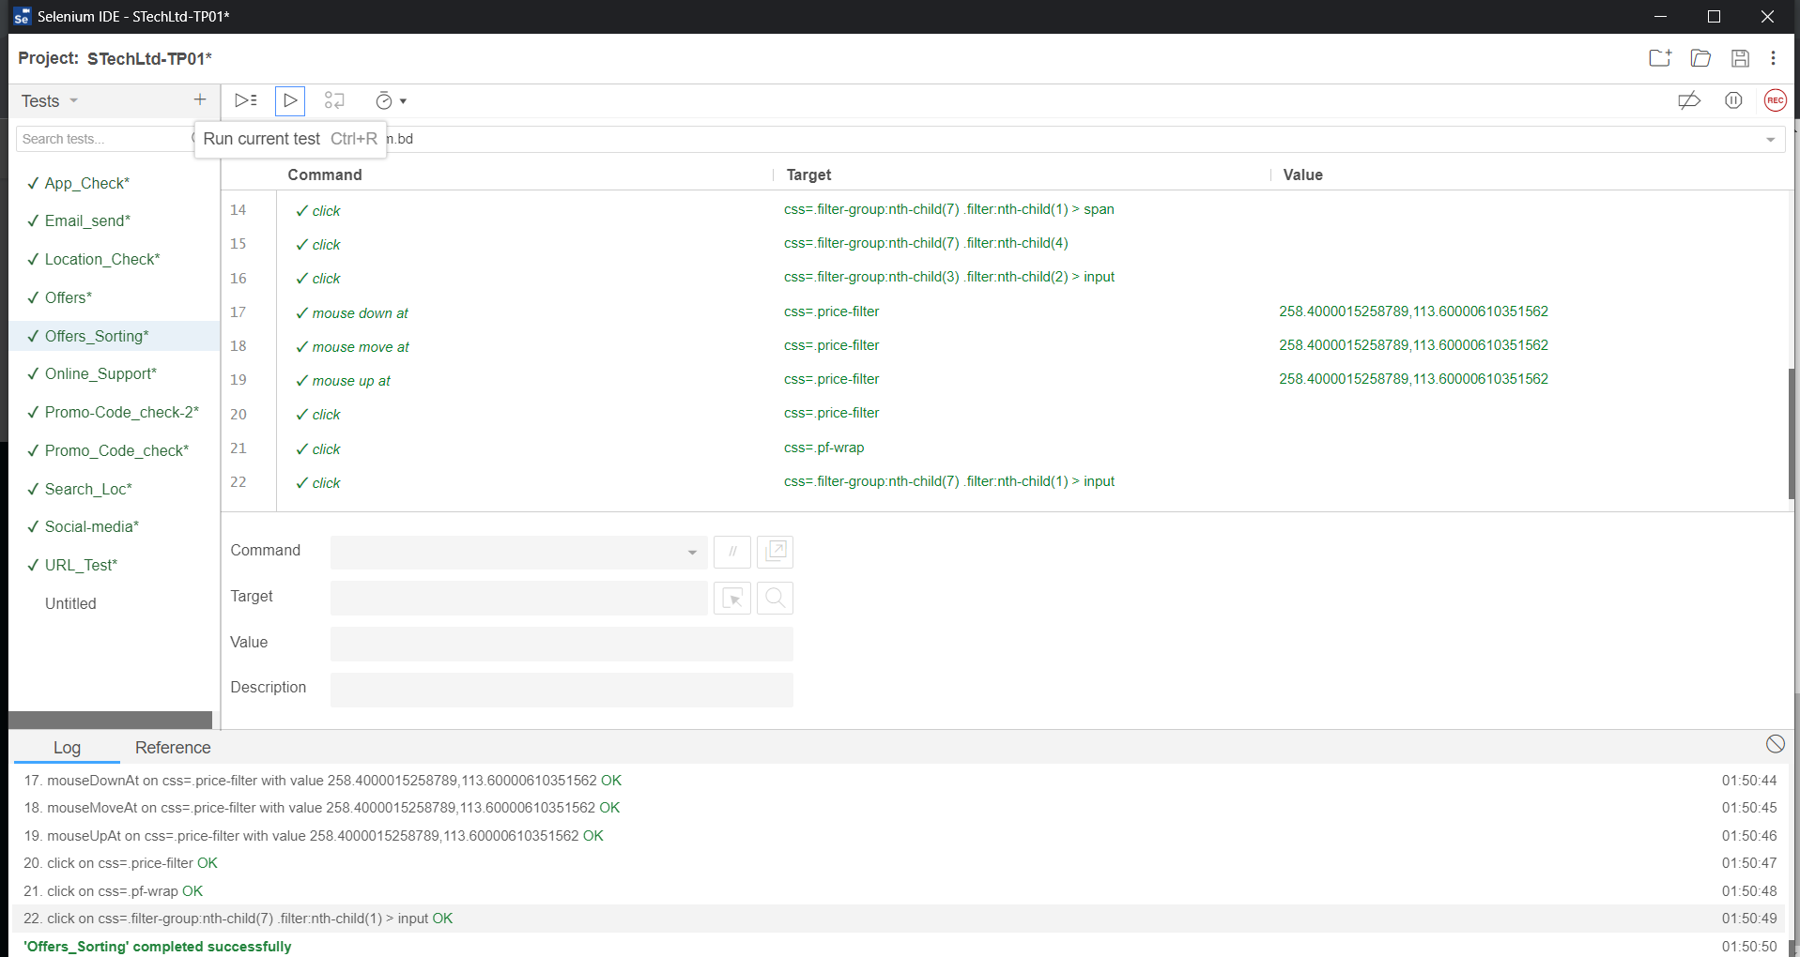

**Fig-65: Offers product sorting test case execution**

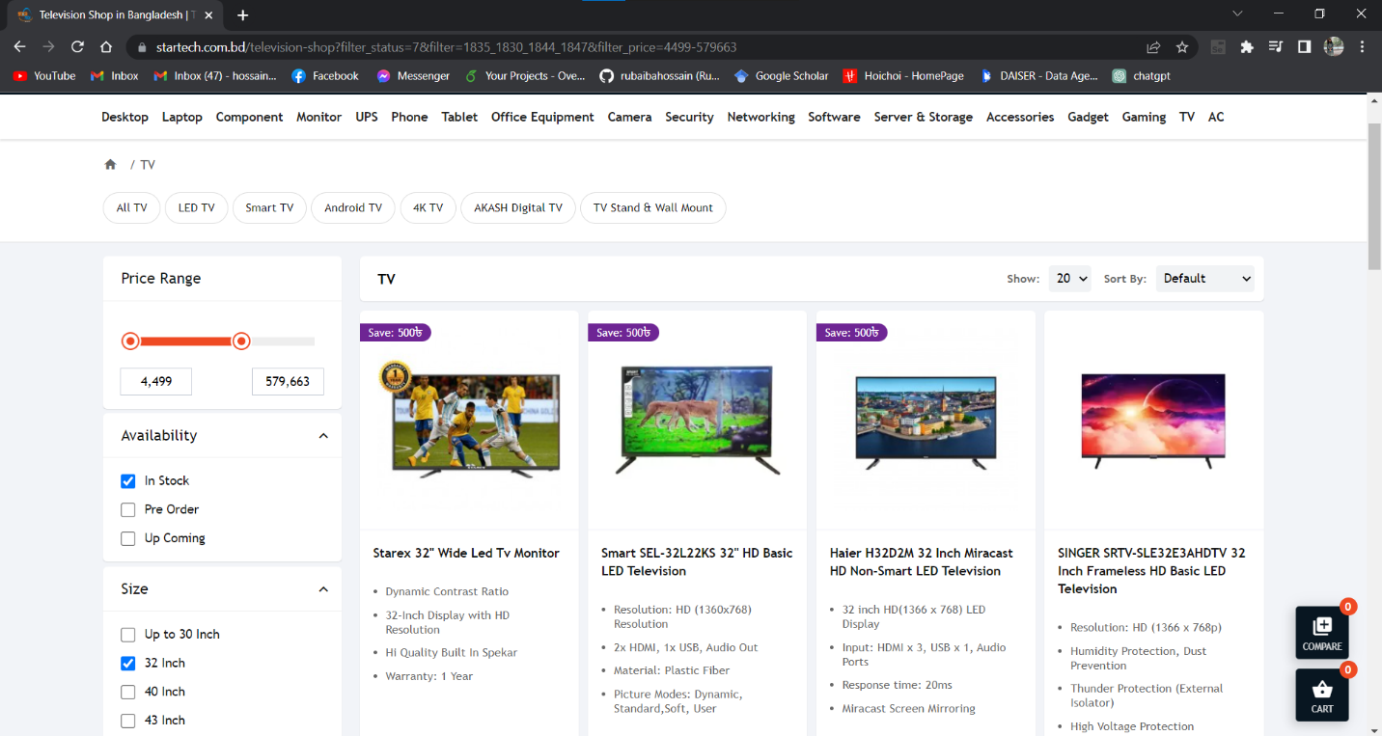

**Fig-66: Offers product sorting**

|  |  |  |  |  |  |
| --- | --- | --- | --- | --- | --- |
| Project Name: Star Tech Ltd | | | Test Designed by: Rubaiba Hossain | | |
| Test Case ID: ST-TC-10 | | | Test Designed date: 14/05/2023 | | |
| Test Priority (Low, Medium, High): Medium | | | Test Executed by: Rubaiba Hossain | | |
| Module Name: Promo Code Check | | | Test Execution date: 14/05/2023 | | |
| Test Title: Offers promo code checking | | |  | | |
| Description: Test if we input wrong promo code | | |  | | |
| Precondition (If any): User must login into their account. | | | | | |
| Test Steps | Test Data | Expected Results | | Actual Results | Status (Pass/Fail) |
| 1. Go to the website 2. Click on Offers 3. Click on one product view details 4. Click on buy now 5. Click on view cart 6. Type wrong code 7. Click apply cupon | Wrong promo code | User can’t use any invalid or wrong promo code. | | As expected, | Pass |
| Post Condition: User will not be able to apply wrong code for offer. | | | | | |

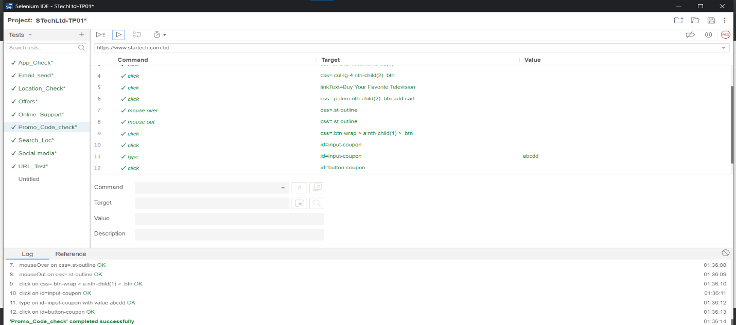

**Fig-67: Offers promo code test case execution**

|  |  |  |  |  |  |
| --- | --- | --- | --- | --- | --- |
| Project Name: Star Tech Ltd | | | Test Designed by: Rubaiba Hossain | | |
| Test Case ID: ST-TC-11 | | | Test Designed date: 14/05/2023 | | |
| Test Priority (Low, Medium, High): Medium | | | Test Executed by: Rubaiba Hossain | | |
| Module Name: Promo Code Check-2 | | | Test Execution date: 14/05/2023 | | |
| Test Title: Offers promo code checking | | |  | | |
| Description: Test promo code with valid code | | |  | | |
| Precondition (If any): User must login into their account. | | | | | |
| Test Steps | Test Data | Expected Results | | Actual Results | Status (Pass/Fail) |
| 1. Go to the website 2. Click on Offers 3. Click on one product view details 4. Click on buy now 5. Click on view cart 6. Type valid code 7. Click apply cupon | HOOOT30 | User can get the offer by using valid promo code | | As expected, | Pass |
| Post Condition: User will be able to apply right code for offer and get the offer. | | | | | |

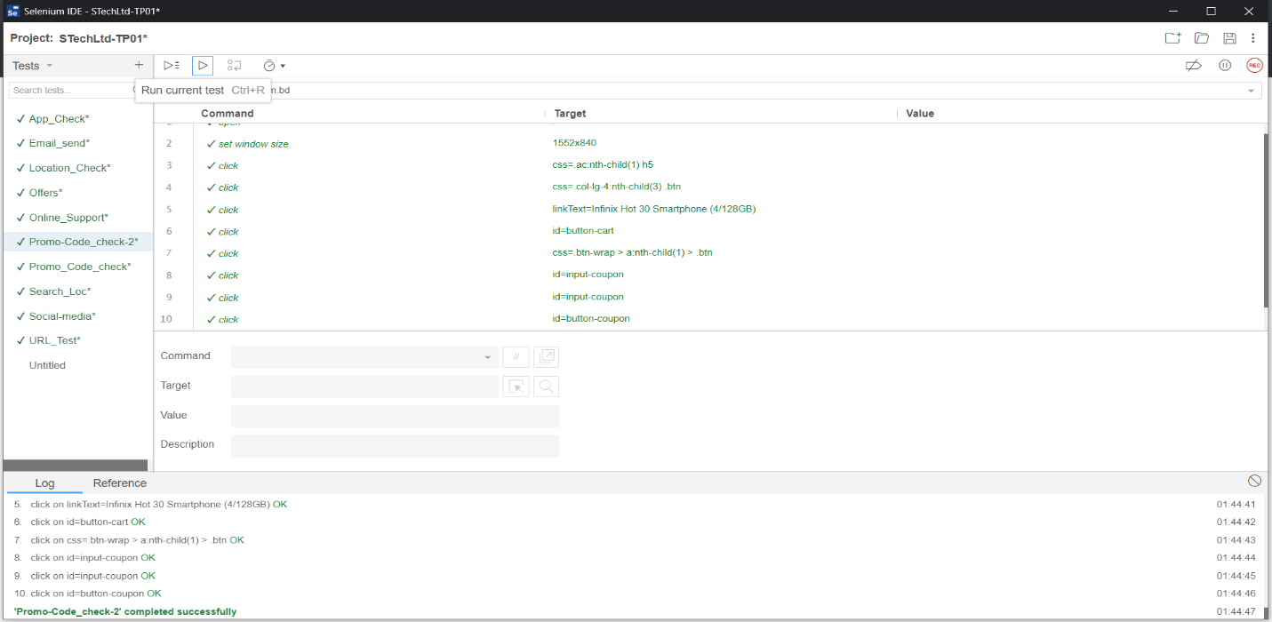

**Fig-68: Right promo code test case execution**

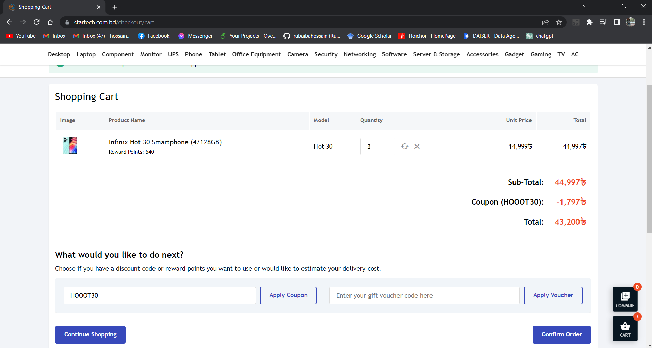

**Fig-69: Right promo code**

|  |  |  |  |  |  |
| --- | --- | --- | --- | --- | --- |
| Project Name: StarTech | | | Test Designed by: Azraf Faheem | | |
| Test Case ID: ST-TC01 | | | Test Designed date: 12/05/2023 | | |
| Test Priority (Low, Medium, High): Medium | | | Test Executed by: Azraf Faheem | | |
| Module Name: Search Products | | | Test Execution date: 12/05/2023 | | |
| Test Title: Search Products | | |  | | |
| Description: Test whether the user can search for desired items or not | | |  | | |
| Precondition (If any): N/A | | | | | |
| Test Steps | Test Data | Expected Results | | Actual Results | Status  (Pass/Fail) |
| 1. Go to the Startech website 2. Click on “Search products” 3. Type the name of desired product 4. Click Submit | Randomly generated products name | User will be able to see the search products as a list | | As expected, | Pass |
| Post Condition: After searching the product user will be able to see the searched items. | | | | | |

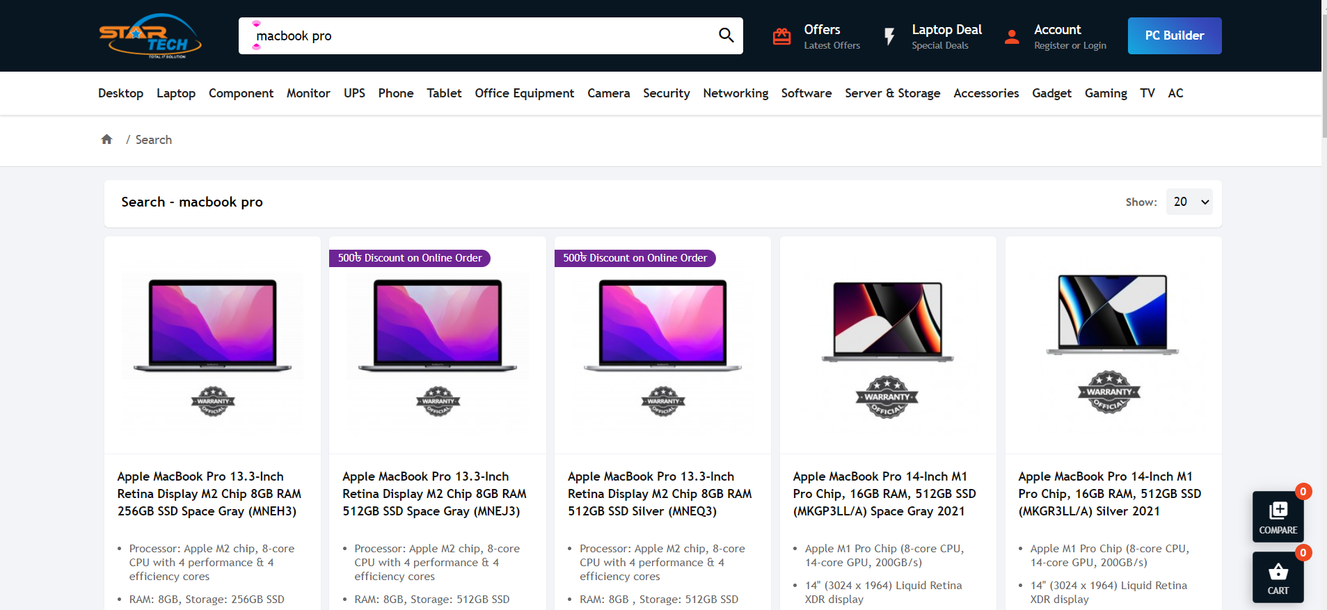

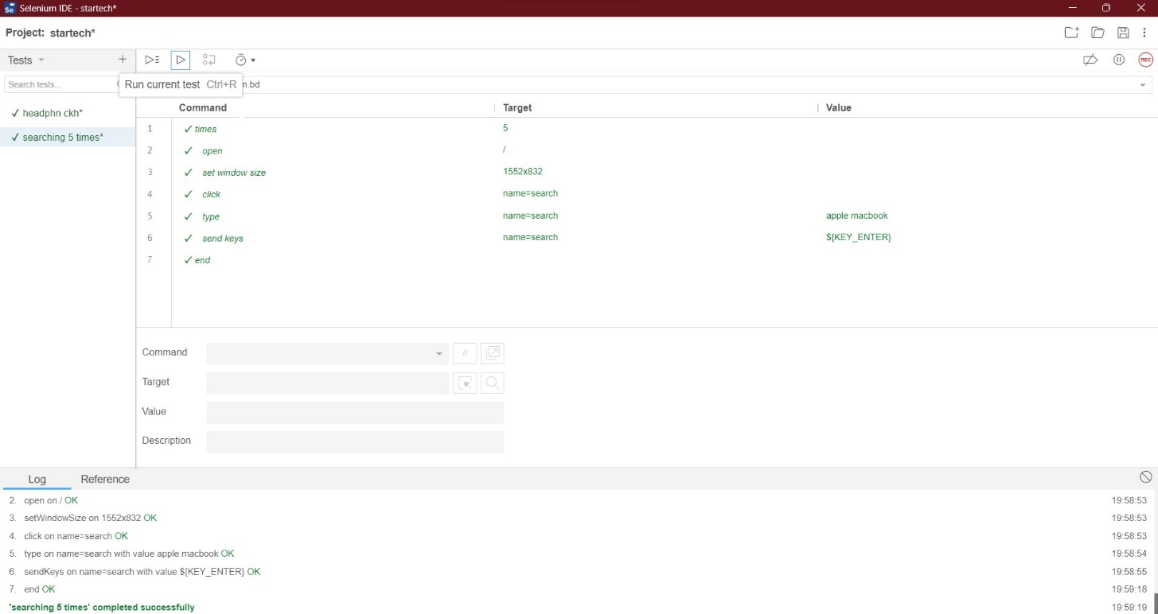

**Fig-70: Searching test case execution.**

|  |  |  |  |  |  |
| --- | --- | --- | --- | --- | --- |
| Project Name: StarTech | | | Test Designed by: Azraf Faheem | | |
| Test Case ID: ST-TC02 | | | Test Designed date: 12/05/2023 | | |
| Test Priority (Low, Medium, High): High | | | Test Executed by: Azraf Faheem | | |
| Module Name: Laptop deals | | | Test Execution date: 12/05/2023 | | |
| Test Title: Laptop deals check | | |  | | |
| Description: Test whether the user can avail a ongoing deal or not | | |  | | |
| Precondition (If any): User must Login with a valid Startech user ID | | | | | |
| Test Steps | Test Data | Expected Results | | Actual Results | Status  (Pass/Fail) |
| 1. Go to the Startech website 2. Click on “Laptop deals”      1. Click on “Buy now” 2. Click “Submit” 3. Click “View Cart” | laptop deals section | User will be able to avail Laptop deals and get the discount on the cart. | | As expected, | Pass |
| Post Condition: After adding to cart user will get the deal. | | | | | |

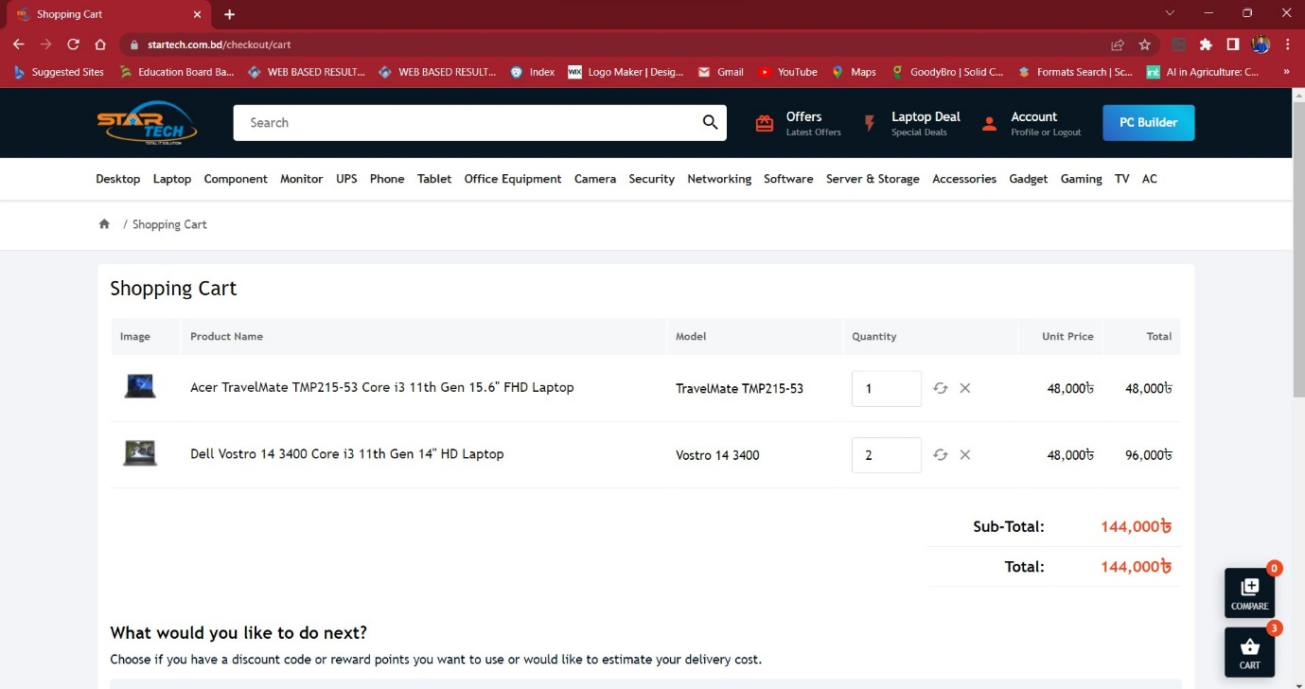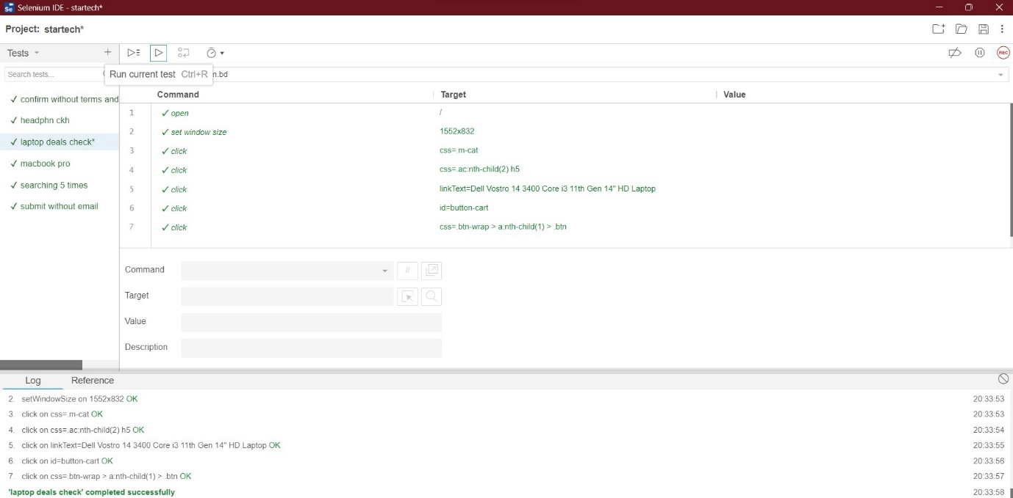

**Fig-71: Laptop deals test case execution.**

|  |  |  |  |  |  |
| --- | --- | --- | --- | --- | --- |
| Project Name: StarTech | | | Test Designed by: Azraf Faheem | | |
| Test Case ID: ST-TC03 | | | Test Designed date: 12/05/2023 | | |
| Test Priority (Low, Medium, High): High | | | Test Executed by: Azraf Faheem | | |
| Module Name: Phone accessories | | | Test Execution date: 12/05/2023 | | |
| Test Title: Online order discount check | | |  | | |
| Description: Test whether the user can get discount on online order | | |  | | |
| Precondition (If any): User must Login with a valid Startech user ID | | | | | |
| Test Steps | Test Data | Expected Results | | Actual Results | Status  (Pass/Fail) |
| 1. Go to the Startech website 2. Click on “Search products” 3. Search for “phone charger” 4. Click on “Buy now” 5. Click “Submit” 6. Click “View Cart” | Online order deals | User will be able to can get discount on online order on the cart. | | As expected, | Pass |
| Post Condition: After adding to cart user will get the online order discount. | | | | | |

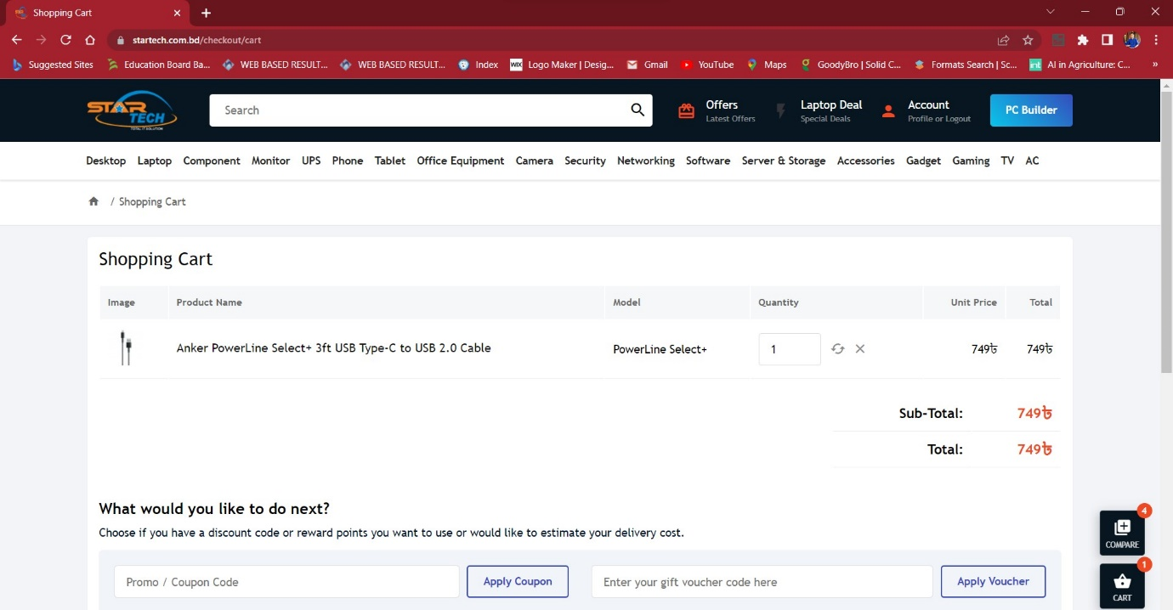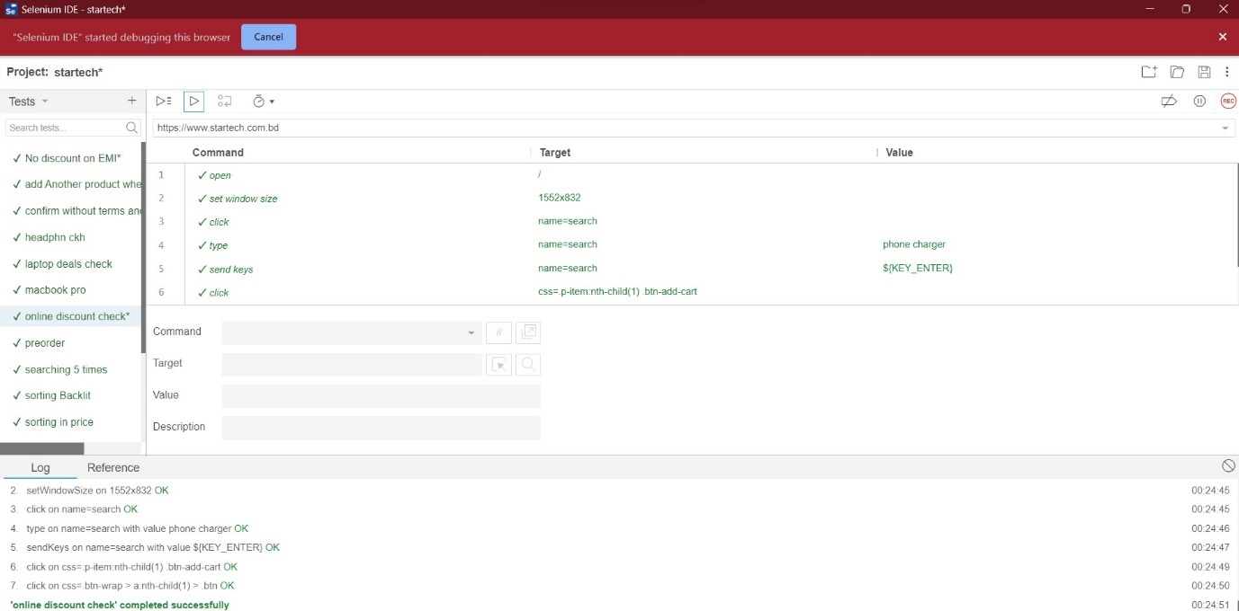

**Fig-72: Online order discount test case execution.**

|  |  |  |  |  |  |
| --- | --- | --- | --- | --- | --- |
| Project Name: StarTech | | | Test Designed by: Azraf Faheem | | |
| Test Case ID: ST-TC04 | | | Test Designed date: 12/05/2023 | | |
| Test Priority (Low, Medium, High): Medium | | | Test Executed by: Azraf Faheem | | |
| Module Name: Laptop | | | Test Execution date: 12/05/2023 | | |
| Test Title: Laptop sorting on basis of keyboard style | | |  | | |
| Description: Test whether the user can get sorted list on laptop | | |  | | |
| Precondition (If any): N/A | | | | | |
| Test Steps | Test Data | Expected Results | | Actual Results | Status  (Pass/Fail) |
| 1. Go to the Startech website 2. Click on “Laptops” 3. Click on “Backlit keyboard” 4. Click “Submit” | Laptops | User will be able to see a sorted list of laptops which have backlit keyboard. | | Not expected,  User got a list where non-backlit keyboard laptops were also included. | fail |

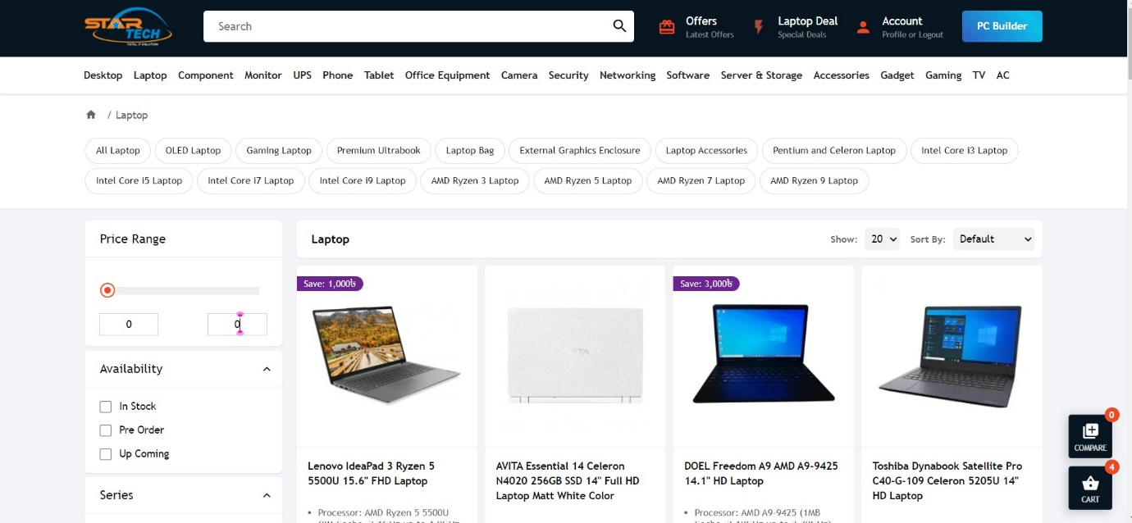

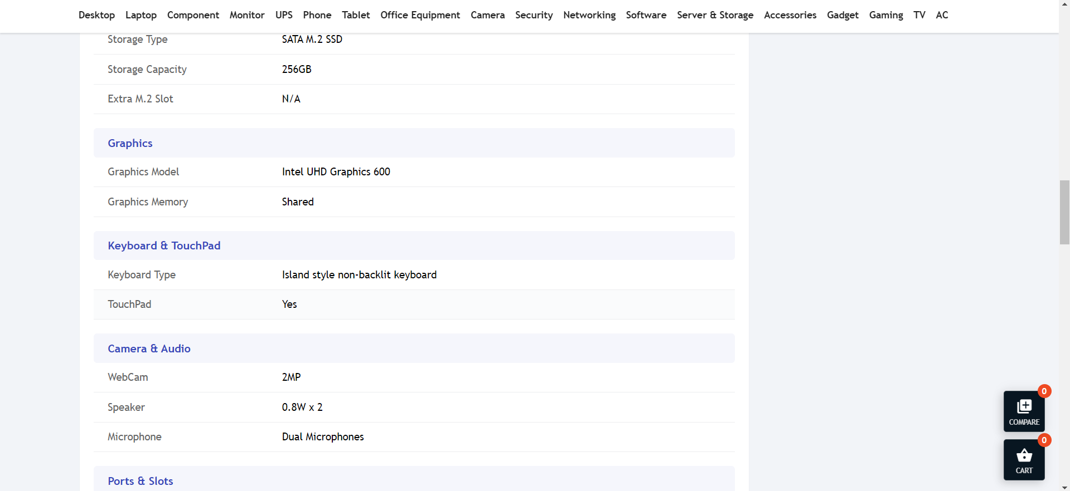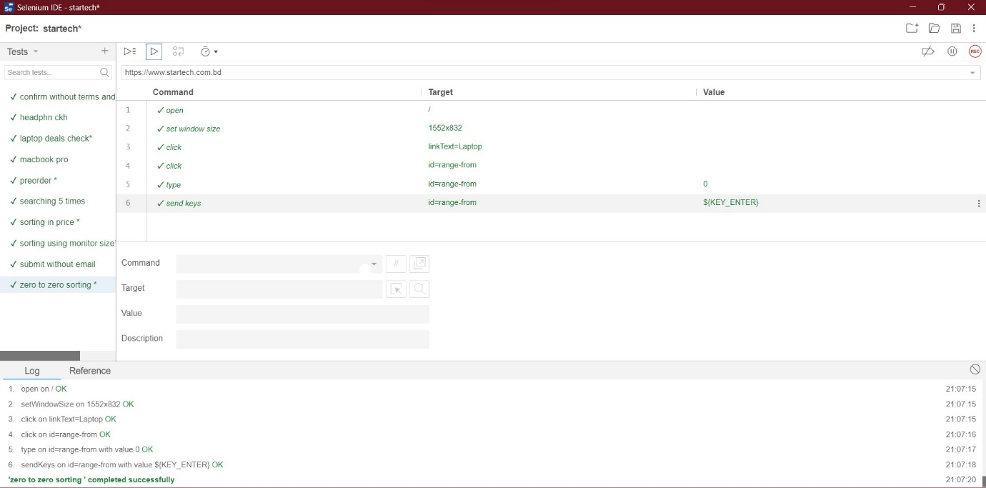

**Fig-73: Sorting on basis of keyboard test case execution.**

|  |  |  |  |  |  |
| --- | --- | --- | --- | --- | --- |
| Project Name: StarTech | | | Test Designed by: Azraf Faheem | | |
| Test Case ID: ST-TC05 | | | Test Designed date: 12/05/2023 | | |
| Test Priority (Low, Medium, High): Low | | | Test Executed by: Azraf Faheem | | |
| Module Name: Laptop | | | Test Execution date: 12/05/2023 | | |
| Test Title: Laptop sorting on Price | | |  | | |
| Description: Test whether the user can get sorted list of laptop on basis of price | | |  | | |
| Precondition (If any): N/A | | | | | |
| Test Steps | Test Data | Expected Results | | Actual Results | Status  (Pass/Fail) |
| 1. Go to the Startech website 2. Click on “Laptops” 3. Click on “Price” 4. Select “low as 0 and high as 0” 5. Click “Submit” | Laptops | User will not be able to see any laptops list. | | Not expected,  User got the same unsorted list of laptops. | fail |



**Fig-74: Sorting on basis of price test case execution.**

|  |  |  |  |  |  |
| --- | --- | --- | --- | --- | --- |
| Project Name: StarTech | | | Test Designed by: Azraf Faheem | | |
| Test Case ID: ST-TC06 | | | Test Designed date: 12/05/2023 | | |
| Test Priority (Low, Medium, High): Low | | | Test Executed by: Azraf Faheem | | |
| Module Name: Monitor | | | Test Execution date: 12/05/2023 | | |
| Test Title: Monitor sorting on size | | |  | | |
| Description: Test whether the user can get sorted list of monitors on basis of size | | |  | | |
| Precondition (If any): N/A | | | | | |
| Test Steps | Test Data | Expected Results | | Actual Results | Status  (Pass/Fail) |
| 1. Go to the Startech website 2. Click on “monitors” 3. Click on “size from 30” 4. Click “Submit” | monitors | User see a list of monitors above the selected size | | as expected, | pass |

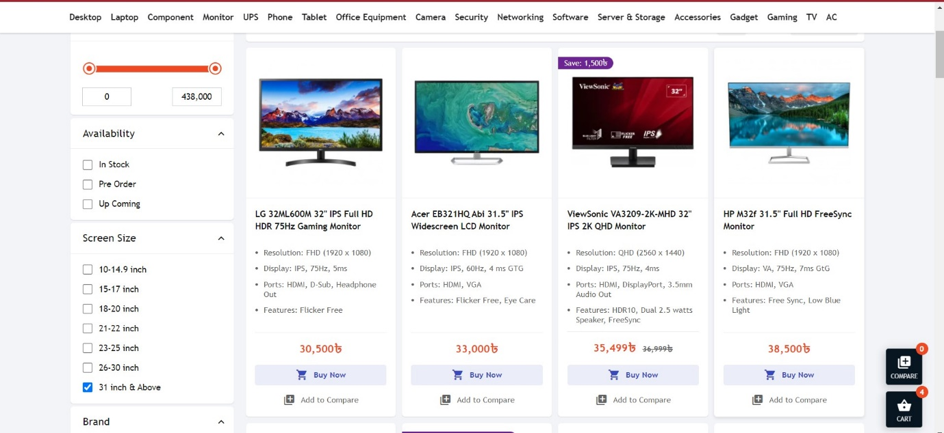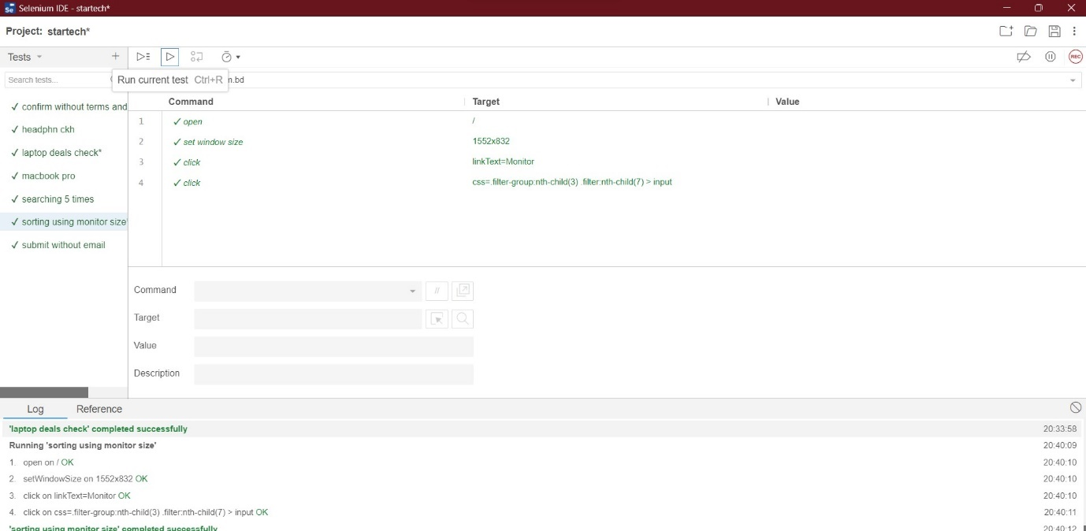

**Fig-75: Monitor Sorting on basis of size test case execution.**

|  |  |  |  |  |  |
| --- | --- | --- | --- | --- | --- |
| Project Name: StarTech | | | Test Designed by: Azraf Faheem | | |
| Test Case ID: ST-TC07 | | | Test Designed date: 12/05/2023 | | |
| Test Priority (Low, Medium, High): Low | | | Test Executed by: Azraf Faheem | | |
| Module Name: Monitor | | | Test Execution date: 12/05/2023 | | |
| Test Title: Pre-order check | | |  | | |
| Description: Test whether the user can get sorted list of monitors which have be pre-ordered | | |  | | |
| Precondition (If any): N/A | | | | | |
| Test Steps | Test Data | Expected Results | | Actual Results | Status  (Pass/Fail) |
| 1. Go to the Startech website 2. Click on “monitors” 3. Click on “pre-order” 4. Click “Submit” | monitors | User see a list of monitors which have be pre-ordered. | | as expected, | pass |

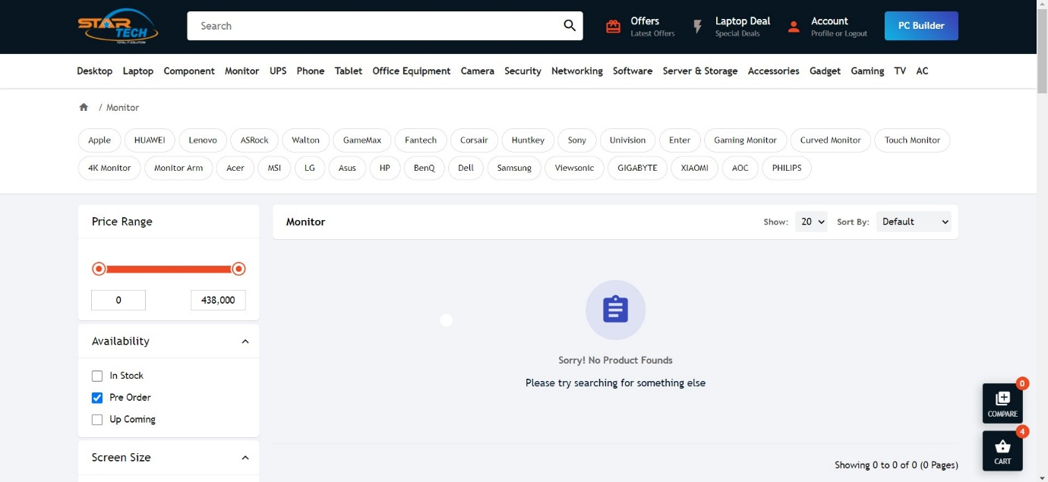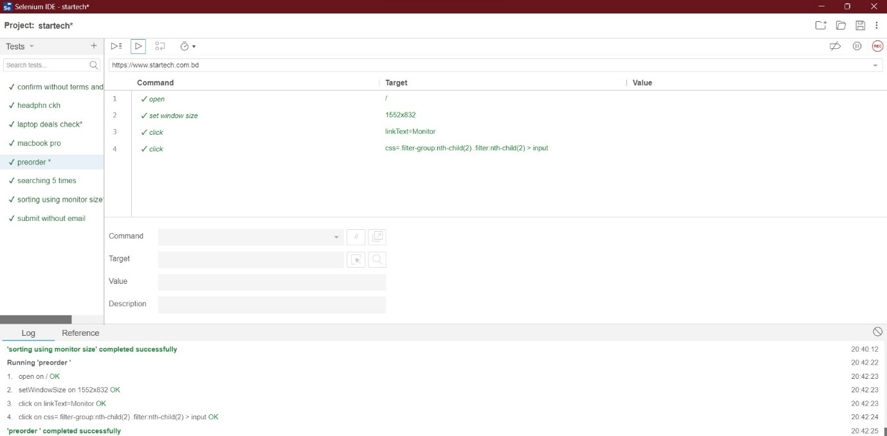

**Fig-76: Pre-order test case execution.**

|  |  |  |  |  |  |
| --- | --- | --- | --- | --- | --- |
| Project Name: StarTech | | | Test Designed by: Azraf Faheem | | |
| Test Case ID: ST-TC07 | | | Test Designed date: 12/05/2023 | | |
| Test Priority (Low, Medium, High): Low | | | Test Executed by: Azraf Faheem | | |
| Module Name: Checkout | | | Test Execution date: 12/05/2023 | | |
| Test Title: Order without e-mail | | |  | | |
| Description: Test whether the user can order without e-mail | | |  | | |
| Precondition (If any): User must Login with a valid Startech user ID | | | | | |
| Test Steps | Test Data | Expected Results | | Actual Results | Status  (Pass/Fail) |
| 1. Go to the Startech website 2. Add any product on cart. 3. Click on “checkout” 4. Keep the email section empty 5. Click “Submit” | null | User should be able to order without an e-mail id | | as expected, | pass |

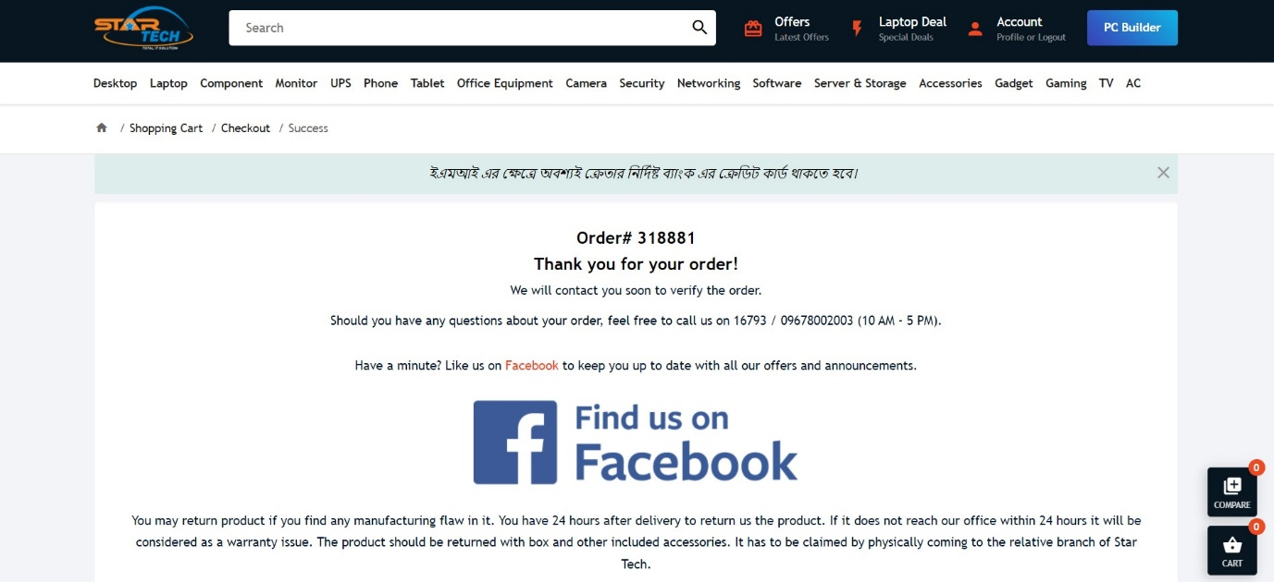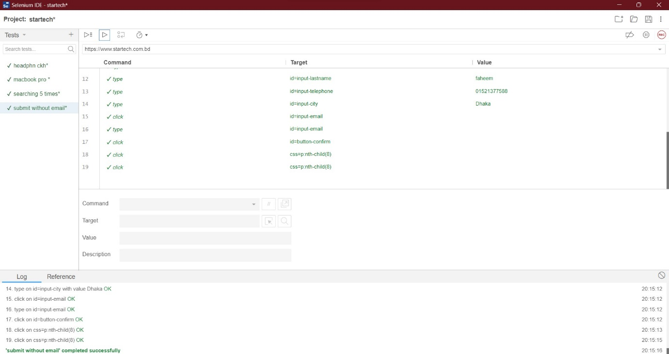

**Fig-77: Order without email test case execution.**

|  |  |  |  |  |  |
| --- | --- | --- | --- | --- | --- |
| Project Name: StarTech | | | Test Designed by: Azraf Faheem | | |
| Test Case ID: ST-TC08 | | | Test Designed date: 12/05/2023 | | |
| Test Priority (Low, Medium, High): High | | | Test Executed by: Azraf Faheem | | |
| Module Name: Checkout | | | Test Execution date: 12/05/2023 | | |
| Test Title: Order without Terms and Condition. | | |  | | |
| Description: Test whether the user can order without accepting terms and conditions. | | |  | | |
| Precondition (If any): User must Login with a valid Startech user ID | | | | | |
| Test Steps | Test Data | Expected Results | | Actual Results | Status  (Pass/Fail) |
| 1. Go to the Startech website 2. Add any product on cart. 3. Click on “checkout” 4. Do not check on “Terms and condition” 5. Click “Submit” | null | User should not be able to place order without accepting terms and conditions. | | as expected, | pass |

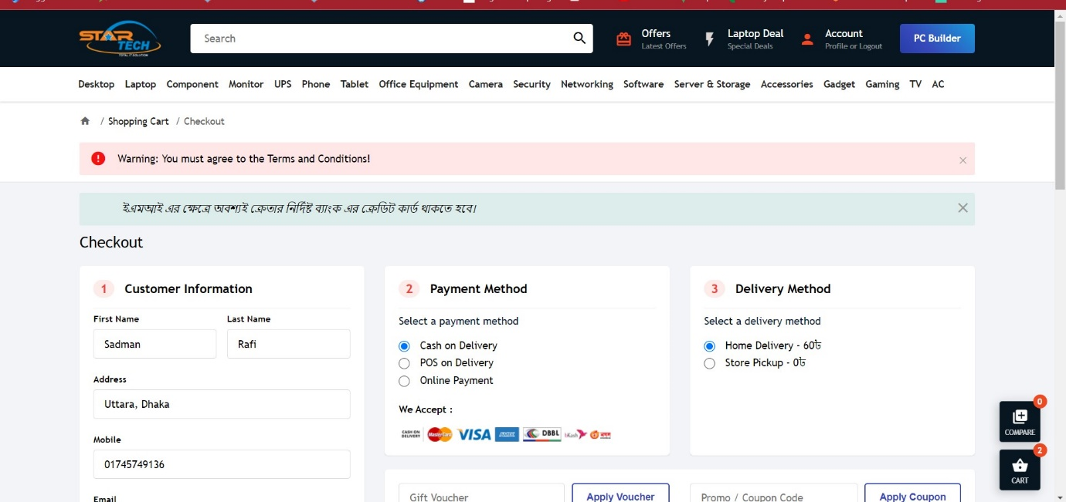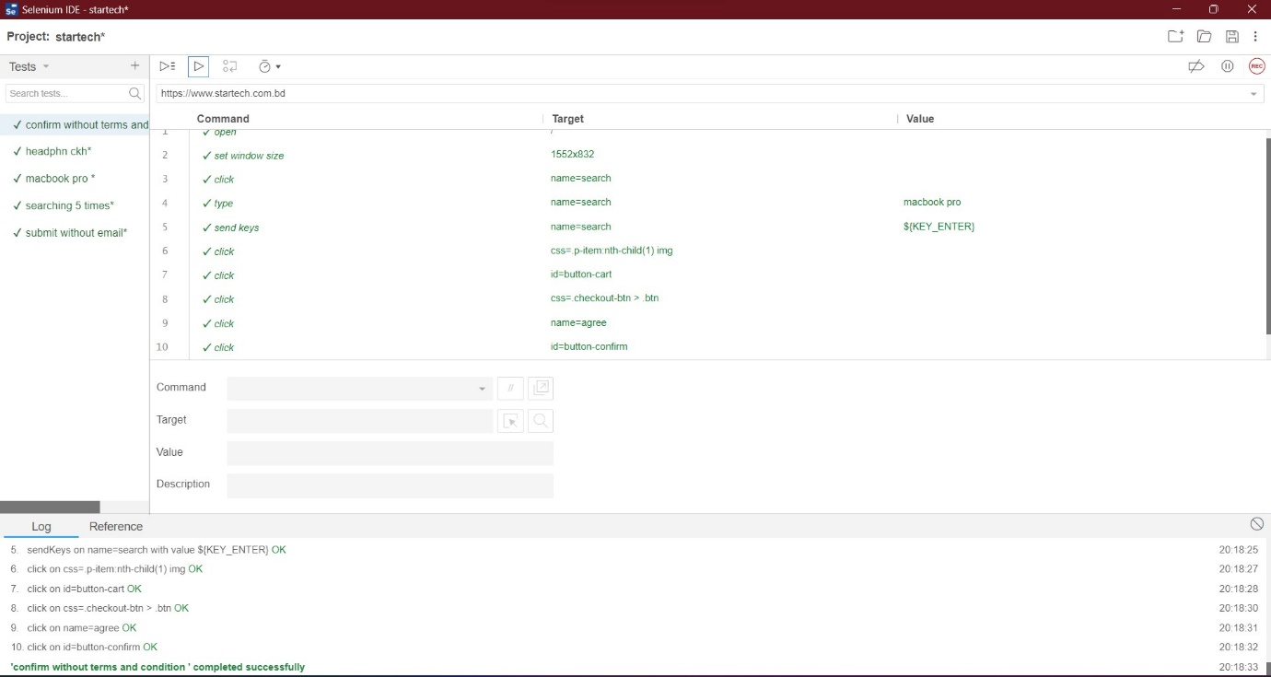

**Fig-78: confirm without terms and condition test case execution.**

|  |  |  |  |  |  |
| --- | --- | --- | --- | --- | --- |
| Project Name: StarTech | | | Test Designed by: Azraf Faheem | | |
| Test Case ID: ST-TC09 | | | Test Designed date: 12/05/2023 | | |
| Test Priority (Low, Medium, High): High | | | Test Executed by: Azraf Faheem | | |
| Module Name: Cart | | | Test Execution date: 12/05/2023 | | |
| Test Title: No discount on EMI | | |  | | |
| Description: Test whether the user can get discount while purchasing on EMI | | |  | | |
| Precondition (If any): User must Login with a valid Startech user ID | | | | | |
| Test Steps | Test Data | Expected Results | | Actual Results | Status  (Pass/Fail) |
| 1. Go to the Startech website 2. Add any product with discount on cart. 3. Select “EMI” 4. Click on “Cart” | Random discounted order | User should not get any discount while purchasing on EMI | | as expected, | pass |

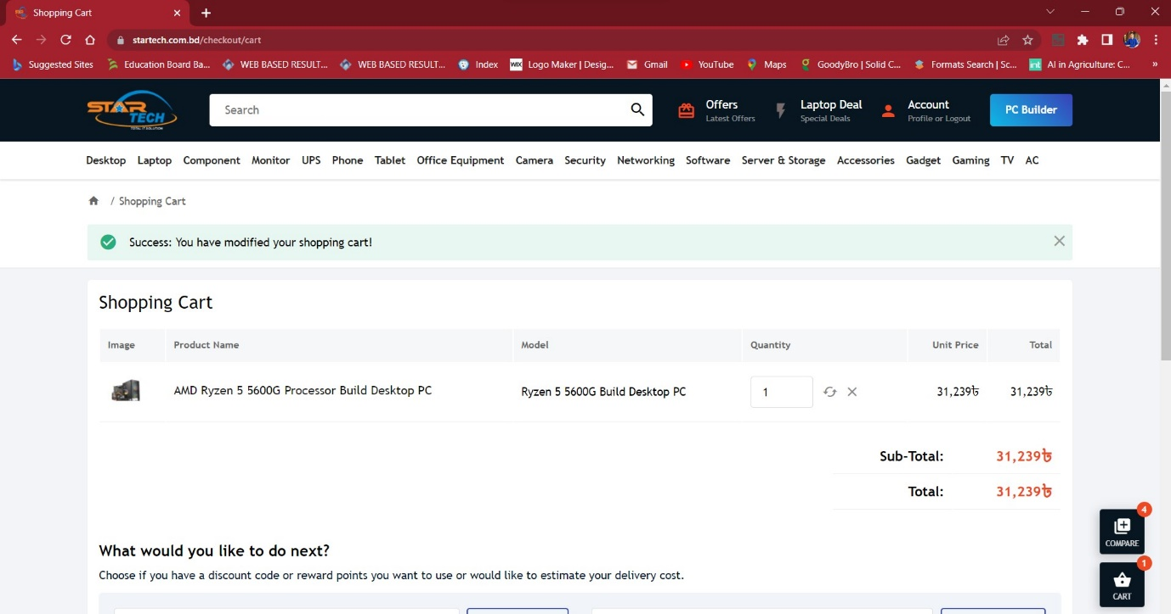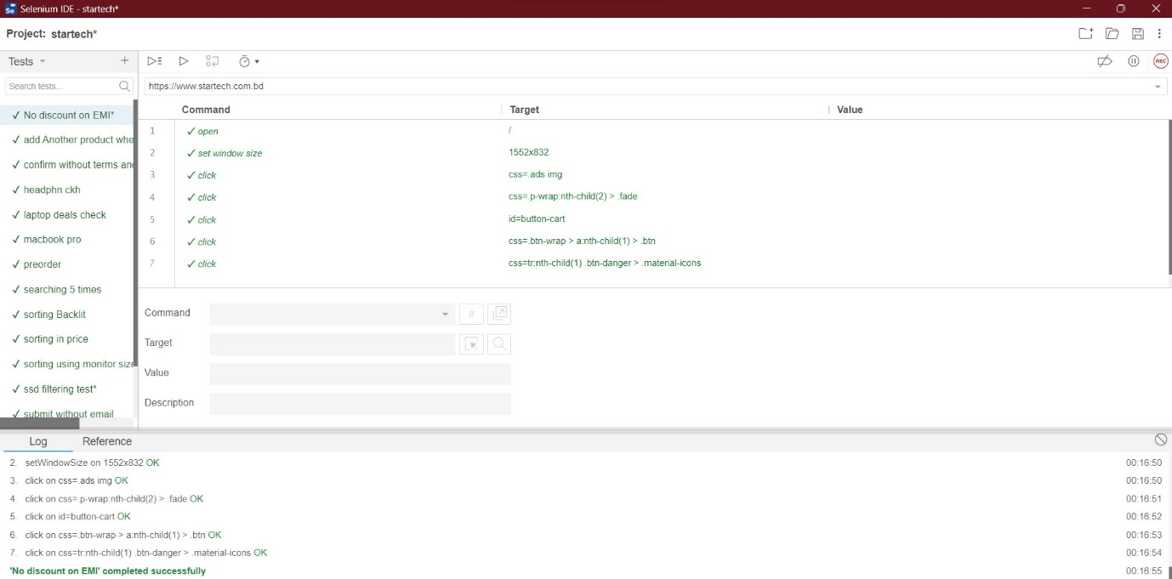

**Fig-79: No discount on EMI test case execution.**

|  |  |  |  |  |  |
| --- | --- | --- | --- | --- | --- |
| Project Name: StarTech | | | Test Designed by: Azraf Faheem | | |
| Test Case ID: ST-TC10 | | | Test Designed date: 12/05/2023 | | |
| Test Priority (Low, Medium, High): High | | | Test Executed by: Azraf Faheem | | |
| Module Name: Cart | | | Test Execution date: 12/05/2023 | | |
| Test Title: Cannot add product without confirming EMI product | | |  | | |
| Description: Test whether the user can add products to the cart while having one EMI item existing. | | |  | | |
| Precondition (If any): User must Login with a valid Startech user ID | | | | | |
| Test Steps | Test Data | Expected Results | | Actual Results | Status  (Pass/Fail) |
| 1. Go to the Startech website 2. Add any product on cart. 3. Click on “Cart” | Random order | User should not be able to add anything on cart without confirming existing EMI product. | | as expected, | pass |

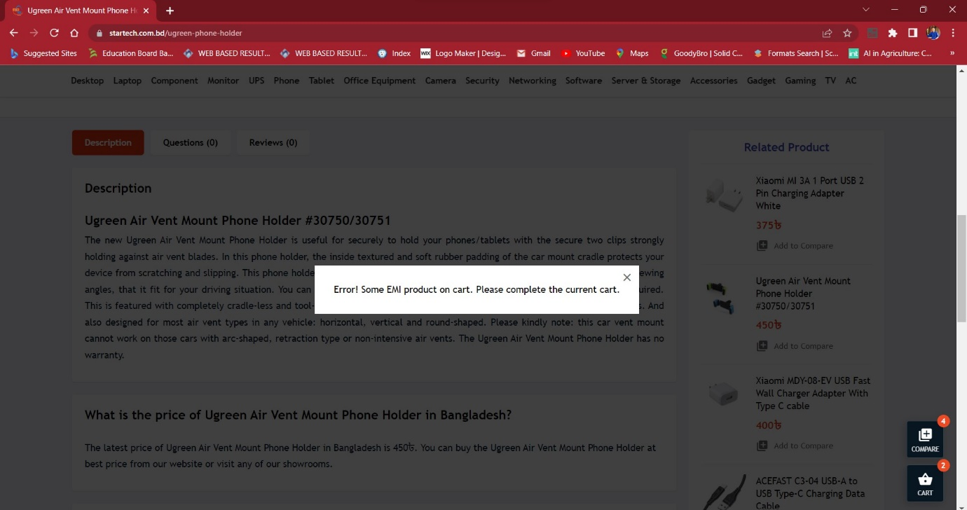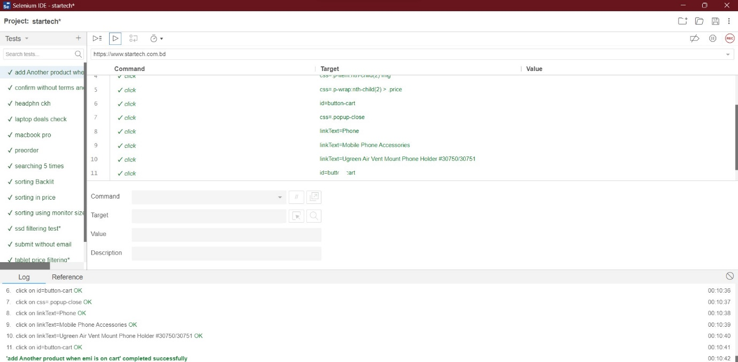

**Fig-80: Add extra on EMI test case execution.**

|  |  |  |  |  |  |
| --- | --- | --- | --- | --- | --- |
| Project Name: StarTech | | | Test Designed by: Azraf Faheem | | |
| Test Case ID: ST-TC11 | | | Test Designed date: 12/05/2023 | | |
| Test Priority (Low, Medium, High): Low | | | Test Executed by: Azraf Faheem | | |
| Module Name: Tablet | | | Test Execution date: 12/05/2023 | | |
| Test Title: Tablet price filtering by High to Low Price | | |  | | |
| Description: Test whether the user can filter tablet price from high to low. | | |  | | |
| Precondition (If any): N/A | | | | | |
| Test Steps | Test Data | Expected Results | | Actual Results | Status  (Pass/Fail) |
| 1. Go to the Startech website 2. Click on “Tablets”. 3. Click on “Price High>Low” 4. Click on “Submit” | Random sorting | User should get a list of products from high to low price. | | as expected, | pass |

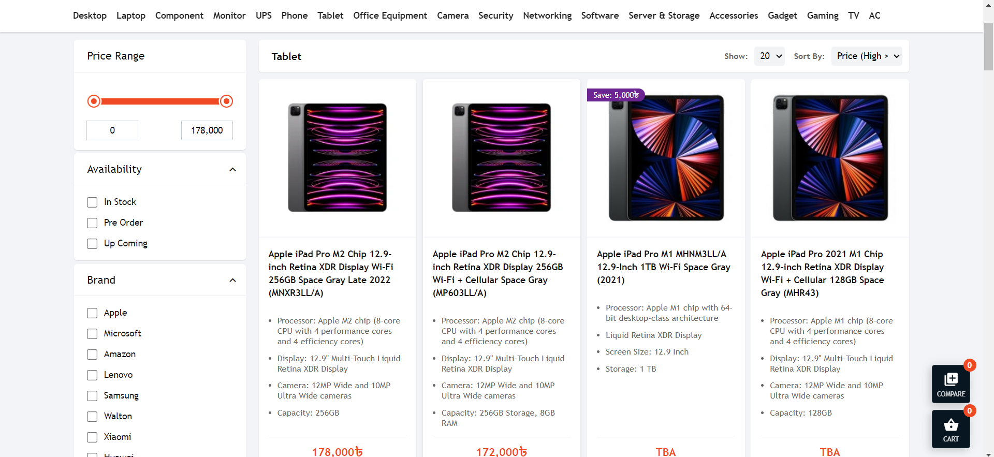

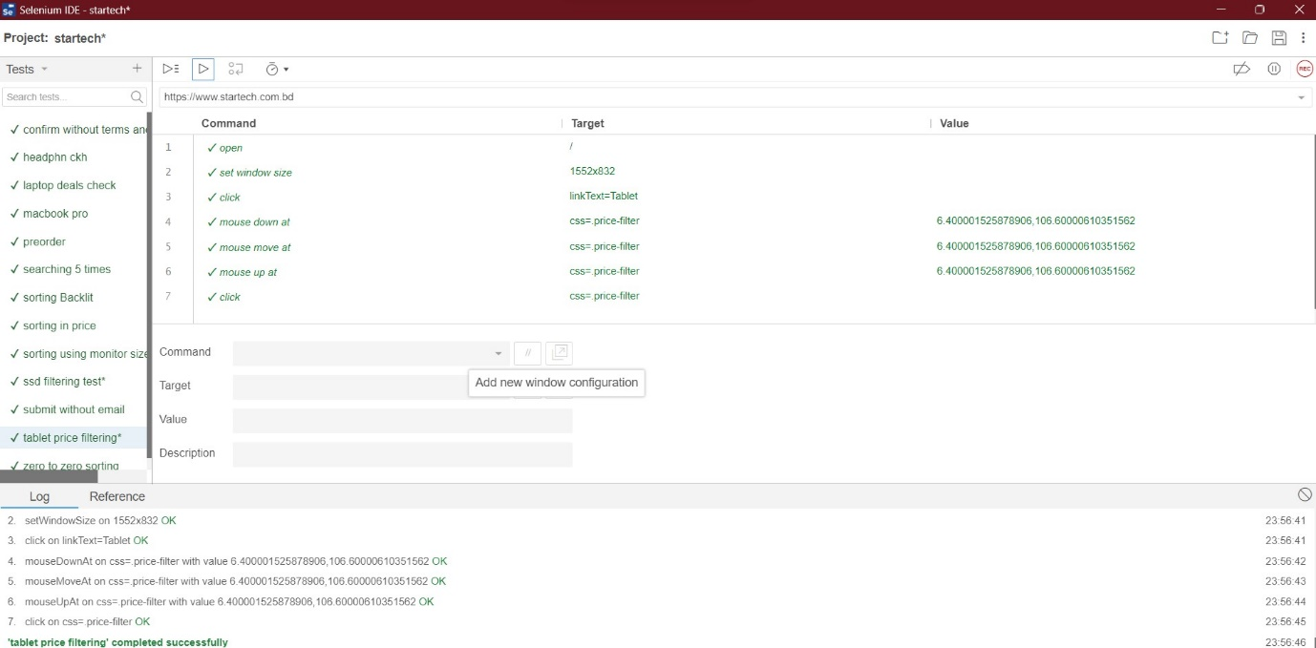

**Fig-81: Tablet Price filtering test case execution.**

|  |  |  |  |  |  |
| --- | --- | --- | --- | --- | --- |
| Project Name: StarTech | | | Test Designed by: Azraf Faheem | | |
| Test Case ID: ST-TC12 | | | Test Designed date: 12/05/2023 | | |
| Test Priority (Low, Medium, High): Low | | | Test Executed by: Azraf Faheem | | |
| Module Name: Search | | | Test Execution date: 12/05/2023 | | |
| Test Title: SSD searching only for desktop. | | |  | | |
| Description: Test whether the user get SSD only for desktop. | | |  | | |
| Precondition (If any): N/A | | | | | |
| Test Steps | Test Data | Expected Results | | Actual Results | Status  (Pass/Fail) |
| 1. Go to the Startech website 2. Click on “search”. 3. Search for “SSD for Desktop” 4. Click on “Submit” | Random searching | User should get a list of SSD that are only for DESKTOPS | | as expected, | pass |

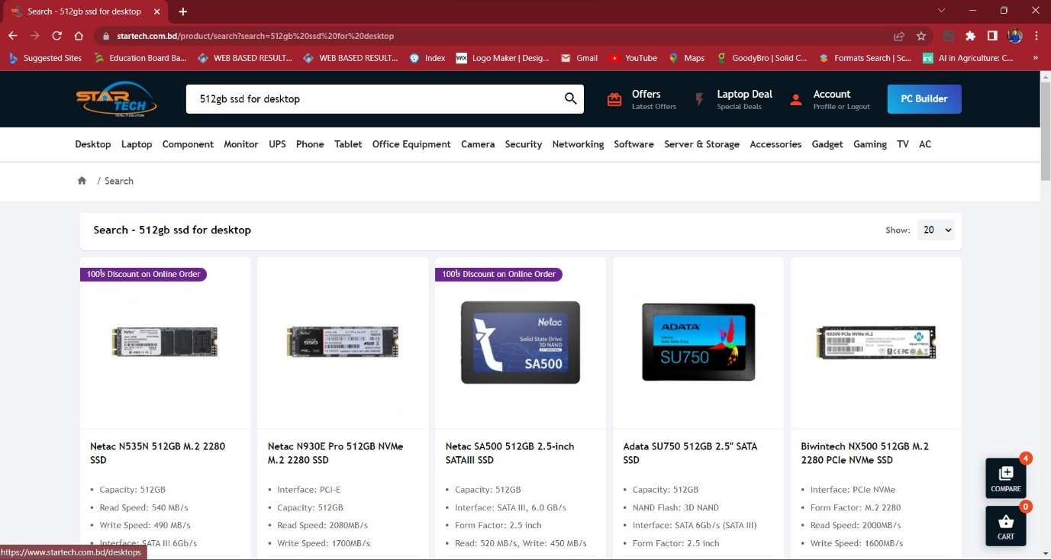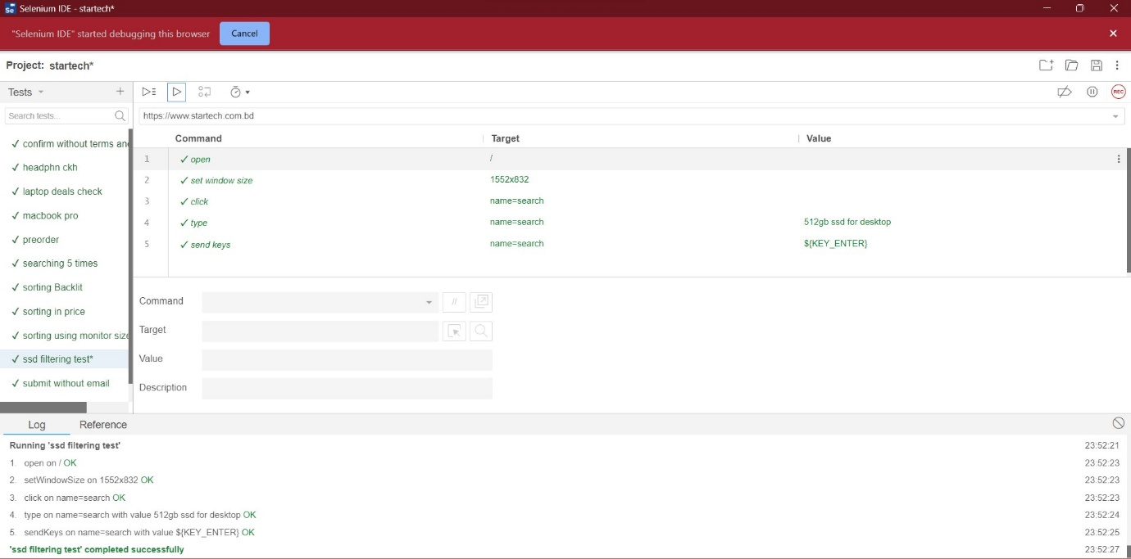

**Fig-82: SSD sorting test case execution.**

|  |  |  |  |  |  |
| --- | --- | --- | --- | --- | --- |
| Project Name: StarTech | | | Test Designed by: Azraf Faheem | | |
| Test Case ID: ST-TC13 | | | Test Designed date: 12/05/2023 | | |
| Test Priority (Low, Medium, High): High | | | Test Executed by: Azraf Faheem | | |
| Module Name: Checkout | | | Test Execution date: 12/05/2023 | | |
| Test Title: Order without e-mail | | |  | | |
| Description: Test whether the user can order without address | | |  | | |
| Precondition (If any): User must Login with a valid Startech user ID | | | | | |
| Test Steps | Test Data | Expected Results | | Actual Results | Status  (Pass/Fail) |
| 1. Go to the Startech website 2. Add any product on cart. 3. Click on “checkout” 4. Keep the address section empty 5. Click “Submit” | null | User should not be able to order without address | | as expected, | pass |

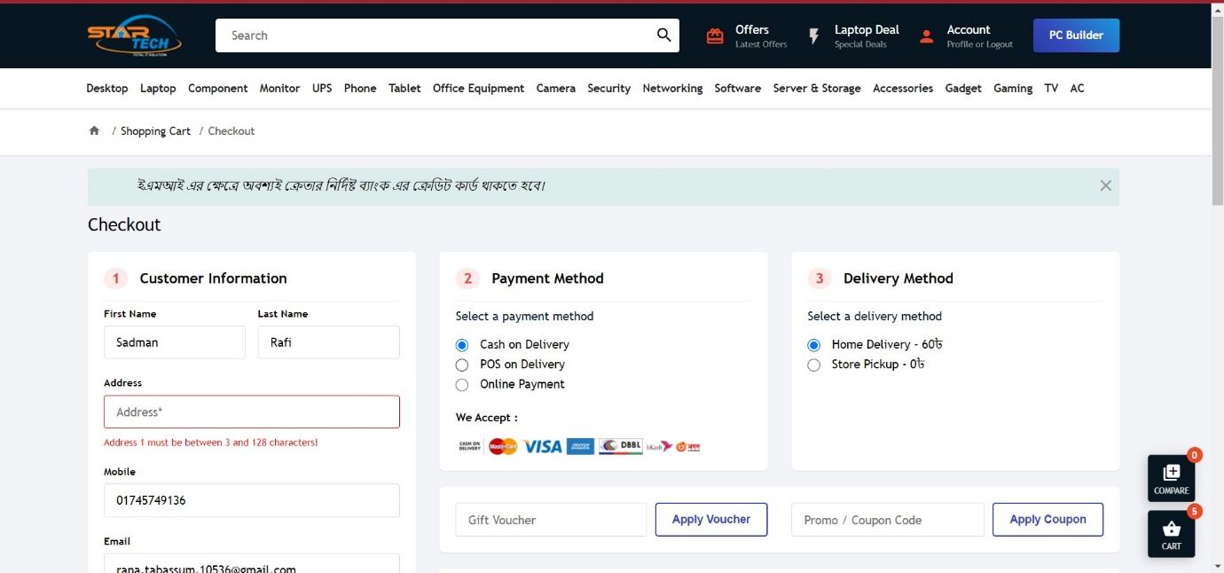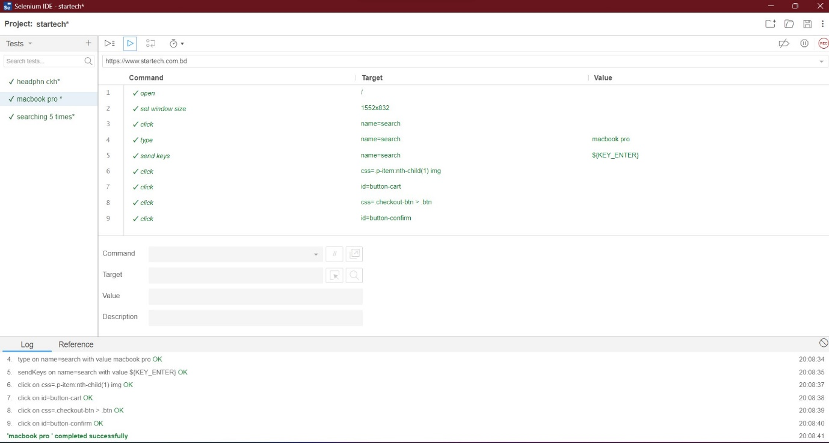

**Fig-83: Without Address test case execution.**

# ITEM PASS/FAIL CRITERIA

Around all of test cases passed while 5 of test cases failed. A test was considered as passed if it goes through each step without facing any interface errors or missing validation errors. With these criteria around 5 defects were found. However, most of the defects were found on the test cases with medium priority and low priority respectively with 3 defects detected in the medium priority test case and 2 defects detected in the low priority test case.

# TESTING SCHEDULE

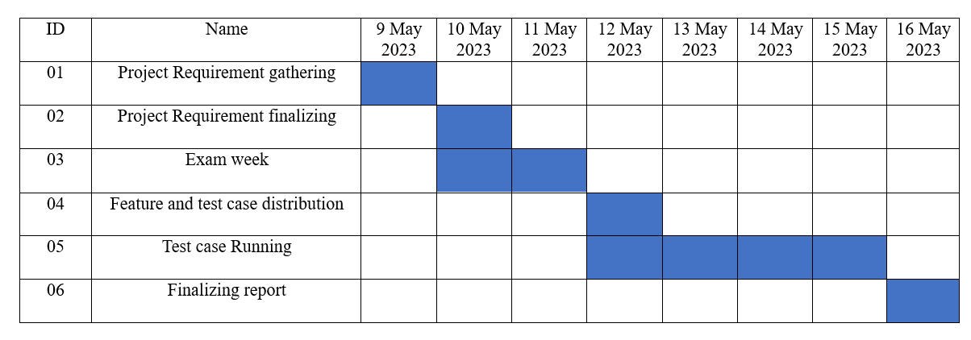

**Fig-84: Testing schedule for the project.**